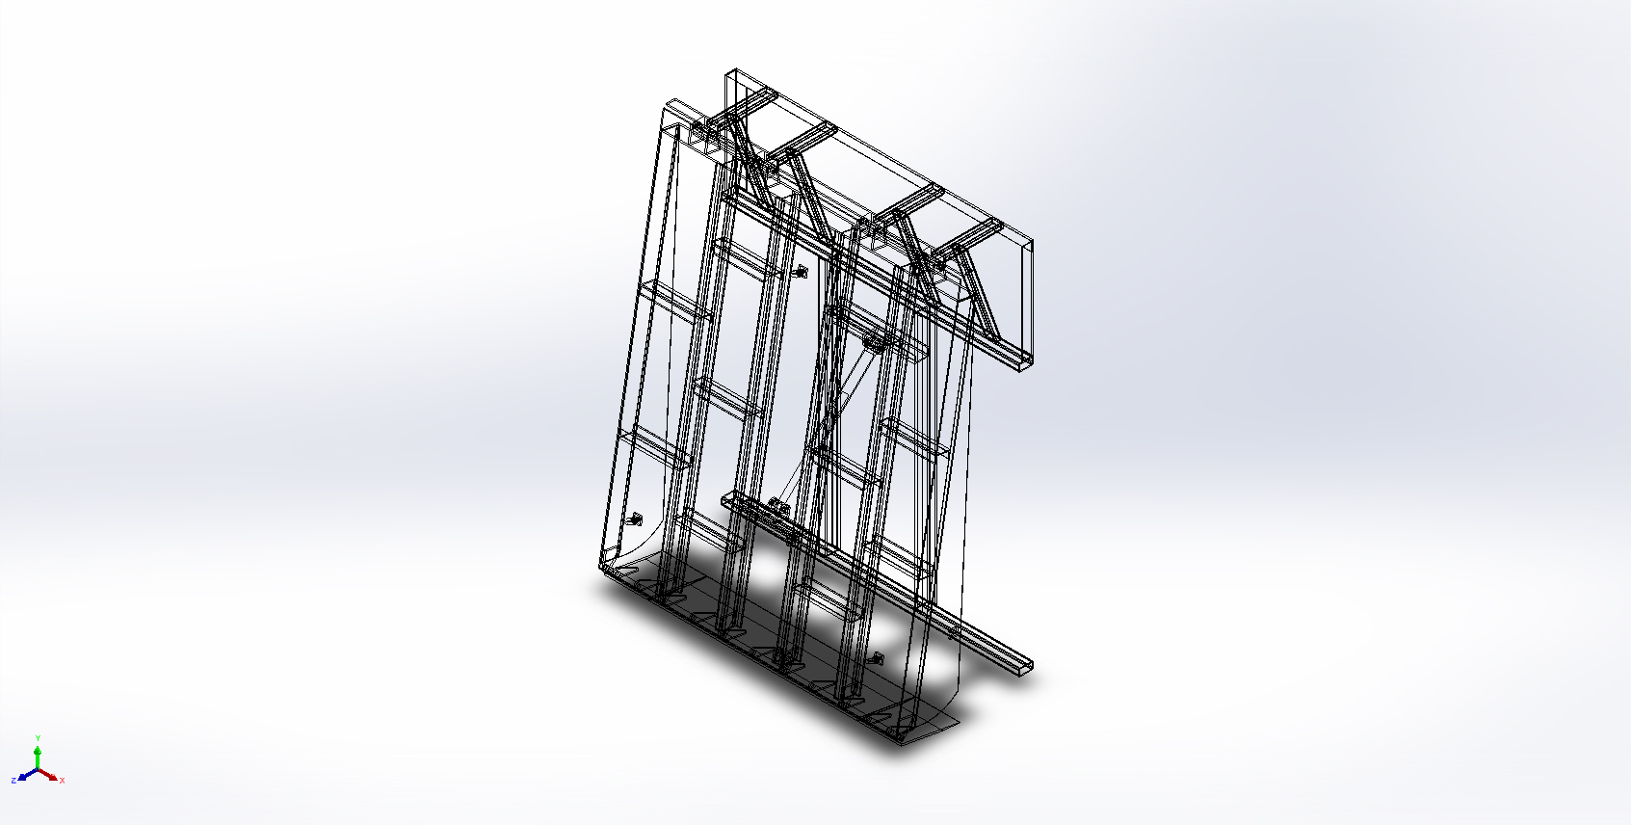
  Simulation of Main Dock Leveler Assembly
  Date: 07 December 2024
  Designer: Sumit Jadhav
  Study name: Static 1
  Analysis type: Static
  Table of Contents
  Description 1
  Assumptions 2
  Model Information 2
  Study Properties 24
  Units 25
  Material Properties 26
  Loads and Fixtures 33
  Connector Definitions 34
  Contact Information 35
  Mesh information 36
  Sensor Details 37
  Resultant Forces 38
  Beams 39
  Study Results 47
  Conclusion 50

Description
No Data

Assumptions

Model Information

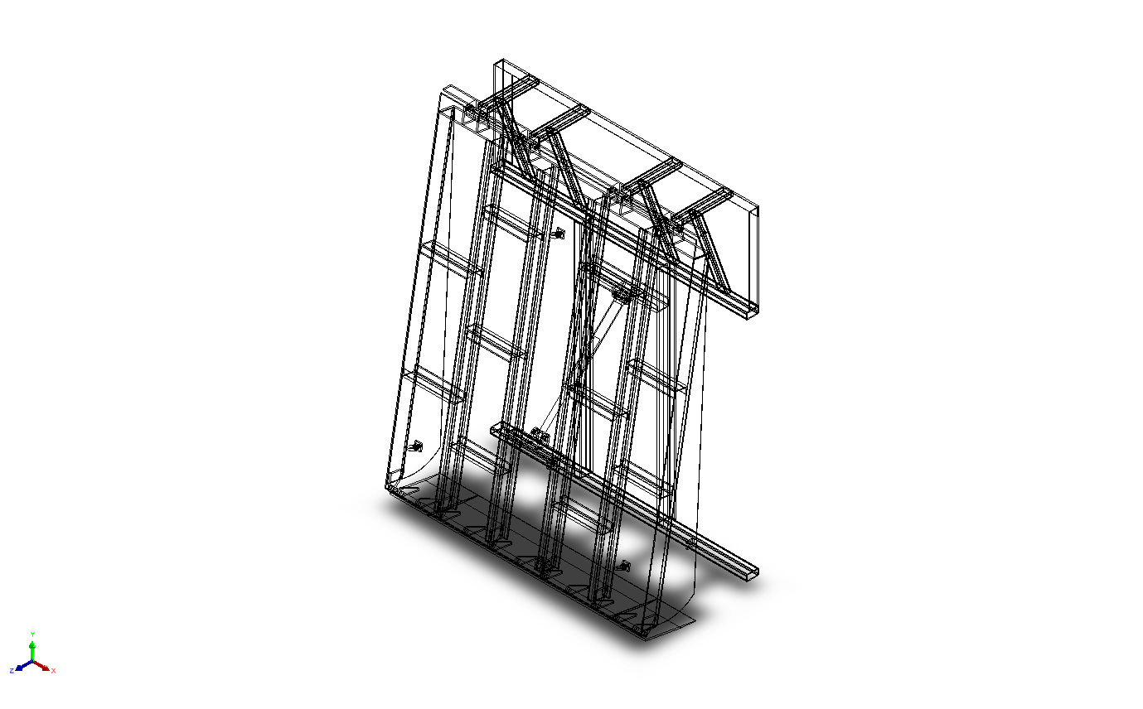
Model name: Main Dock Leveler Assembly
Current Configuration: Default
Solid Bodies
Document Name and Reference | Treated As | Volumetric Properties | Document Path/Date Modified
Fillet1 | Solid Body | Mass:0.490506 kg  Volume:6.20894e-05 m^3  Density:7,900 kg/m^3  Weight:4.80696 N | E:\NIHVA AUTOMATION 2024\AUTOMATION\DOCK LEVELER\MARCS PETCARE\DOCK LEVELER 3D\Flip Plate MTG BKT.SLDPRT  Dec 3 17:24:34 2024
Fillet1 | Solid Body | Mass:0.490506 kg  Volume:6.20894e-05 m^3  Density:7,900 kg/m^3  Weight:4.80696 N | E:\NIHVA AUTOMATION 2024\AUTOMATION\DOCK LEVELER\MARCS PETCARE\DOCK LEVELER 3D\Flip Plate MTG BKT.SLDPRT  Dec 3 17:24:34 2024
Fillet1 | Solid Body | Mass:0.490506 kg  Volume:6.20894e-05 m^3  Density:7,900 kg/m^3  Weight:4.80696 N | E:\NIHVA AUTOMATION 2024\AUTOMATION\DOCK LEVELER\MARCS PETCARE\DOCK LEVELER 3D\Flip Plate MTG BKT.SLDPRT  Dec 3 17:24:34 2024
Fillet1 | Solid Body | Mass:0.490506 kg  Volume:6.20894e-05 m^3  Density:7,900 kg/m^3  Weight:4.80696 N | E:\NIHVA AUTOMATION 2024\AUTOMATION\DOCK LEVELER\MARCS PETCARE\DOCK LEVELER 3D\Flip Plate MTG BKT.SLDPRT  Dec 3 17:24:34 2024
Cut-Extrude4[1] | Solid Body | Mass:0.271829 kg  Volume:3.44087e-05 m^3  Density:7,900 kg/m^3  Weight:2.66392 N | E:\NIHVA AUTOMATION 2024\AUTOMATION\DOCK LEVELER\MARCS PETCARE\DOCK LEVELER 3D\1600 mm filp plate.SLDPRT  Dec 6 16:08:18 2024
Cut-Extrude4[2] | Solid Body | Mass:0.271829 kg  Volume:3.44087e-05 m^3  Density:7,900 kg/m^3  Weight:2.66392 N | E:\NIHVA AUTOMATION 2024\AUTOMATION\DOCK LEVELER\MARCS PETCARE\DOCK LEVELER 3D\1600 mm filp plate.SLDPRT  Dec 6 16:08:18 2024
Fillet1 | Solid Body | Mass:0.490506 kg  Volume:6.20894e-05 m^3  Density:7,900 kg/m^3  Weight:4.80696 N | E:\NIHVA AUTOMATION 2024\AUTOMATION\DOCK LEVELER\MARCS PETCARE\DOCK LEVELER 3D\Flip Plate MTG BKT.SLDPRT  Dec 3 17:24:34 2024
Fillet1 | Solid Body | Mass:0.490506 kg  Volume:6.20894e-05 m^3  Density:7,900 kg/m^3  Weight:4.80696 N | E:\NIHVA AUTOMATION 2024\AUTOMATION\DOCK LEVELER\MARCS PETCARE\DOCK LEVELER 3D\Flip Plate MTG BKT.SLDPRT  Dec 3 17:24:34 2024
Fillet1 | Solid Body | Mass:0.490506 kg  Volume:6.20894e-05 m^3  Density:7,900 kg/m^3  Weight:4.80696 N | E:\NIHVA AUTOMATION 2024\AUTOMATION\DOCK LEVELER\MARCS PETCARE\DOCK LEVELER 3D\Flip Plate MTG BKT.SLDPRT  Dec 3 17:24:34 2024
Fillet1 | Solid Body | Mass:0.490506 kg  Volume:6.20894e-05 m^3  Density:7,900 kg/m^3  Weight:4.80696 N | E:\NIHVA AUTOMATION 2024\AUTOMATION\DOCK LEVELER\MARCS PETCARE\DOCK LEVELER 3D\Flip Plate MTG BKT.SLDPRT  Dec 3 17:24:34 2024
Fillet1 | Solid Body | Mass:0.490506 kg  Volume:6.20894e-05 m^3  Density:7,900 kg/m^3  Weight:4.80696 N | E:\NIHVA AUTOMATION 2024\AUTOMATION\DOCK LEVELER\MARCS PETCARE\DOCK LEVELER 3D\Flip Plate MTG BKT.SLDPRT  Dec 3 17:24:34 2024
Fillet1 | Solid Body | Mass:0.490506 kg  Volume:6.20894e-05 m^3  Density:7,900 kg/m^3  Weight:4.80696 N | E:\NIHVA AUTOMATION 2024\AUTOMATION\DOCK LEVELER\MARCS PETCARE\DOCK LEVELER 3D\Flip Plate MTG BKT.SLDPRT  Dec 3 17:24:34 2024
Fillet1 | Solid Body | Mass:0.490506 kg  Volume:6.20894e-05 m^3  Density:7,900 kg/m^3  Weight:4.80696 N | E:\NIHVA AUTOMATION 2024\AUTOMATION\DOCK LEVELER\MARCS PETCARE\DOCK LEVELER 3D\Flip Plate MTG BKT.SLDPRT  Dec 3 17:24:34 2024
Cut-Extrude1  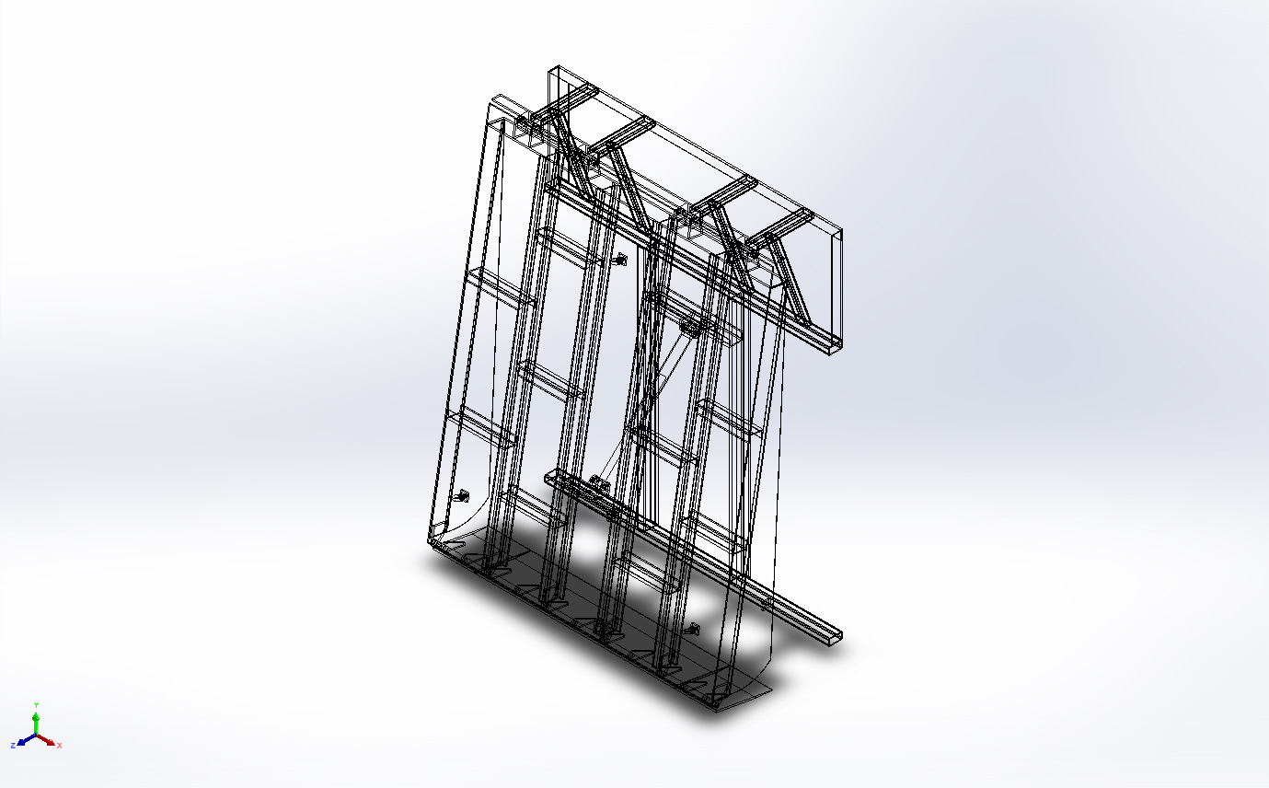 | Solid Body | Mass:118,427 kg  Volume:14.9908 m^3  Density:7,900 kg/m^3  Weight:1.16059e+06 N | E:\NIHVA AUTOMATION 2024\AUTOMATION\DOCK LEVELER\MARCS PETCARE\DOCK LEVELER 3D\BS.SLDPRT  Dec 7 09:49:01 2024
Boss-Extrude1  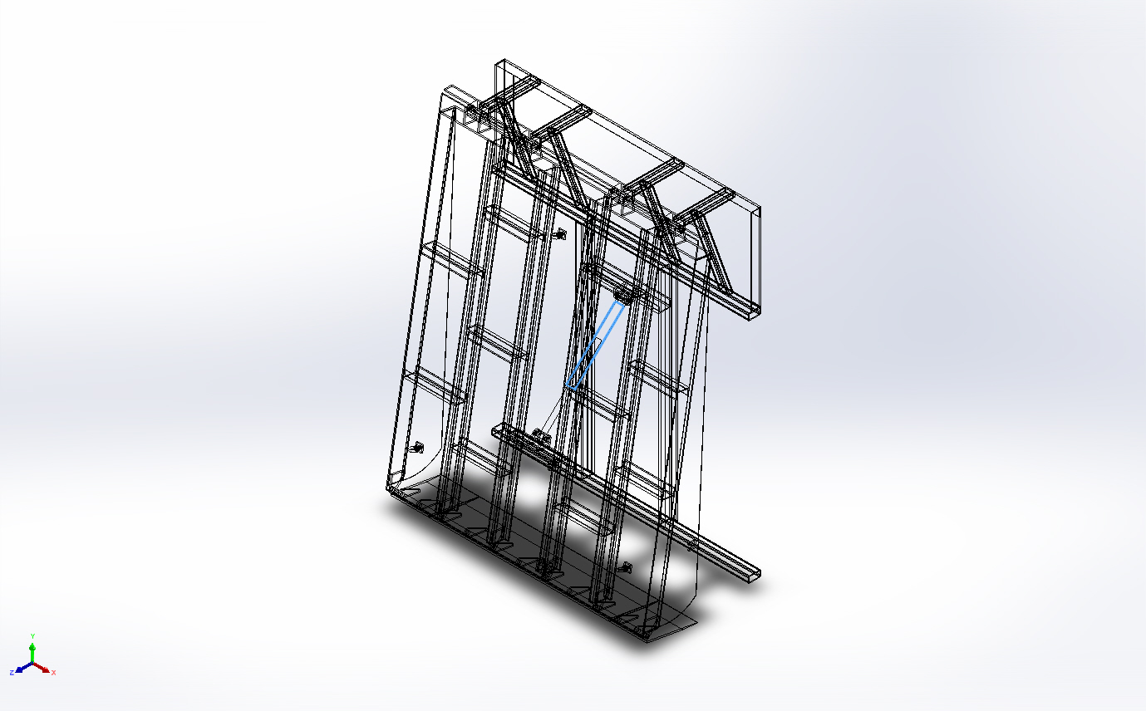 | Solid Body | Mass:3.64461 kg  Volume:0.000461343 m^3  Density:7,900 kg/m^3  Weight:35.7172 N | E:\NIHVA AUTOMATION 2024\AUTOMATION\DOCK LEVELER\MARCS PETCARE\DOCK LEVELER 3D\CYL BODY 01.SLDPRT  Dec 5 14:51:41 2024
Boss-Extrude3  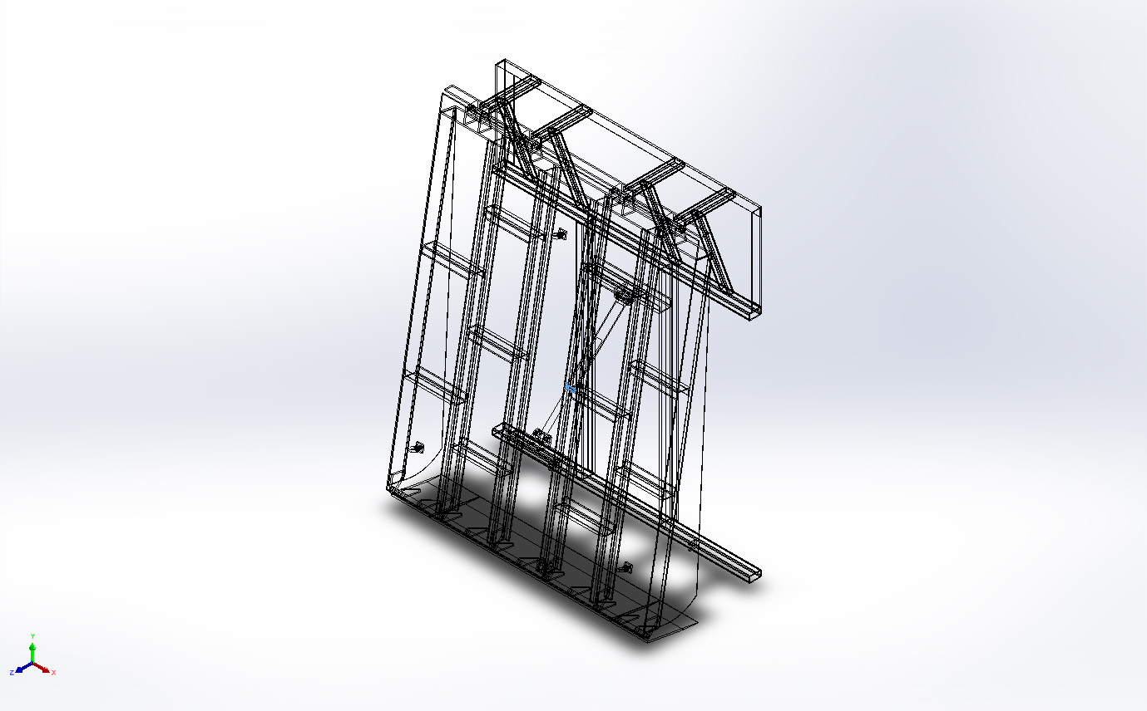 | Solid Body | Mass:0.22104 kg  Volume:2.79798e-05 m^3  Density:7,900 kg/m^3  Weight:2.1662 N | E:\NIHVA AUTOMATION 2024\AUTOMATION\DOCK LEVELER\MARCS PETCARE\DOCK LEVELER 3D\CYL BODY 01.SLDPRT  Dec 5 14:51:41 2024
Mirror4[1]  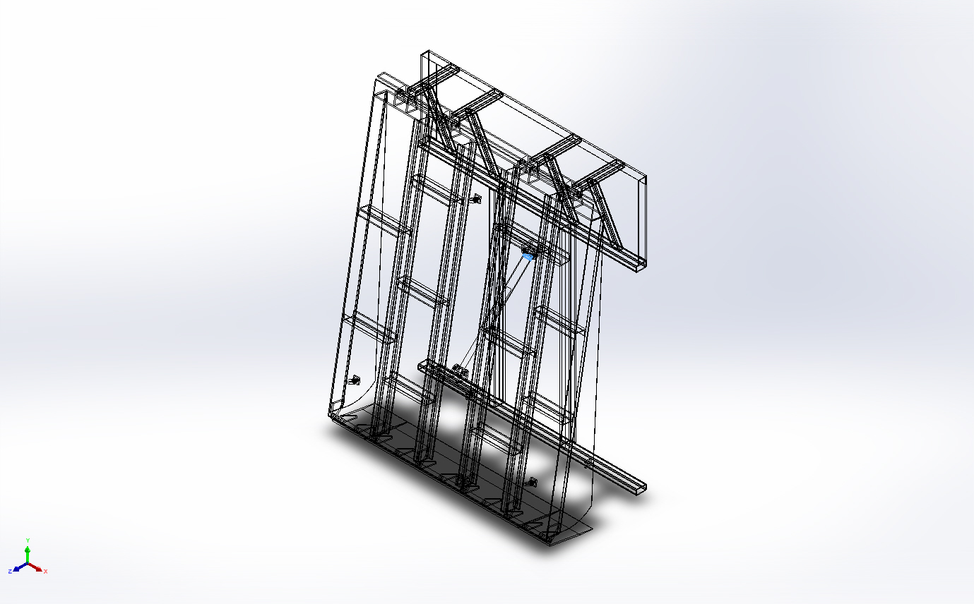 | Solid Body | Mass:0.261488 kg  Volume:3.30998e-05 m^3  Density:7,900 kg/m^3  Weight:2.56258 N | E:\NIHVA AUTOMATION 2024\AUTOMATION\DOCK LEVELER\MARCS PETCARE\DOCK LEVELER 3D\CYL BODY 01.SLDPRT  Dec 5 14:51:41 2024
Mirror4[2]  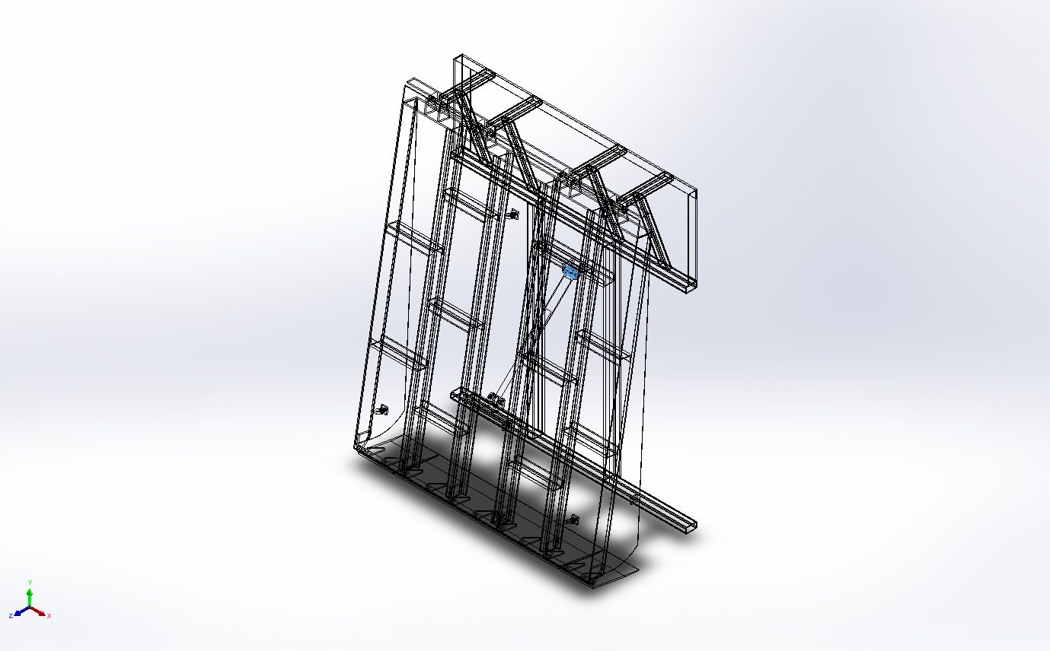 | Solid Body | Mass:0.796641 kg  Volume:0.000100841 m^3  Density:7,900 kg/m^3  Weight:7.80708 N | E:\NIHVA AUTOMATION 2024\AUTOMATION\DOCK LEVELER\MARCS PETCARE\DOCK LEVELER 3D\CYL BODY 01.SLDPRT  Dec 5 14:51:41 2024
Cut-Extrude1  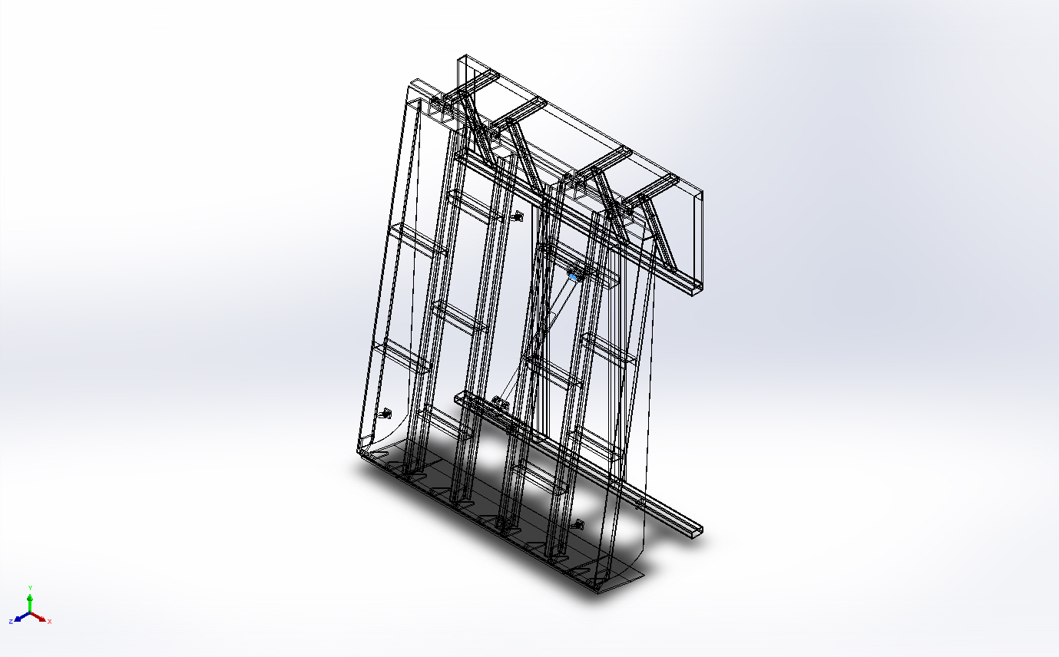 | Solid Body | Mass:0.0404501 kg  Volume:5.12027e-06 m^3  Density:7,900 kg/m^3  Weight:0.396411 N | E:\NIHVA AUTOMATION 2024\AUTOMATION\DOCK LEVELER\MARCS PETCARE\DOCK LEVELER 3D\CYL BODY 01.SLDPRT  Dec 5 14:51:41 2024
Mirror2[2]  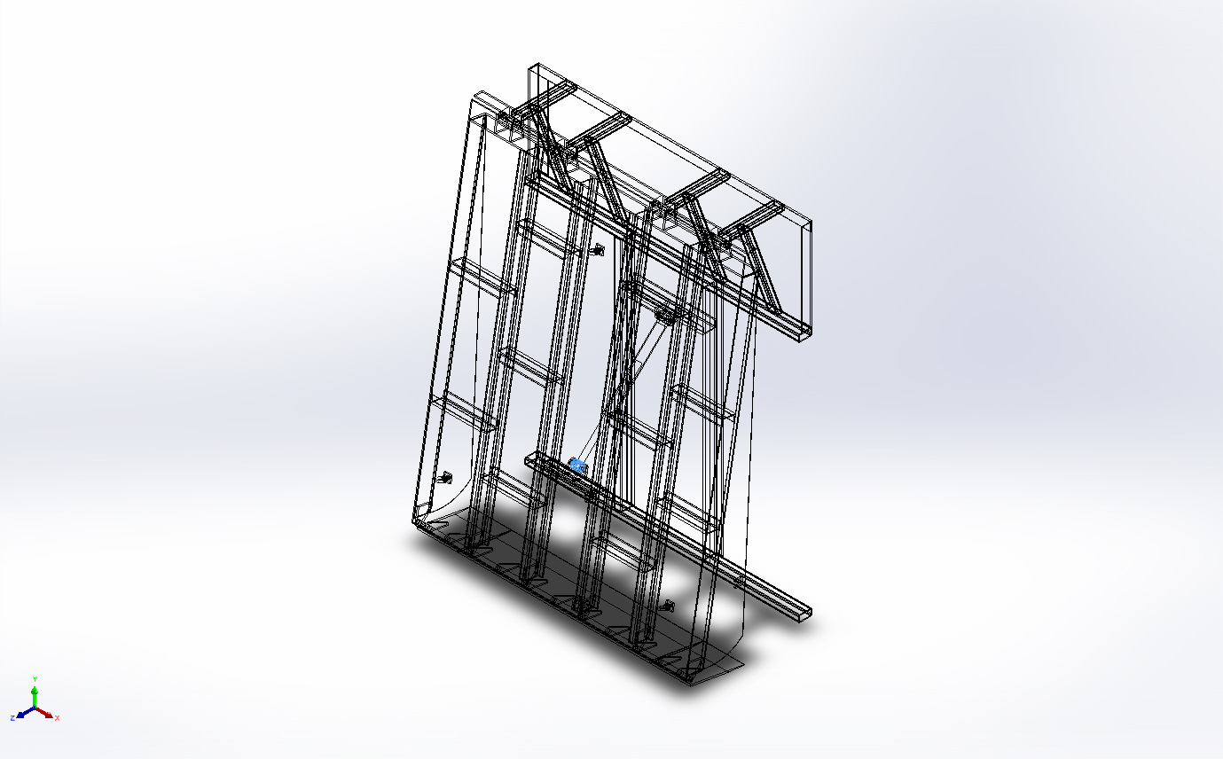 | Solid Body | Mass:0.646077 kg  Volume:8.17819e-05 m^3  Density:7,900 kg/m^3  Weight:6.33155 N | E:\NIHVA AUTOMATION 2024\AUTOMATION\DOCK LEVELER\MARCS PETCARE\DOCK LEVELER 3D\CYL SHAFT01.SLDPRT  Dec 5 14:52:05 2024
Cut-Extrude1  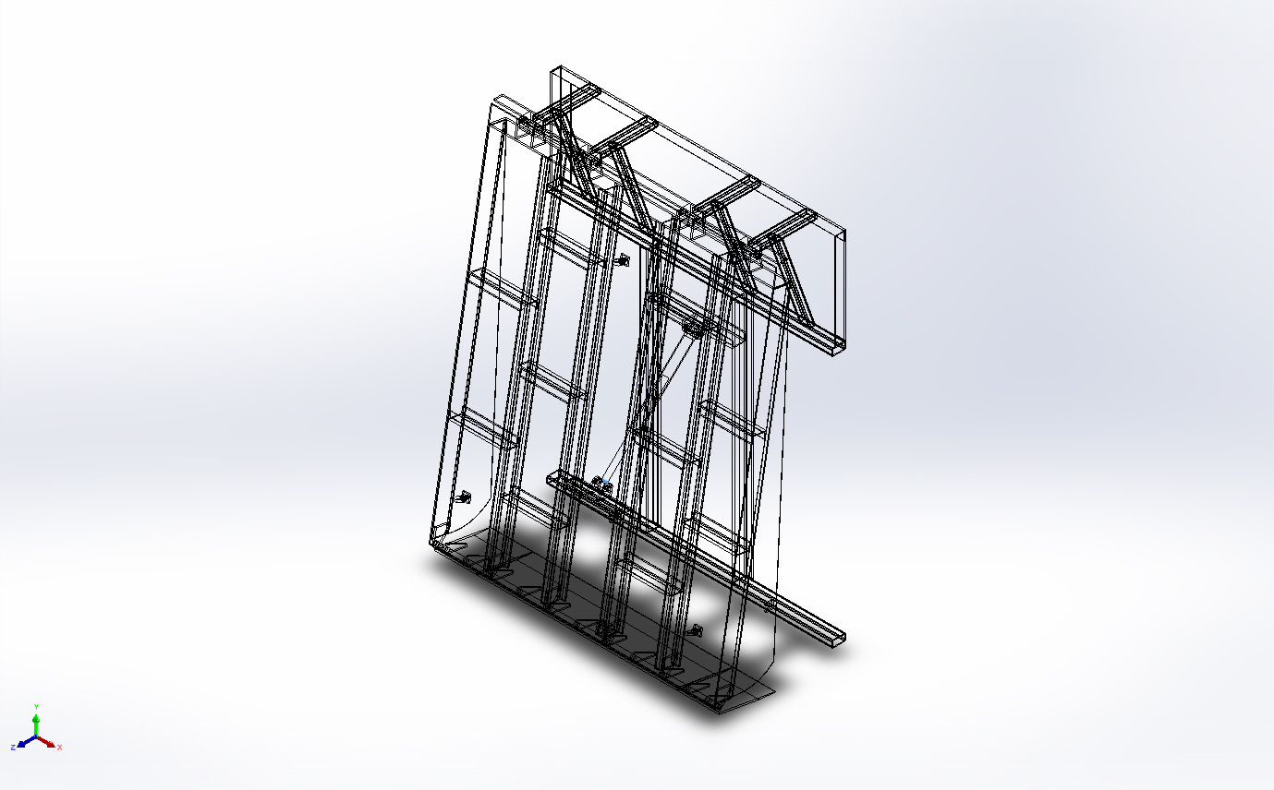 | Solid Body | Mass:0.00622352 kg  Volume:7.87732e-07 m^3  Density:7,900.55 kg/m^3  Weight:0.0609904 N | E:\NIHVA AUTOMATION 2024\AUTOMATION\DOCK LEVELER\MARCS PETCARE\DOCK LEVELER 3D\CYL SHAFT01.SLDPRT  Dec 5 14:52:05 2024
Mirror2[1]  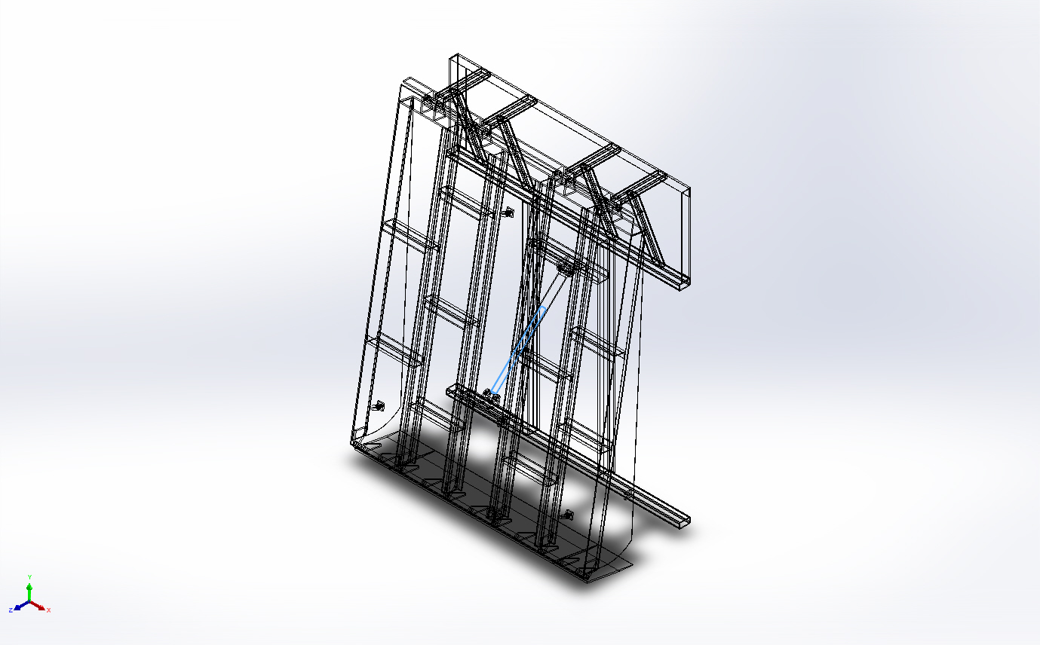 | Solid Body | Mass:4.56665 kg  Volume:0.000578057 m^3  Density:7,900 kg/m^3  Weight:44.7532 N | E:\NIHVA AUTOMATION 2024\AUTOMATION\DOCK LEVELER\MARCS PETCARE\DOCK LEVELER 3D\CYL SHAFT01.SLDPRT  Dec 5 14:52:05 2024
Cut-Extrude1  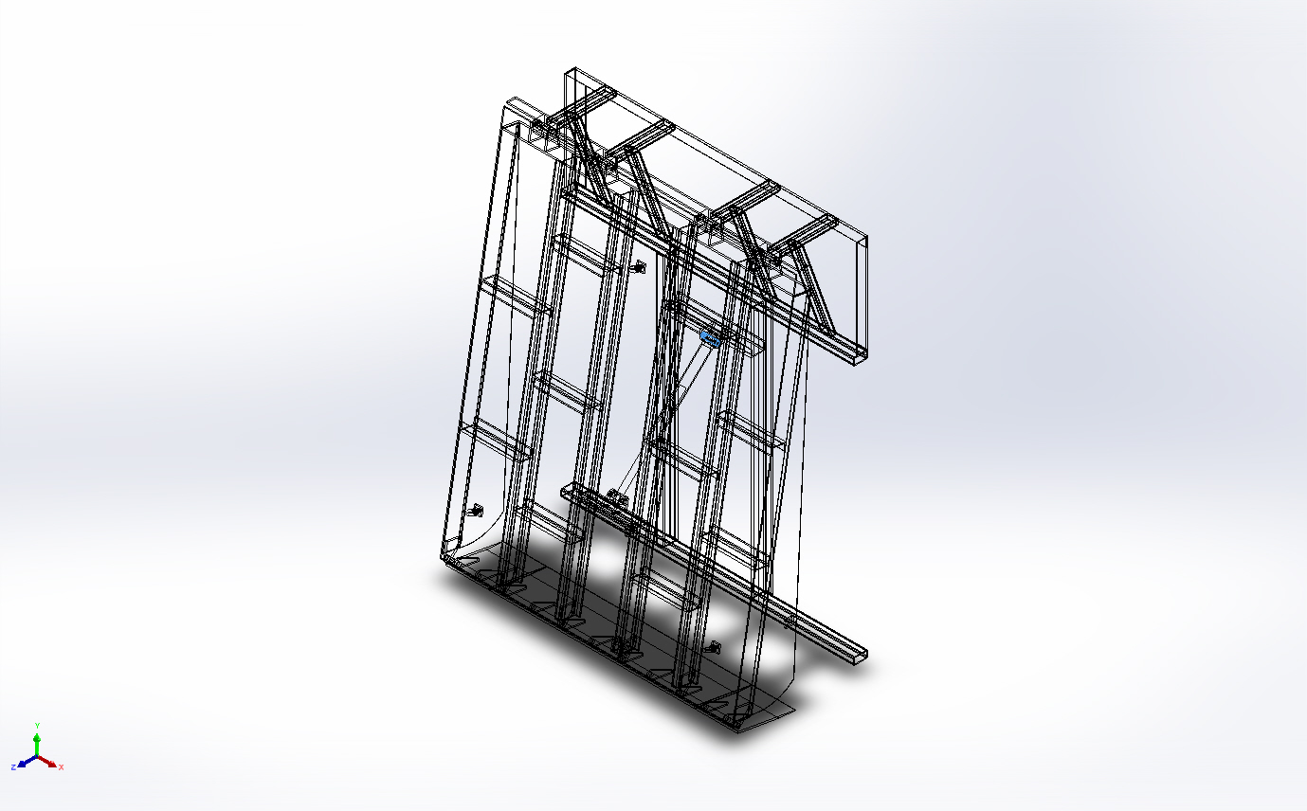 | Solid Body | Mass:0.394409 kg  Volume:4.99252e-05 m^3  Density:7,900 kg/m^3  Weight:3.86521 N | E:\NIHVA AUTOMATION 2024\AUTOMATION\DOCK LEVELER\MARCS PETCARE\DOCK LEVELER 3D\Cyl mtg pin.SLDPRT  Dec 5 15:06:54 2024
Boss-Extrude2  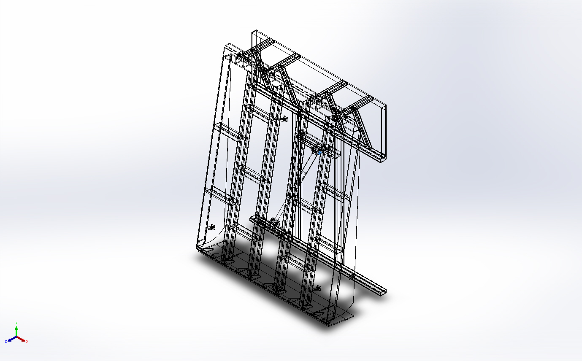 | Solid Body | Mass:0.0558418 kg  Volume:7.06858e-06 m^3  Density:7,900 kg/m^3  Weight:0.54725 N | E:\NIHVA AUTOMATION 2024\AUTOMATION\DOCK LEVELER\MARCS PETCARE\DOCK LEVELER 3D\Cyl mtg pin.SLDPRT  Dec 5 15:06:54 2024
Cut-Extrude1  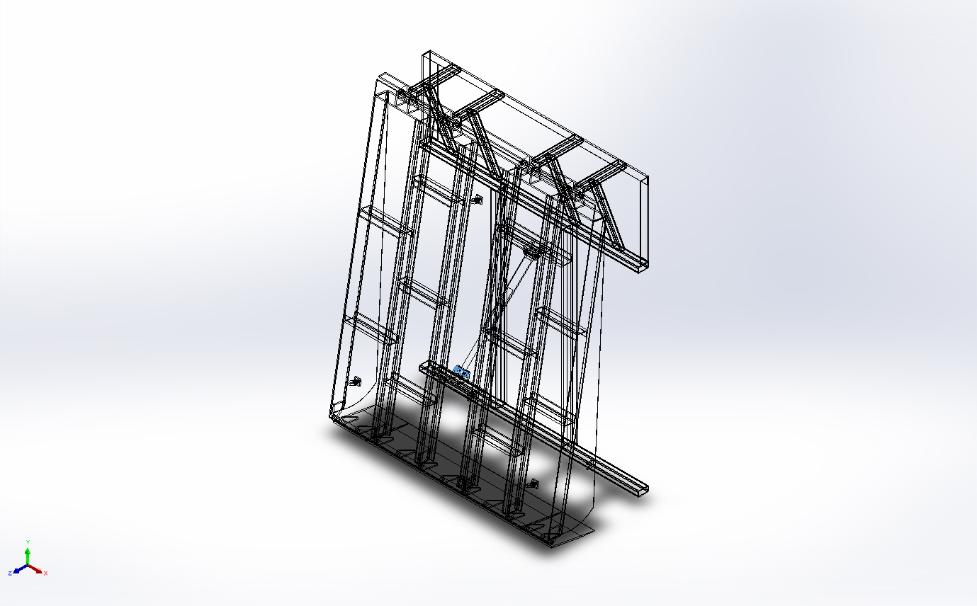 | Solid Body | Mass:0.394409 kg  Volume:4.99252e-05 m^3  Density:7,900 kg/m^3  Weight:3.86521 N | E:\NIHVA AUTOMATION 2024\AUTOMATION\DOCK LEVELER\MARCS PETCARE\DOCK LEVELER 3D\Cyl mtg pin.SLDPRT  Dec 5 15:06:54 2024
Boss-Extrude2  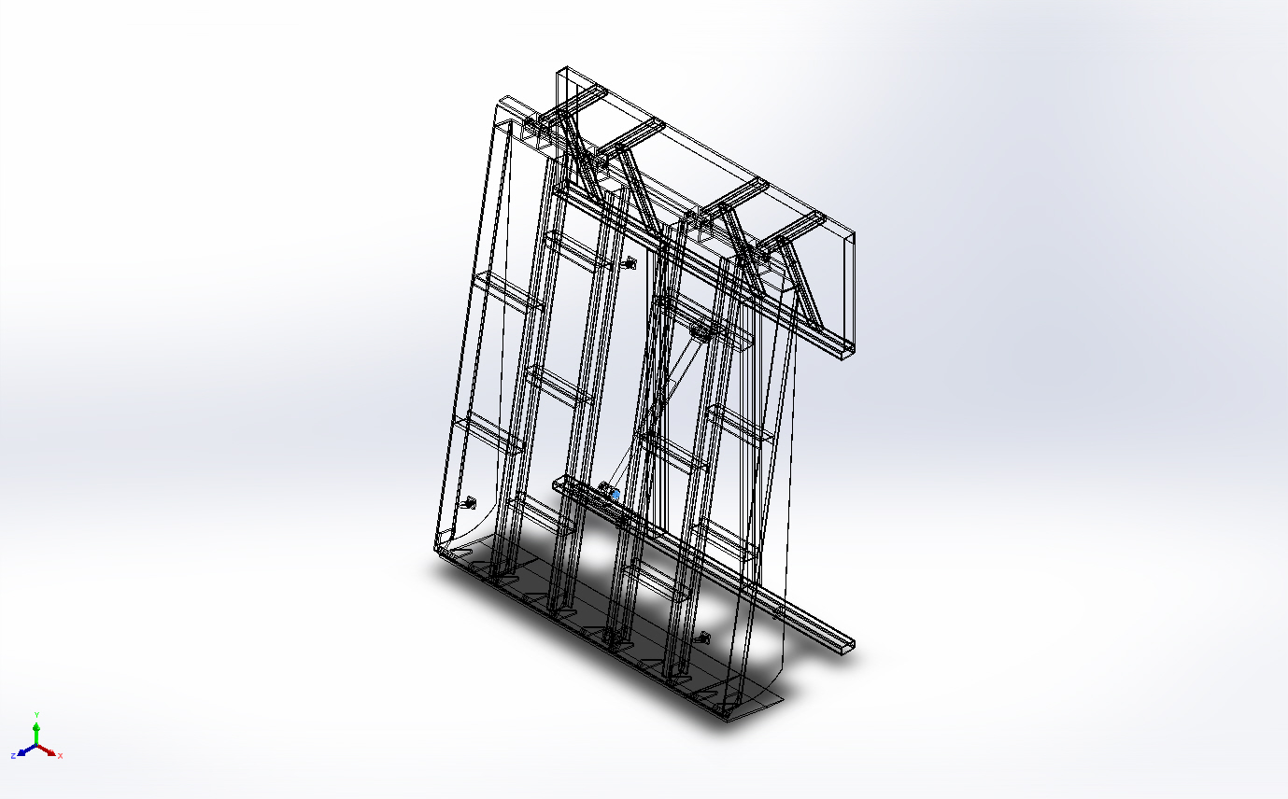 | Solid Body | Mass:0.0558418 kg  Volume:7.06858e-06 m^3  Density:7,900 kg/m^3  Weight:0.54725 N | E:\NIHVA AUTOMATION 2024\AUTOMATION\DOCK LEVELER\MARCS PETCARE\DOCK LEVELER 3D\Cyl mtg pin.SLDPRT  Dec 5 15:06:54 2024
Boss-Extrude1  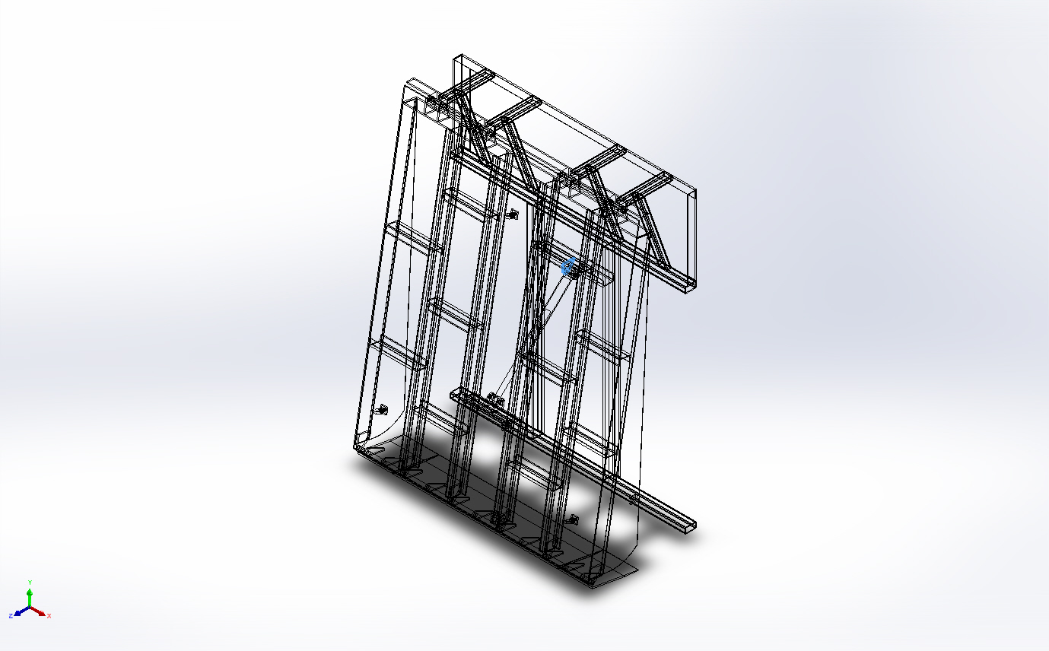 | Solid Body | Mass:0.468505 kg  Volume:5.93045e-05 m^3  Density:7,900 kg/m^3  Weight:4.59135 N | E:\NIHVA AUTOMATION 2024\AUTOMATION\DOCK LEVELER\MARCS PETCARE\DOCK LEVELER 3D\Cylinder MTG BKT.SLDPRT  Dec 4 09:47:05 2024
Boss-Extrude1  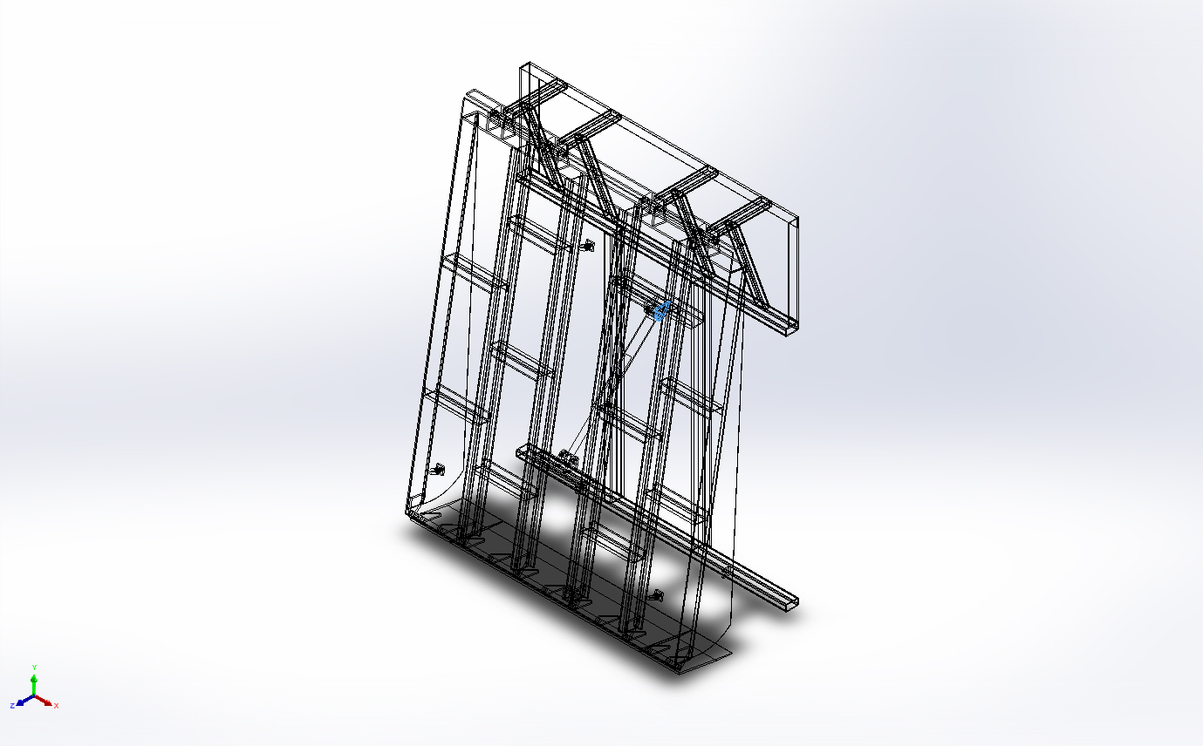 | Solid Body | Mass:0.468505 kg  Volume:5.93045e-05 m^3  Density:7,900 kg/m^3  Weight:4.59135 N | E:\NIHVA AUTOMATION 2024\AUTOMATION\DOCK LEVELER\MARCS PETCARE\DOCK LEVELER 3D\Cylinder MTG BKT.SLDPRT  Dec 4 09:47:05 2024
Boss-Extrude1  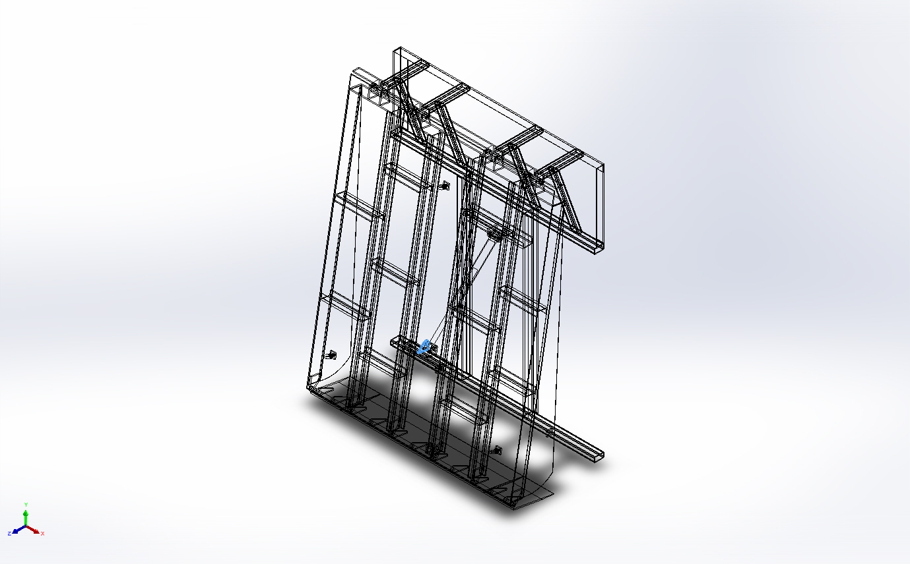 | Solid Body | Mass:0.468505 kg  Volume:5.93045e-05 m^3  Density:7,900 kg/m^3  Weight:4.59135 N | E:\NIHVA AUTOMATION 2024\AUTOMATION\DOCK LEVELER\MARCS PETCARE\DOCK LEVELER 3D\Cylinder MTG BKT.SLDPRT  Dec 4 09:47:05 2024
Boss-Extrude1  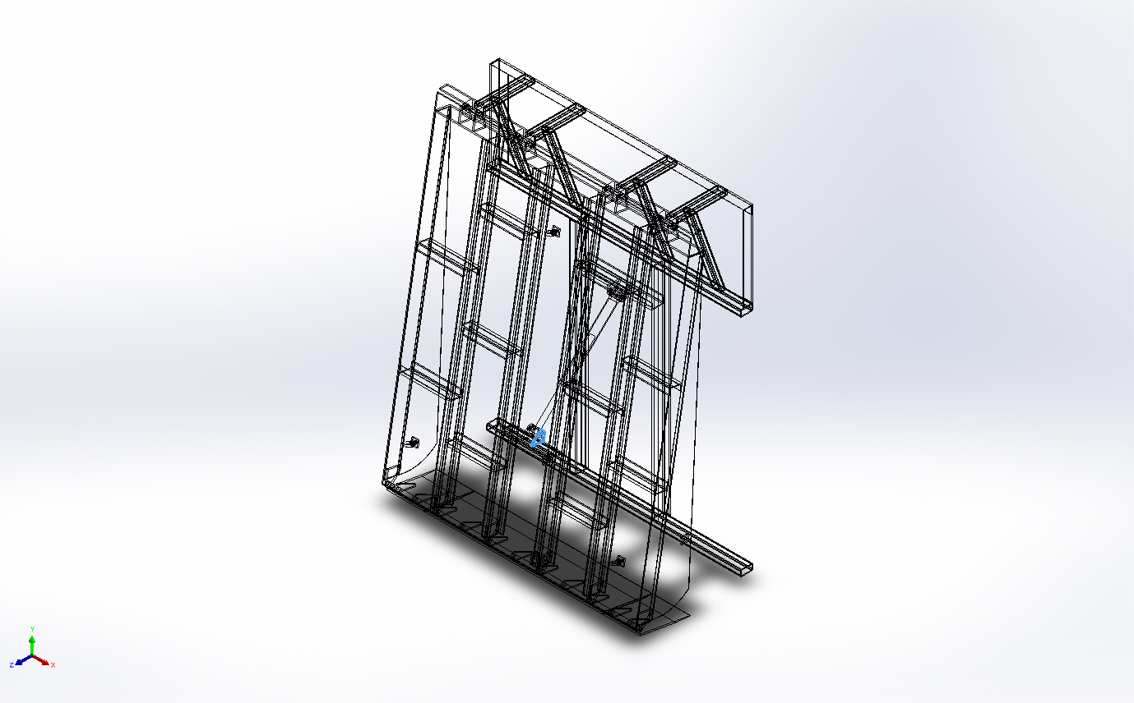 | Solid Body | Mass:0.468505 kg  Volume:5.93045e-05 m^3  Density:7,900 kg/m^3  Weight:4.59135 N | E:\NIHVA AUTOMATION 2024\AUTOMATION\DOCK LEVELER\MARCS PETCARE\DOCK LEVELER 3D\Cylinder MTG BKT.SLDPRT  Dec 4 09:47:05 2024
Cut-Extrude2  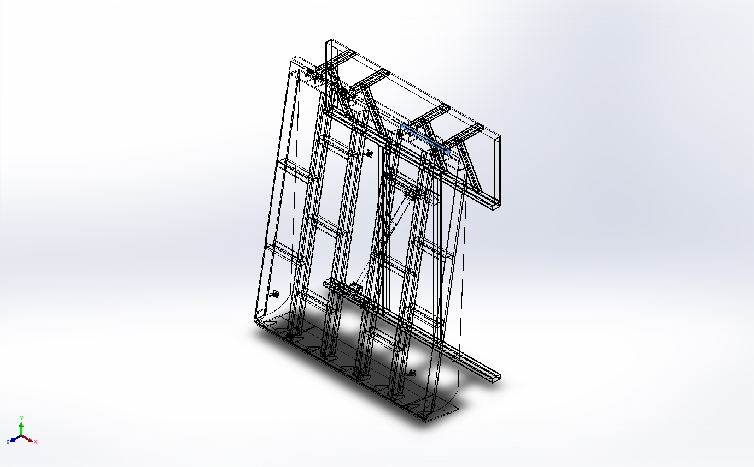 | Solid Body | Mass:2.13057 kg  Volume:0.000269693 m^3  Density:7,900 kg/m^3  Weight:20.8796 N | E:\NIHVA AUTOMATION 2024\AUTOMATION\DOCK LEVELER\MARCS PETCARE\DOCK LEVELER 3D\Dack bar.SLDPRT  Dec 7 10:54:53 2024
Cut-Extrude2  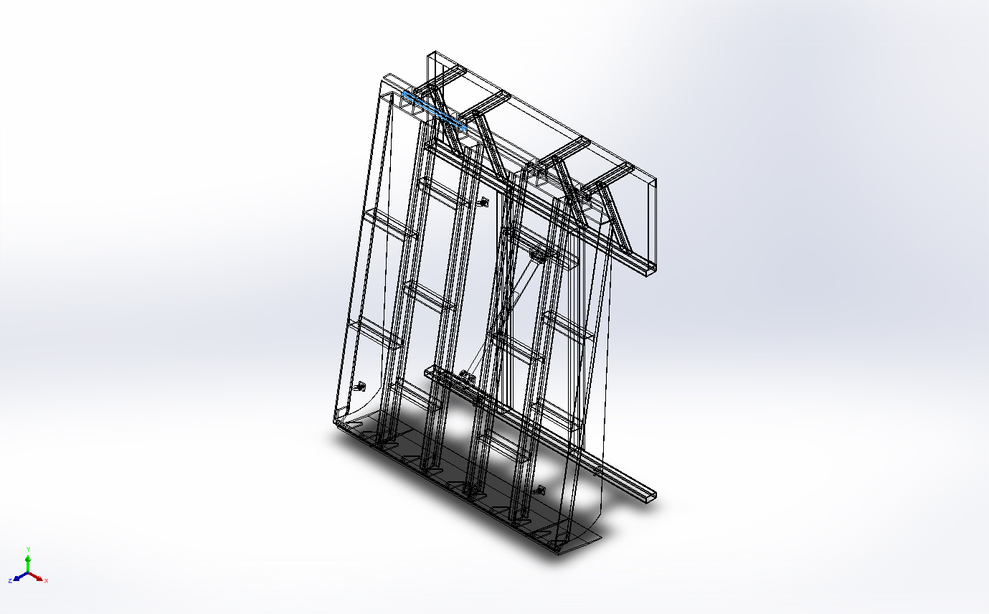 | Solid Body | Mass:2.13057 kg  Volume:0.000269693 m^3  Density:7,900 kg/m^3  Weight:20.8796 N | E:\NIHVA AUTOMATION 2024\AUTOMATION\DOCK LEVELER\MARCS PETCARE\DOCK LEVELER 3D\Dack bar.SLDPRT  Dec 7 10:54:53 2024
External Circlip 22mm.STEP  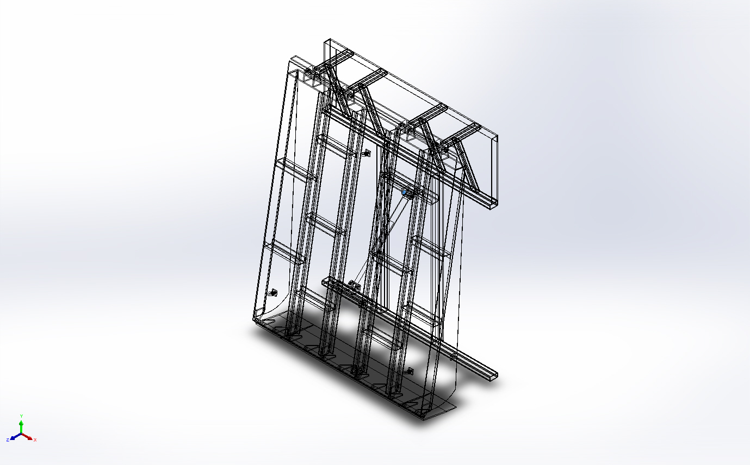 | Solid Body | Mass:0.00181394 kg  Volume:2.29612e-07 m^3  Density:7,900 kg/m^3  Weight:0.0177766 N | C:\Users\DESIGN\AppData\Local\Temp\swx6860\IC~~\External Circlip 22mm.step.SLDPRT  Dec 7 11:36:01 2024
External Circlip 22mm.STEP  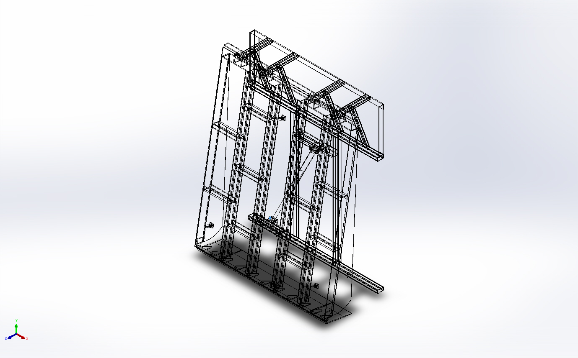 | Solid Body | Mass:0.00181394 kg  Volume:2.29612e-07 m^3  Density:7,900 kg/m^3  Weight:0.0177766 N | C:\Users\DESIGN\AppData\Local\Temp\swx6860\IC~~\External Circlip 22mm.step.SLDPRT  Dec 7 11:36:01 2024
External Circlip 22mm.STEP  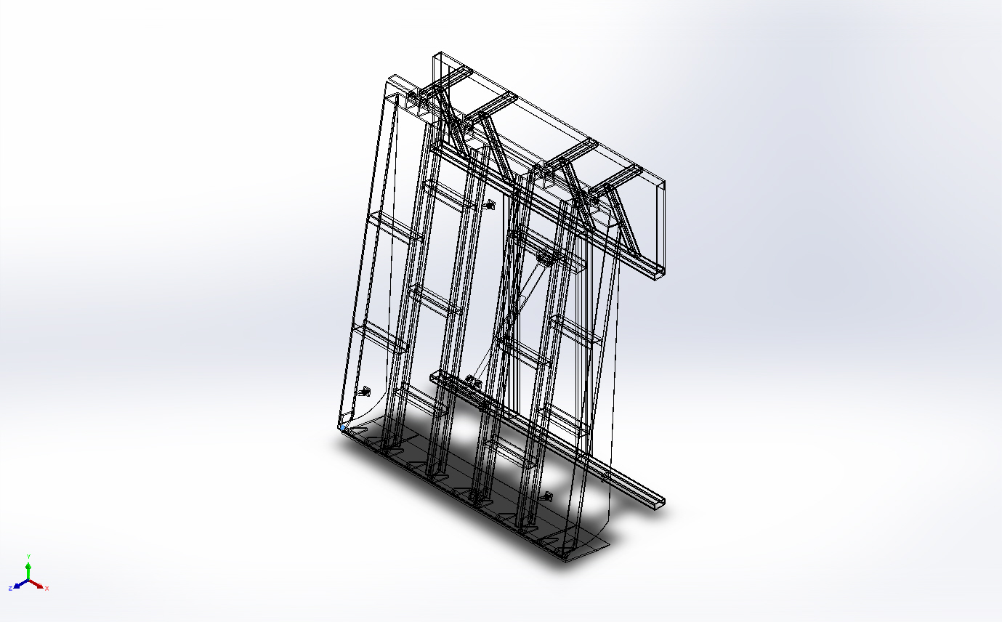 | Solid Body | Mass:0.00181394 kg  Volume:2.29612e-07 m^3  Density:7,900 kg/m^3  Weight:0.0177766 N | C:\Users\DESIGN\AppData\Local\Temp\swx6860\IC~~\External Circlip 22mm.step.SLDPRT  Dec 7 11:36:01 2024
External Circlip 22mm.STEP  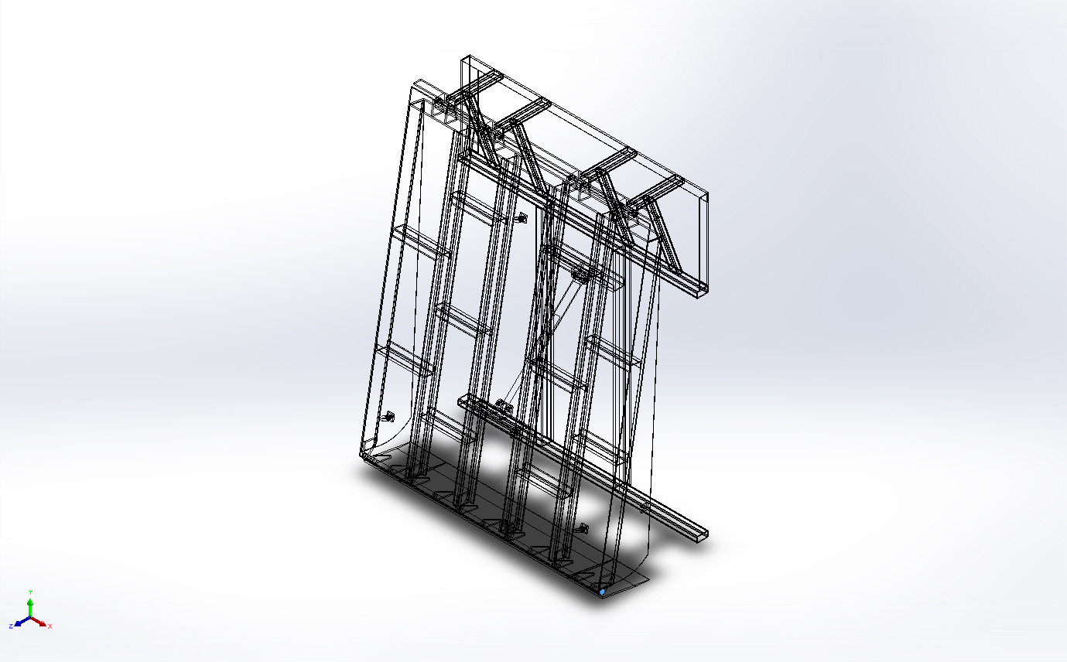 | Solid Body | Mass:0.00181394 kg  Volume:2.29612e-07 m^3  Density:7,900 kg/m^3  Weight:0.0177766 N | C:\Users\DESIGN\AppData\Local\Temp\swx6860\IC~~\External Circlip 22mm.step.SLDPRT  Dec 7 11:36:01 2024
External Circlip 22mm.STEP  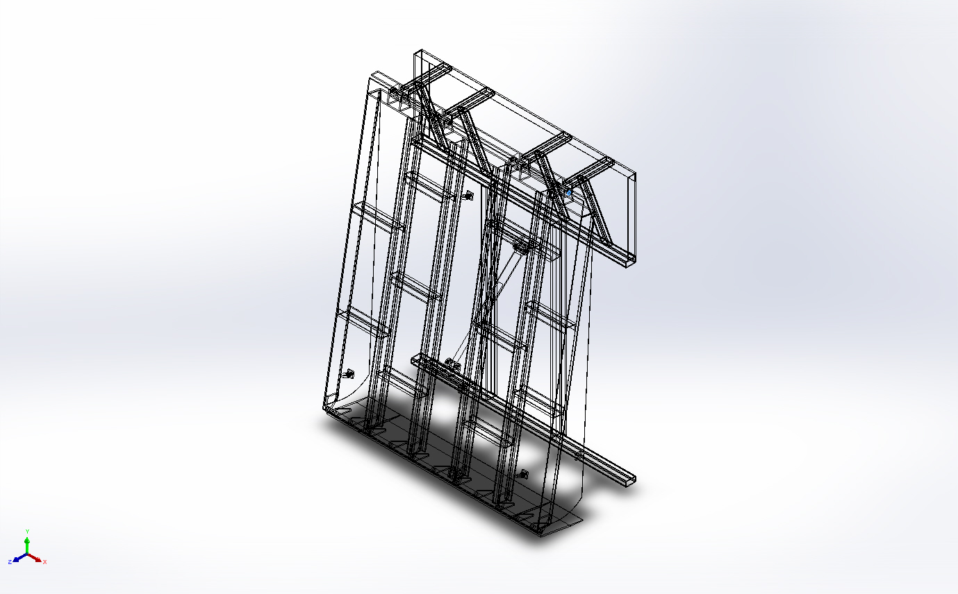 | Solid Body | Mass:0.00181394 kg  Volume:2.29612e-07 m^3  Density:7,900 kg/m^3  Weight:0.0177766 N | C:\Users\DESIGN\AppData\Local\Temp\swx6860\IC~~\External Circlip 22mm.step.SLDPRT  Dec 7 11:36:01 2024
External Circlip 22mm.STEP  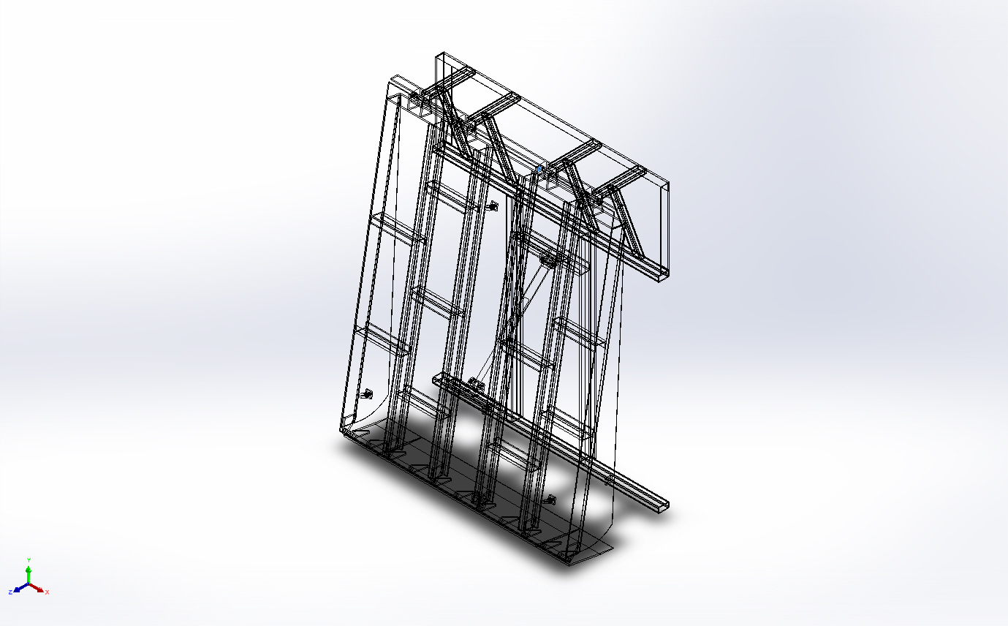 | Solid Body | Mass:0.00181394 kg  Volume:2.29612e-07 m^3  Density:7,900 kg/m^3  Weight:0.0177766 N | C:\Users\DESIGN\AppData\Local\Temp\swx6860\IC~~\External Circlip 22mm.step.SLDPRT  Dec 7 11:36:01 2024
External Circlip 22mm.STEP  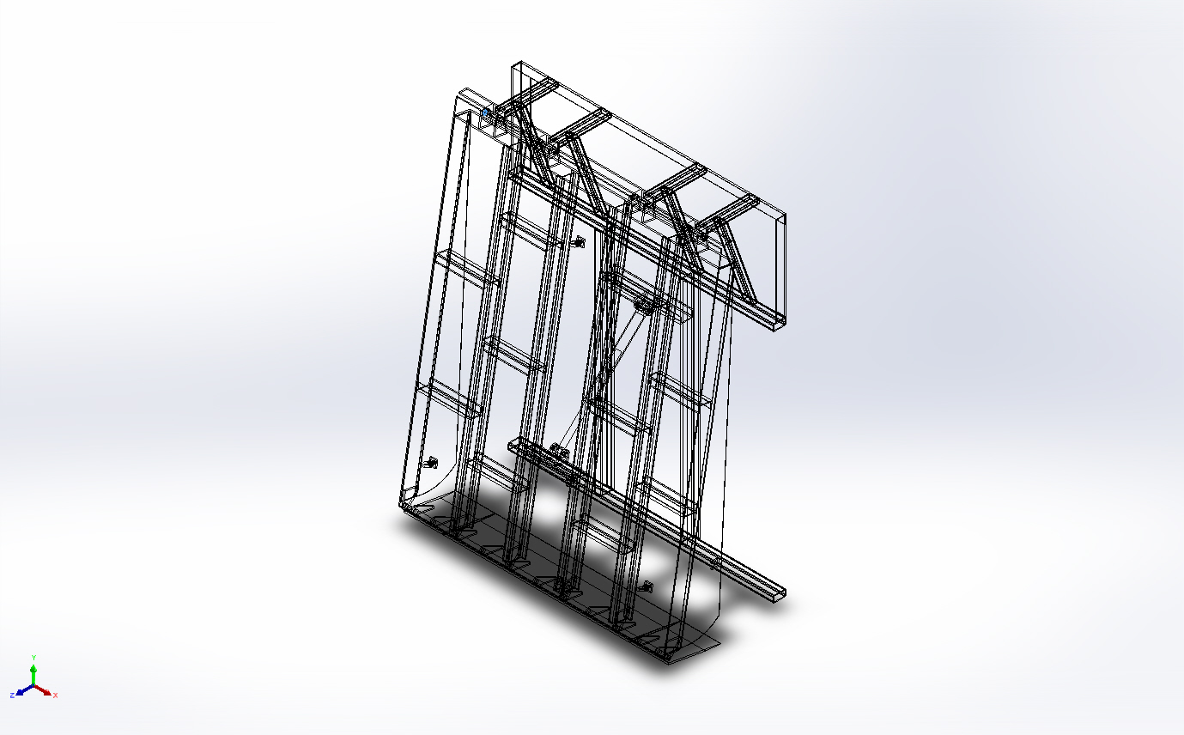 | Solid Body | Mass:0.00181394 kg  Volume:2.29612e-07 m^3  Density:7,900 kg/m^3  Weight:0.0177766 N | C:\Users\DESIGN\AppData\Local\Temp\swx6860\IC~~\External Circlip 22mm.step.SLDPRT  Dec 7 11:36:01 2024
External Circlip 22mm.STEP  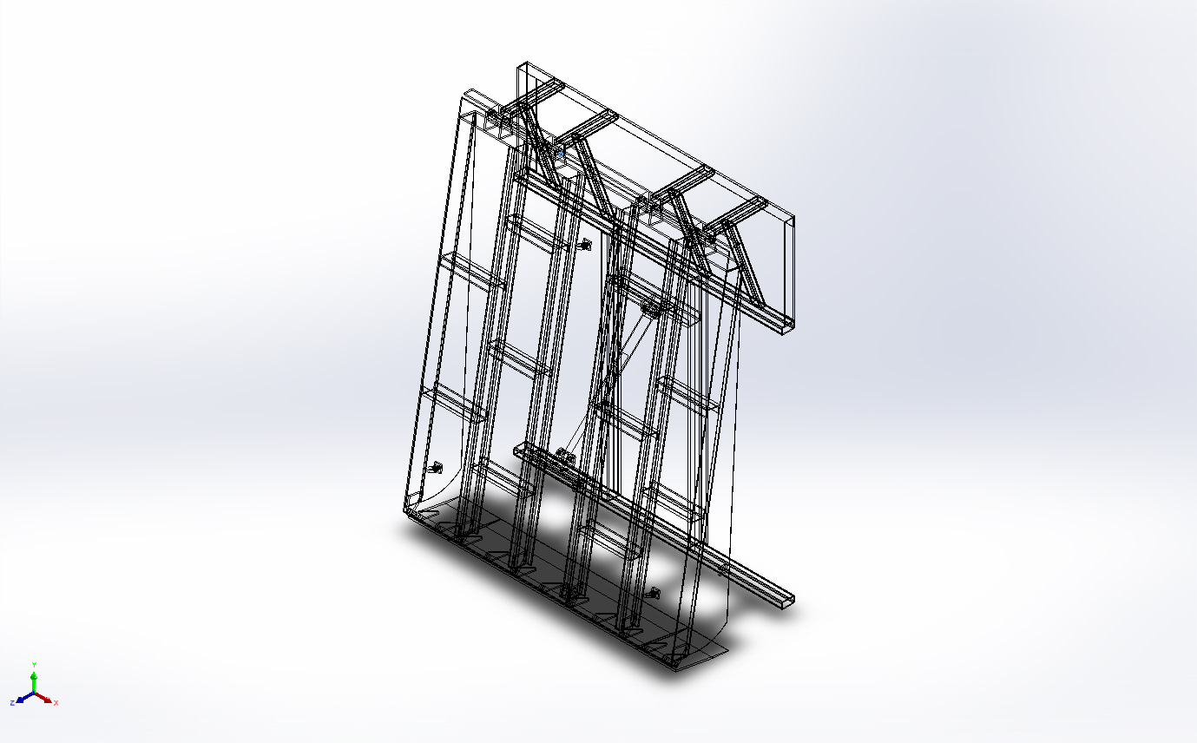 | Solid Body | Mass:0.00181394 kg  Volume:2.29612e-07 m^3  Density:7,900 kg/m^3  Weight:0.0177766 N | C:\Users\DESIGN\AppData\Local\Temp\swx6860\IC~~\External Circlip 22mm.step.SLDPRT  Dec 7 11:36:01 2024
Boss-Extrude2  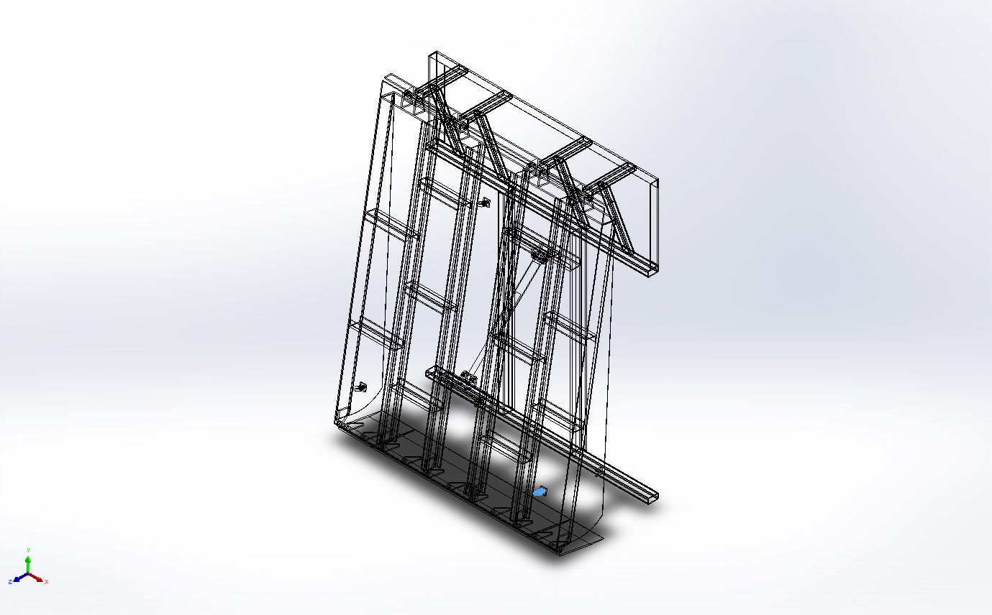 | Solid Body | Mass:0.28826 kg  Volume:3.64889e-05 m^3  Density:7,899.95 kg/m^3  Weight:2.82495 N | E:\NIHVA AUTOMATION 2024\AUTOMATION\DOCK LEVELER\MARCS PETCARE\DOCK LEVELER 3D\STD Cylinder\eye bolt\Lifting eye bolt M16 DIN580.SLDPRT  Mar 17 09:39:04 2021
Boss-Extrude2  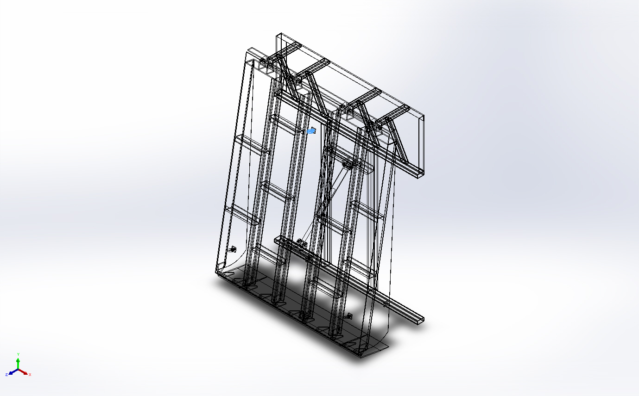 | Solid Body | Mass:0.28826 kg  Volume:3.64889e-05 m^3  Density:7,899.95 kg/m^3  Weight:2.82495 N | E:\NIHVA AUTOMATION 2024\AUTOMATION\DOCK LEVELER\MARCS PETCARE\DOCK LEVELER 3D\STD Cylinder\eye bolt\Lifting eye bolt M16 DIN580.SLDPRT  Mar 17 09:39:04 2021
Boss-Extrude2  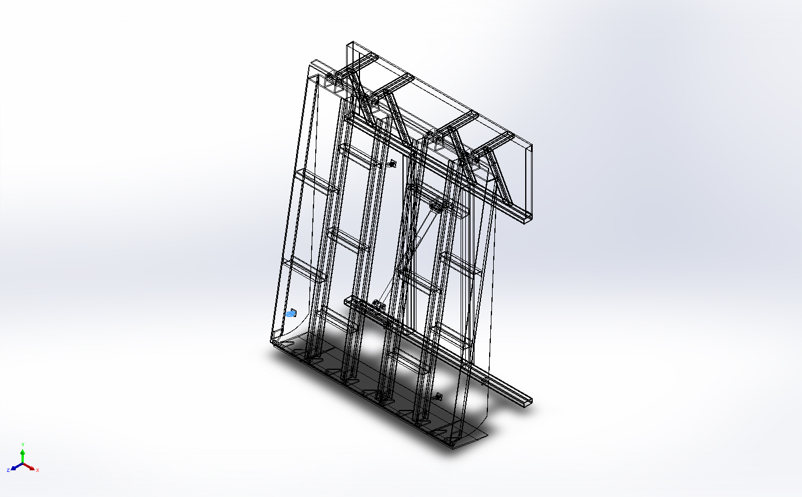 | Solid Body | Mass:0.288262 kg  Volume:3.64889e-05 m^3  Density:7,899.99 kg/m^3  Weight:2.82496 N | E:\NIHVA AUTOMATION 2024\AUTOMATION\DOCK LEVELER\MARCS PETCARE\DOCK LEVELER 3D\STD Cylinder\eye bolt\Lifting eye bolt M16 DIN580.SLDPRT  Mar 17 09:39:04 2021
Cut-Extrude4  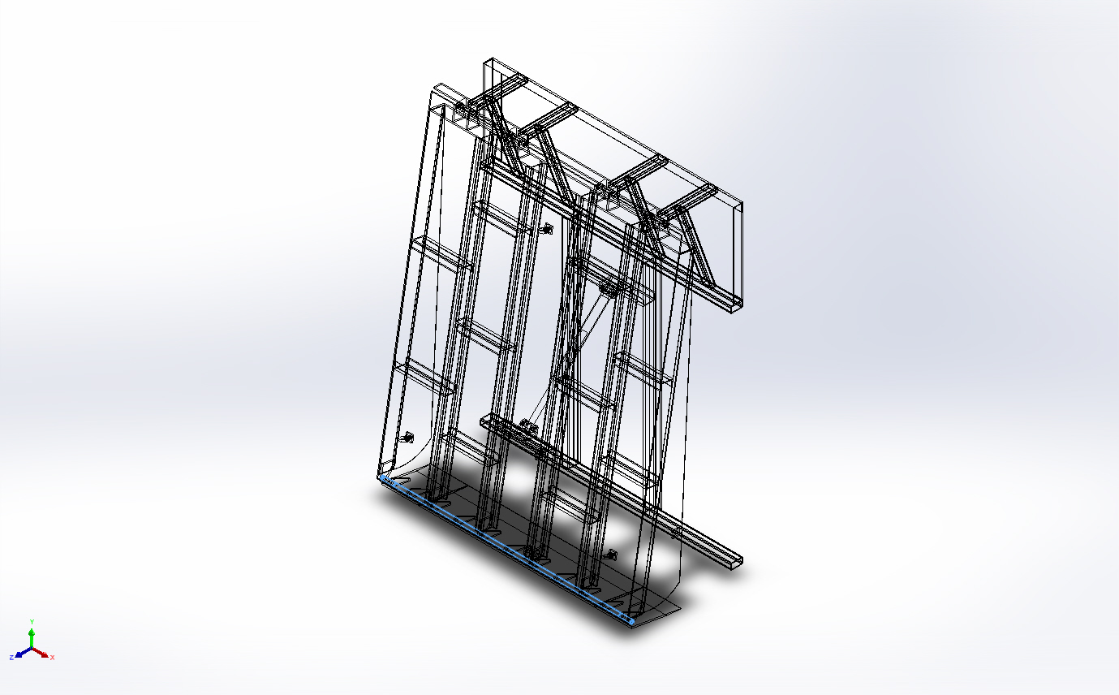 | Solid Body | Mass:7.75075 kg  Volume:0.000981107 m^3  Density:7,900 kg/m^3  Weight:75.9573 N | E:\NIHVA AUTOMATION 2024\AUTOMATION\DOCK LEVELER\MARCS PETCARE\DOCK LEVELER 3D\MS dia 25 Rod.SLDPRT  Dec 6 14:58:20 2024
Boss-Extrude1  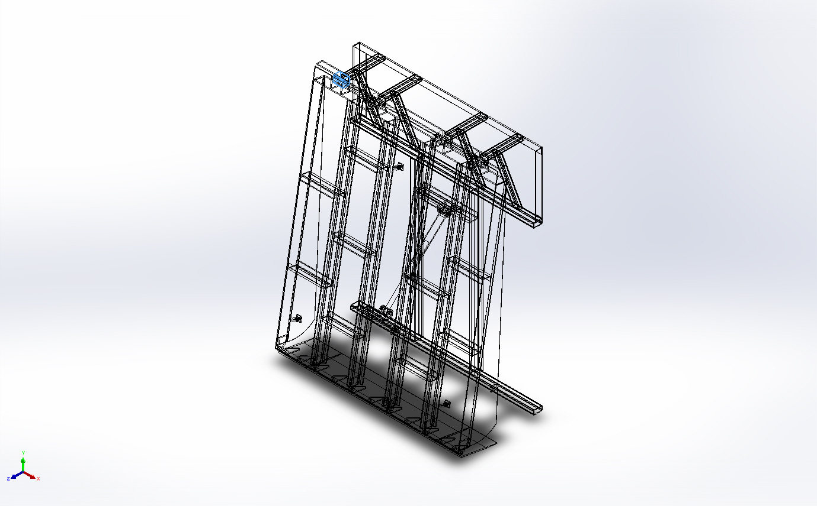 | Solid Body | Mass:4.51021 kg  Volume:0.000570913 m^3  Density:7,900 kg/m^3  Weight:44.2001 N | E:\NIHVA AUTOMATION 2024\AUTOMATION\DOCK LEVELER\MARCS PETCARE\DOCK LEVELER 3D\MTG Block.SLDPRT  Dec 3 16:58:56 2024
Boss-Extrude1  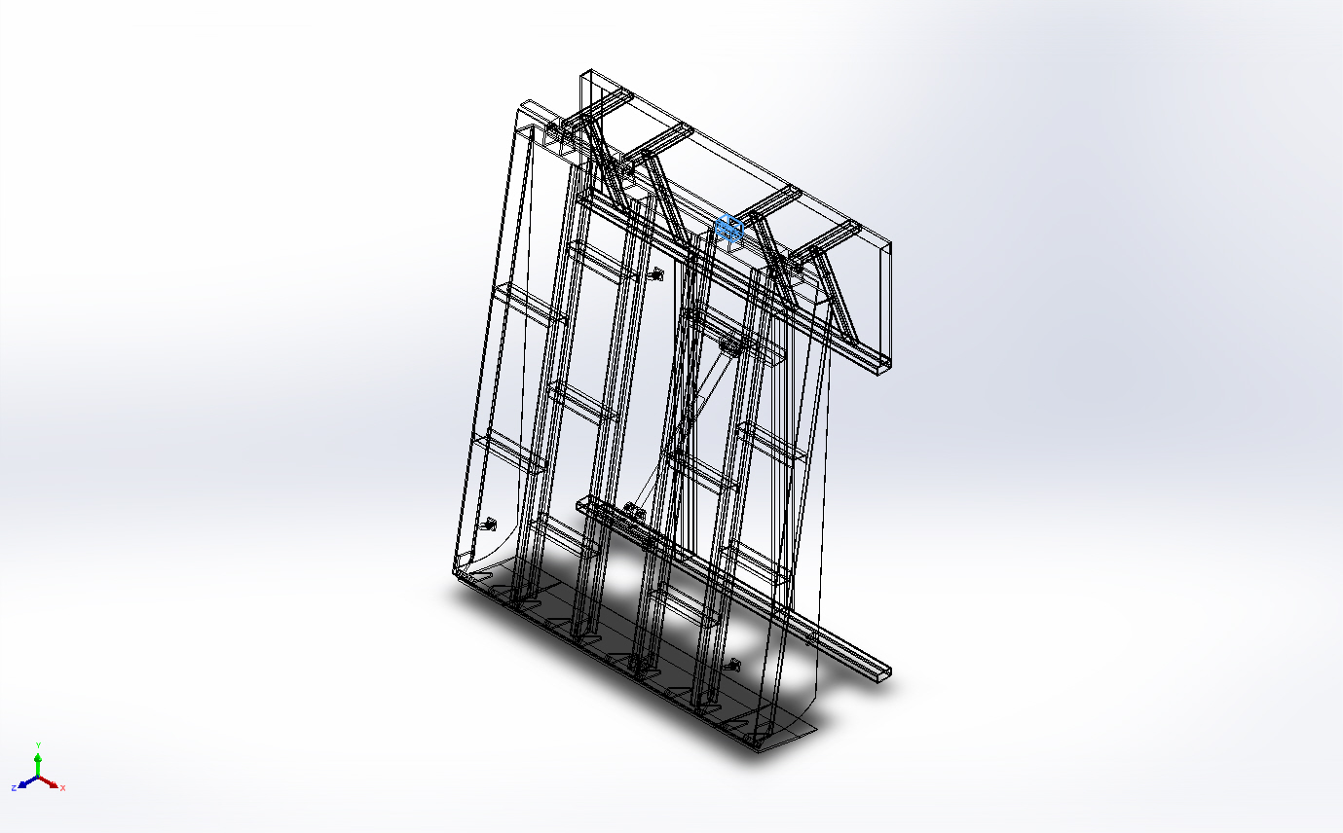 | Solid Body | Mass:4.51021 kg  Volume:0.000570913 m^3  Density:7,900 kg/m^3  Weight:44.2001 N | E:\NIHVA AUTOMATION 2024\AUTOMATION\DOCK LEVELER\MARCS PETCARE\DOCK LEVELER 3D\MTG Block.SLDPRT  Dec 3 16:58:56 2024
Boss-Extrude1  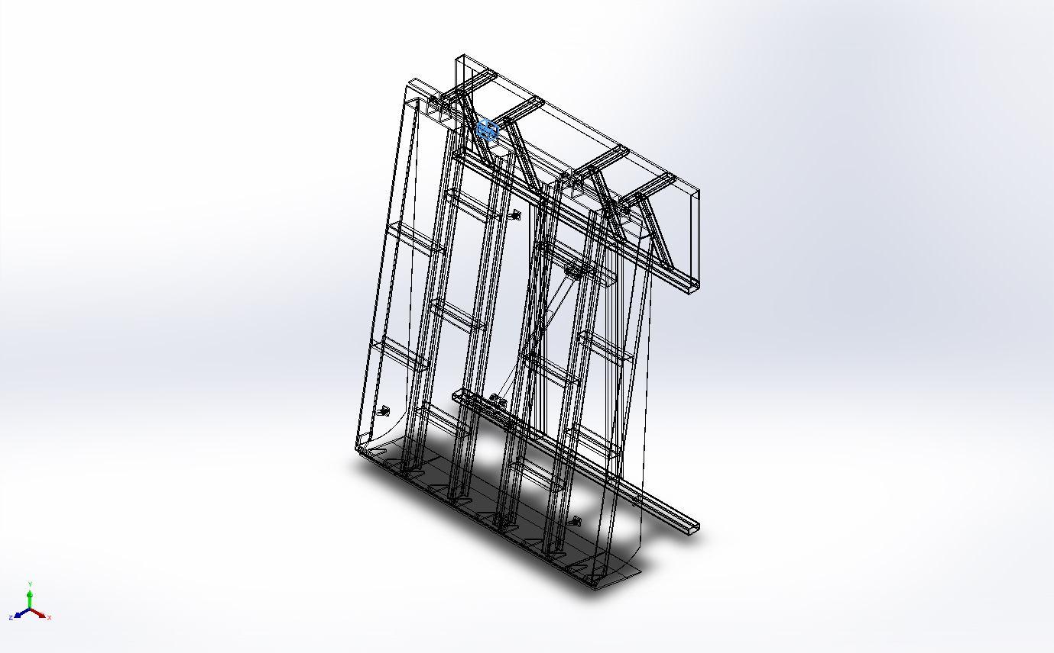 | Solid Body | Mass:4.51021 kg  Volume:0.000570913 m^3  Density:7,900 kg/m^3  Weight:44.2001 N | E:\NIHVA AUTOMATION 2024\AUTOMATION\DOCK LEVELER\MARCS PETCARE\DOCK LEVELER 3D\MTG Block.SLDPRT  Dec 3 16:58:56 2024
Boss-Extrude1  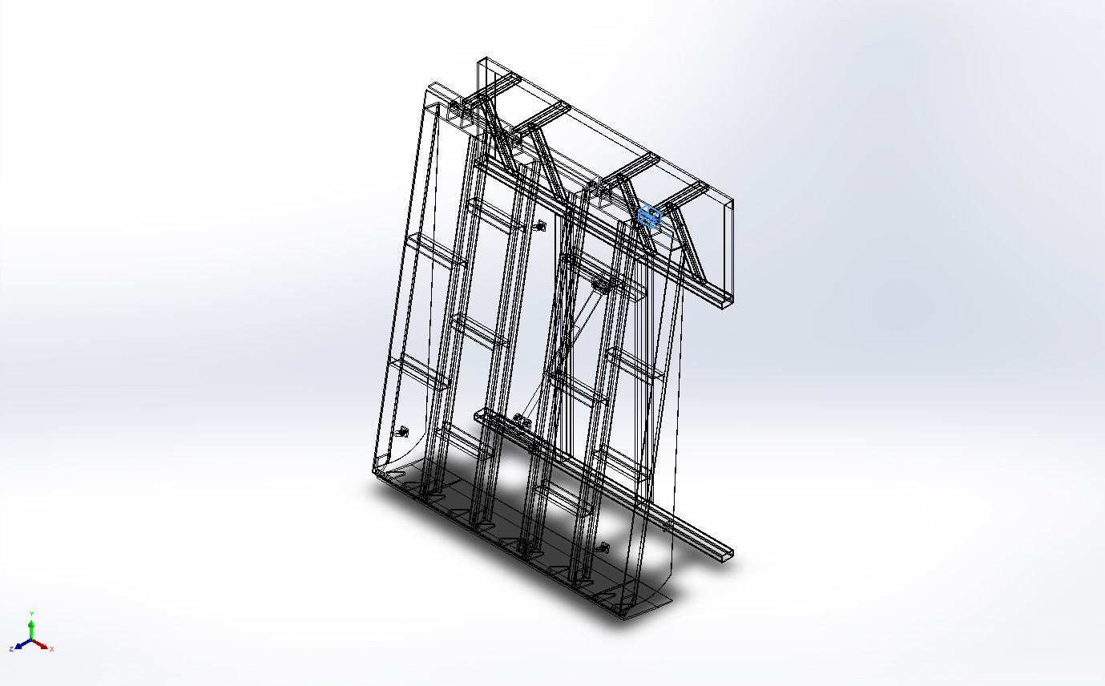 | Solid Body | Mass:4.51021 kg  Volume:0.000570913 m^3  Density:7,900 kg/m^3  Weight:44.2001 N | E:\NIHVA AUTOMATION 2024\AUTOMATION\DOCK LEVELER\MARCS PETCARE\DOCK LEVELER 3D\MTG Block.SLDPRT  Dec 3 16:58:56 2024
Boss-Extrude1  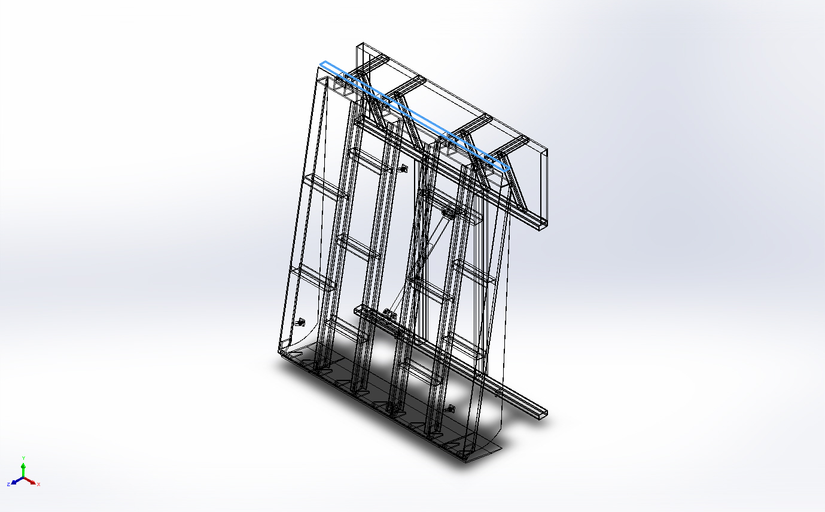 | Solid Body | Mass:9.48 kg  Volume:0.0012 m^3  Density:7,900 kg/m^3  Weight:92.904 N | E:\NIHVA AUTOMATION 2024\AUTOMATION\DOCK LEVELER\MARCS PETCARE\DOCK LEVELER 3D\Support plate.SLDPRT  Dec 6 15:24:06 2024
Cut-Extrude2[1] | Solid Body | Mass:315.952 kg  Volume:0.0399939 m^3  Density:7,900 kg/m^3  Weight:3,096.33 N | E:\NIHVA AUTOMATION 2024\AUTOMATION\DOCK LEVELER\MARCS PETCARE\DOCK LEVELER 3D\DOCK PLATE.SLDPRT  Dec 7 11:07:02 2024
Cut-Extrude2[2] | Solid Body | Mass:0.177397 kg  Volume:2.24553e-05 m^3  Density:7,900 kg/m^3  Weight:1.73849 N | E:\NIHVA AUTOMATION 2024\AUTOMATION\DOCK LEVELER\MARCS PETCARE\DOCK LEVELER 3D\DOCK PLATE.SLDPRT  Dec 7 11:07:02 2024
Boss-Extrude6 | Solid Body | Mass:13.3668 kg  Volume:0.001692 m^3  Density:7,900 kg/m^3  Weight:130.995 N | E:\NIHVA AUTOMATION 2024\AUTOMATION\DOCK LEVELER\MARCS PETCARE\DOCK LEVELER 3D\DOCK PLATE.SLDPRT  Dec 7 11:07:02 2024
Boss-Extrude5 | Solid Body | Mass:13.3668 kg  Volume:0.001692 m^3  Density:7,900 kg/m^3  Weight:130.995 N | E:\NIHVA AUTOMATION 2024\AUTOMATION\DOCK LEVELER\MARCS PETCARE\DOCK LEVELER 3D\DOCK PLATE.SLDPRT  Dec 7 11:07:02 2024
Boss-Extrude7 | Solid Body | Mass:18.96 kg  Volume:0.0024 m^3  Density:7,900 kg/m^3  Weight:185.808 N | E:\NIHVA AUTOMATION 2024\AUTOMATION\DOCK LEVELER\MARCS PETCARE\DOCK LEVELER 3D\DOCK PLATE.SLDPRT  Dec 7 11:07:02 2024
Cut-Extrude2[4] | Solid Body | Mass:0.177397 kg  Volume:2.24553e-05 m^3  Density:7,900 kg/m^3  Weight:1.73849 N | E:\NIHVA AUTOMATION 2024\AUTOMATION\DOCK LEVELER\MARCS PETCARE\DOCK LEVELER 3D\DOCK PLATE.SLDPRT  Dec 7 11:07:02 2024
Cut-Extrude2[3] | Solid Body | Mass:0.177397 kg  Volume:2.24553e-05 m^3  Density:7,900 kg/m^3  Weight:1.73849 N | E:\NIHVA AUTOMATION 2024\AUTOMATION\DOCK LEVELER\MARCS PETCARE\DOCK LEVELER 3D\DOCK PLATE.SLDPRT  Dec 7 11:07:02 2024
Boss-Extrude1 | Solid Body | Mass:0.846595 kg  Volume:0.000107164 m^3  Density:7,900 kg/m^3  Weight:8.29663 N | E:\NIHVA AUTOMATION 2024\AUTOMATION\DOCK LEVELER\MARCS PETCARE\DOCK LEVELER 3D\Dack flip plate bkt.SLDPRT  Nov 29 15:18:15 2024
Boss-Extrude1 | Solid Body | Mass:0.846595 kg  Volume:0.000107164 m^3  Density:7,900 kg/m^3  Weight:8.29663 N | E:\NIHVA AUTOMATION 2024\AUTOMATION\DOCK LEVELER\MARCS PETCARE\DOCK LEVELER 3D\Dack flip plate bkt.SLDPRT  Nov 29 15:18:15 2024
Boss-Extrude1 | Solid Body | Mass:0.846595 kg  Volume:0.000107164 m^3  Density:7,900 kg/m^3  Weight:8.29663 N | E:\NIHVA AUTOMATION 2024\AUTOMATION\DOCK LEVELER\MARCS PETCARE\DOCK LEVELER 3D\Dack flip plate bkt.SLDPRT  Nov 29 15:18:15 2024
Boss-Extrude1 | Solid Body | Mass:0.846595 kg  Volume:0.000107164 m^3  Density:7,900 kg/m^3  Weight:8.29663 N | E:\NIHVA AUTOMATION 2024\AUTOMATION\DOCK LEVELER\MARCS PETCARE\DOCK LEVELER 3D\Dack flip plate bkt.SLDPRT  Nov 29 15:18:15 2024
Boss-Extrude1 | Solid Body | Mass:0.846595 kg  Volume:0.000107164 m^3  Density:7,900 kg/m^3  Weight:8.29663 N | E:\NIHVA AUTOMATION 2024\AUTOMATION\DOCK LEVELER\MARCS PETCARE\DOCK LEVELER 3D\Dack flip plate bkt.SLDPRT  Nov 29 15:18:15 2024
Boss-Extrude1 | Solid Body | Mass:0.846595 kg  Volume:0.000107164 m^3  Density:7,900 kg/m^3  Weight:8.29663 N | E:\NIHVA AUTOMATION 2024\AUTOMATION\DOCK LEVELER\MARCS PETCARE\DOCK LEVELER 3D\Dack flip plate bkt.SLDPRT  Nov 29 15:18:15 2024
Boss-Extrude1 | Solid Body | Mass:6.06509 kg  Volume:0.000767733 m^3  Density:7,900 kg/m^3  Weight:59.4379 N | E:\NIHVA AUTOMATION 2024\AUTOMATION\DOCK LEVELER\MARCS PETCARE\DOCK LEVELER 3D\Side Cover.SLDPRT  Dec 7 11:12:30 2024
Boss-Extrude1 | Solid Body | Mass:6.06509 kg  Volume:0.000767733 m^3  Density:7,900 kg/m^3  Weight:59.4379 N | E:\NIHVA AUTOMATION 2024\AUTOMATION\DOCK LEVELER\MARCS PETCARE\DOCK LEVELER 3D\Side Cover.SLDPRT  Dec 7 11:12:30 2024
Boss-Extrude1 | Solid Body | Mass:0.782407 kg  Volume:9.90389e-05 m^3  Density:7,900 kg/m^3  Weight:7.66759 N | E:\NIHVA AUTOMATION 2024\AUTOMATION\DOCK LEVELER\MARCS PETCARE\DOCK LEVELER 3D\dack bkt.SLDPRT  Dec 3 17:03:03 2024
Boss-Extrude1 | Solid Body | Mass:0.782407 kg  Volume:9.90389e-05 m^3  Density:7,900 kg/m^3  Weight:7.66759 N | E:\NIHVA AUTOMATION 2024\AUTOMATION\DOCK LEVELER\MARCS PETCARE\DOCK LEVELER 3D\dack bkt.SLDPRT  Dec 3 17:03:03 2024
Boss-Extrude1 | Solid Body | Mass:0.782407 kg  Volume:9.90389e-05 m^3  Density:7,900 kg/m^3  Weight:7.66759 N | E:\NIHVA AUTOMATION 2024\AUTOMATION\DOCK LEVELER\MARCS PETCARE\DOCK LEVELER 3D\dack bkt.SLDPRT  Dec 3 17:03:03 2024
Boss-Extrude1 | Solid Body | Mass:0.782407 kg  Volume:9.90389e-05 m^3  Density:7,900 kg/m^3  Weight:7.66759 N | E:\NIHVA AUTOMATION 2024\AUTOMATION\DOCK LEVELER\MARCS PETCARE\DOCK LEVELER 3D\dack bkt.SLDPRT  Dec 3 17:03:03 2024
Boss-Extrude1 | Solid Body | Mass:0.782407 kg  Volume:9.90389e-05 m^3  Density:7,900 kg/m^3  Weight:7.66759 N | E:\NIHVA AUTOMATION 2024\AUTOMATION\DOCK LEVELER\MARCS PETCARE\DOCK LEVELER 3D\dack bkt.SLDPRT  Dec 3 17:03:03 2024
Boss-Extrude1 | Solid Body | Mass:0.782407 kg  Volume:9.90389e-05 m^3  Density:7,900 kg/m^3  Weight:7.66759 N | E:\NIHVA AUTOMATION 2024\AUTOMATION\DOCK LEVELER\MARCS PETCARE\DOCK LEVELER 3D\dack bkt.SLDPRT  Dec 3 17:03:03 2024
Boss-Extrude1 | Solid Body | Mass:0.782407 kg  Volume:9.90389e-05 m^3  Density:7,900 kg/m^3  Weight:7.66759 N | E:\NIHVA AUTOMATION 2024\AUTOMATION\DOCK LEVELER\MARCS PETCARE\DOCK LEVELER 3D\dack bkt.SLDPRT  Dec 3 17:03:03 2024
Boss-Extrude1 | Solid Body | Mass:0.782407 kg  Volume:9.90389e-05 m^3  Density:7,900 kg/m^3  Weight:7.66759 N | E:\NIHVA AUTOMATION 2024\AUTOMATION\DOCK LEVELER\MARCS PETCARE\DOCK LEVELER 3D\dack bkt.SLDPRT  Dec 3 17:03:03 2024
Boss-Extrude1  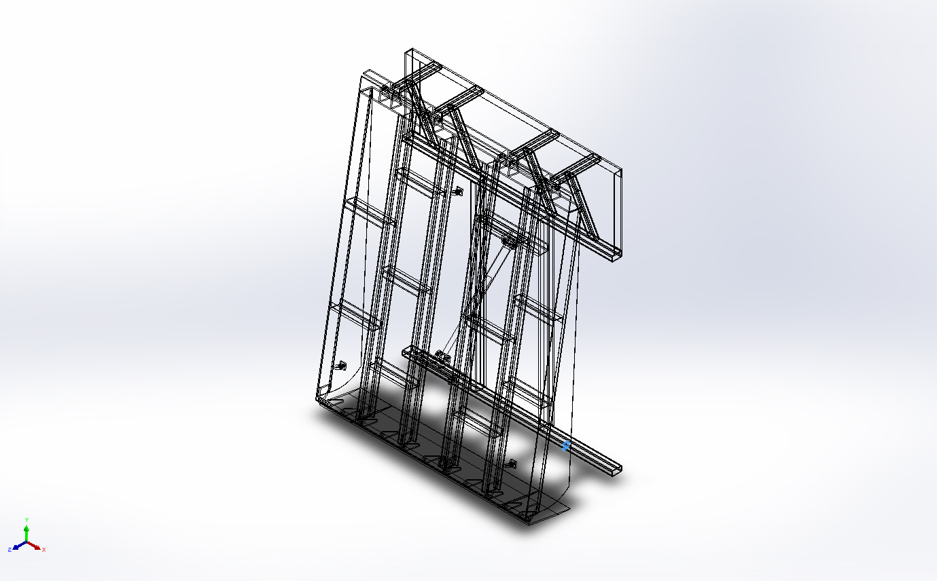 | Solid Body | Mass:0.161343 kg  Volume:2.04231e-05 m^3  Density:7,900 kg/m^3  Weight:1.58116 N | E:\NIHVA AUTOMATION 2024\AUTOMATION\DOCK LEVELER\MARCS PETCARE\DOCK LEVELER 3D\lip plat rest bkt.SLDPRT  Dec 7 10:43:44 2024
Boss-Extrude1  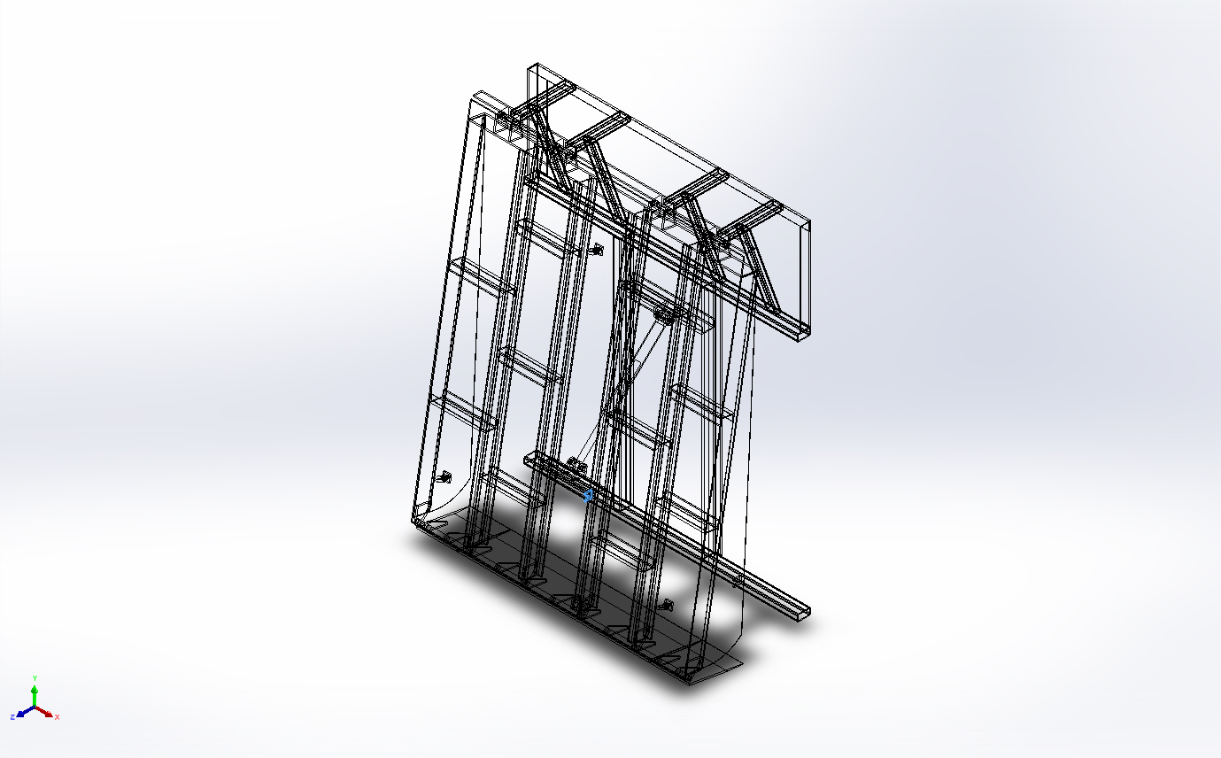 | Solid Body | Mass:0.161343 kg  Volume:2.04231e-05 m^3  Density:7,900 kg/m^3  Weight:1.58116 N | E:\NIHVA AUTOMATION 2024\AUTOMATION\DOCK LEVELER\MARCS PETCARE\DOCK LEVELER 3D\lip plat rest bkt.SLDPRT  Dec 7 10:43:44 2024
Beam Bodies:
Document Name and Reference | Formulation | Properties | Document Path/Date Modified
SolidBody 1(Angle iron - configured 35 X 35 X 5(1)[2]) | Beam – Uniform C/S | Section Standard-weldment profiles/iso/angle iron  Section Area: 0.000719635m^2  Length:2,070.45mm  Volume:0.00148997m^3  Mass Density:7,900kg/m^3  Mass:11.7707kg  Weight:115.353N | E:\NIHVA AUTOMATION 2024\AUTOMATION\DOCK LEVELER\MARCS PETCARE\DOCK LEVELER 3D\BS.SLDPRT  Dec 7 09:49:01 2024
SolidBody 2(Angle iron - configured 35 X 35 X 5(1)[3]) | Beam – Uniform C/S | Section Standard-weldment profiles/iso/angle iron  Section Area: 0.000719635m^2  Length:2,560.22mm  Volume:0.00184243m^3  Mass Density:7,900kg/m^3  Mass:14.5552kg  Weight:142.641N | E:\NIHVA AUTOMATION 2024\AUTOMATION\DOCK LEVELER\MARCS PETCARE\DOCK LEVELER 3D\BS.SLDPRT  Dec 7 09:49:01 2024
SolidBody 3(Angle iron - configured 35 X 35 X 5(1)[1]) | Beam – Uniform C/S | Section Standard-weldment profiles/iso/angle iron  Section Area: 0.000719635m^2  Length:2,560.22mm  Volume:0.00184243m^3  Mass Density:7,900kg/m^3  Mass:14.5552kg  Weight:142.641N | E:\NIHVA AUTOMATION 2024\AUTOMATION\DOCK LEVELER\MARCS PETCARE\DOCK LEVELER 3D\BS.SLDPRT  Dec 7 09:49:01 2024
SolidBody 1(Rectangular tube - configured 70 X 40 X 5(1)[4])  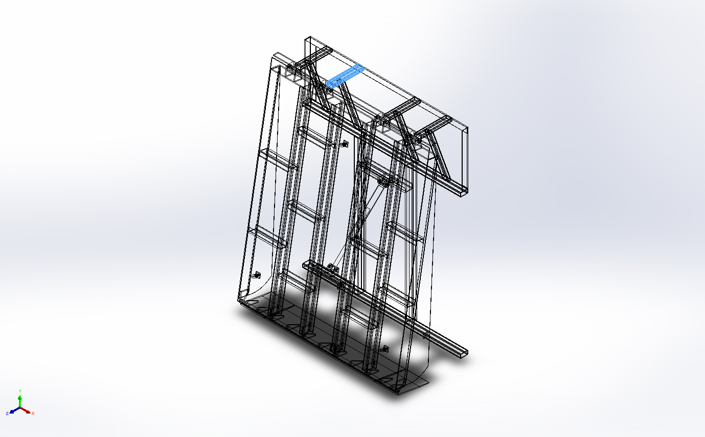 | Beam – Uniform C/S | Section Standard-weldment profiles/iso/rectangular tube  Section Area: 0.00103562m^2  Length:400mm  Volume:0.000414248m^3  Mass Density:7,900kg/m^3  Mass:3.27256kg  Weight:32.0711N | E:\NIHVA AUTOMATION 2024\AUTOMATION\DOCK LEVELER\MARCS PETCARE\DOCK LEVELER 3D\Base Frame.SLDPRT  Dec 7 12:01:58 2024
SolidBody 2(Trim/Extend2[2])  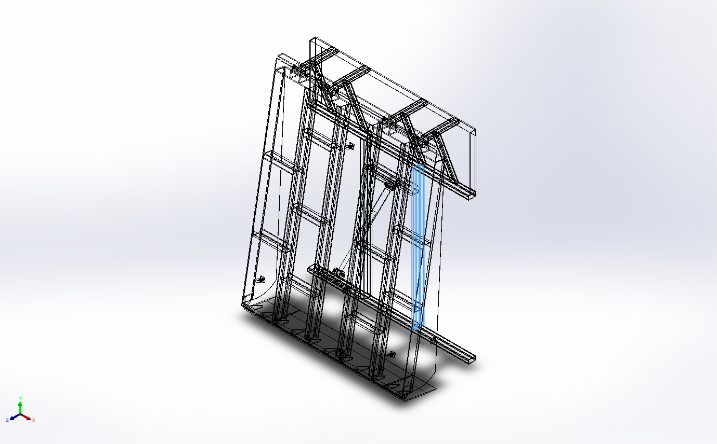 | Beam – Uniform C/S | Section Standard-weldment profiles/iso/c channel  Section Area: 0.00131018m^2  Length:1,725mm  Volume:0.00226005m^3  Mass Density:7,900kg/m^3  Mass:17.8544kg  Weight:174.973N | E:\NIHVA AUTOMATION 2024\AUTOMATION\DOCK LEVELER\MARCS PETCARE\DOCK LEVELER 3D\Base Frame.SLDPRT  Dec 7 12:01:58 2024
SolidBody 3(Trim/Extend7[4])  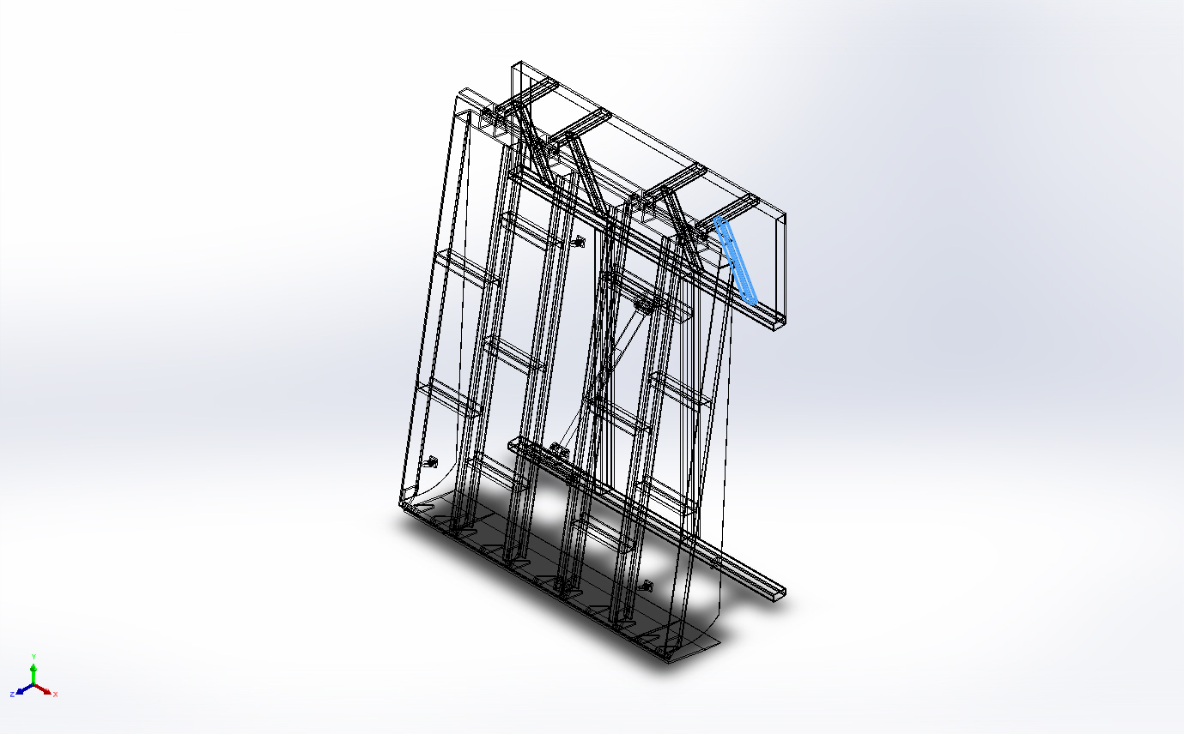 | Beam – Uniform C/S | Section Standard-weldment profiles/iso/rectangular tube  Section Area: 0.00103562m^2  Length:674.282mm  Volume:0.000698282m^3  Mass Density:7,900kg/m^3  Mass:5.51643kg  Weight:54.061N | E:\NIHVA AUTOMATION 2024\AUTOMATION\DOCK LEVELER\MARCS PETCARE\DOCK LEVELER 3D\Base Frame.SLDPRT  Dec 7 12:01:58 2024
SolidBody 4(Rectangular tube - configured 120 X 80 X 8(1)[2])  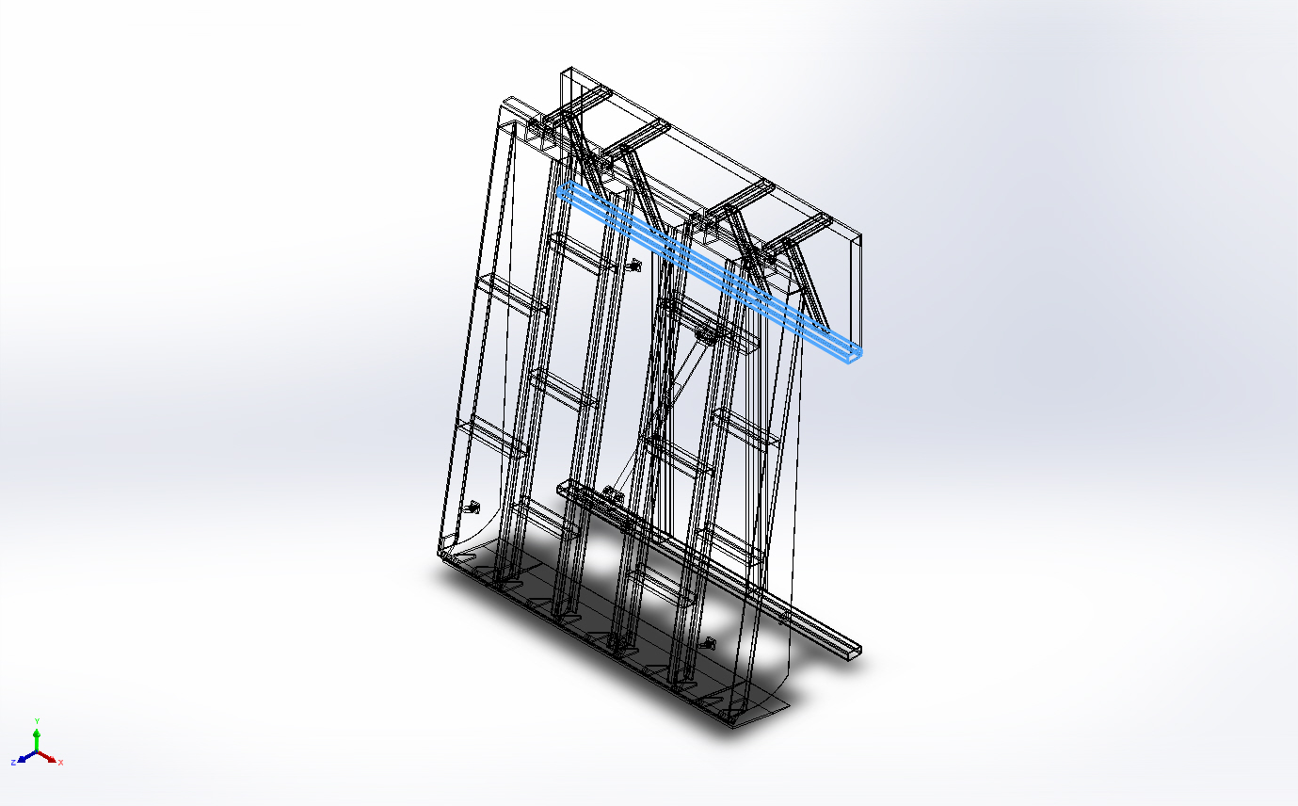 | Beam – Uniform C/S | Section Standard-weldment profiles/iso/rectangular tube  Section Area: 0.00158389m^2  Length:2,000mm  Volume:0.00316779m^3  Mass Density:7,900kg/m^3  Mass:25.0255kg  Weight:245.25N | E:\NIHVA AUTOMATION 2024\AUTOMATION\DOCK LEVELER\MARCS PETCARE\DOCK LEVELER 3D\Base Frame.SLDPRT  Dec 7 12:01:58 2024
SolidBody 5(Angle iron - configured 35 X 35 X 5(1)[1])  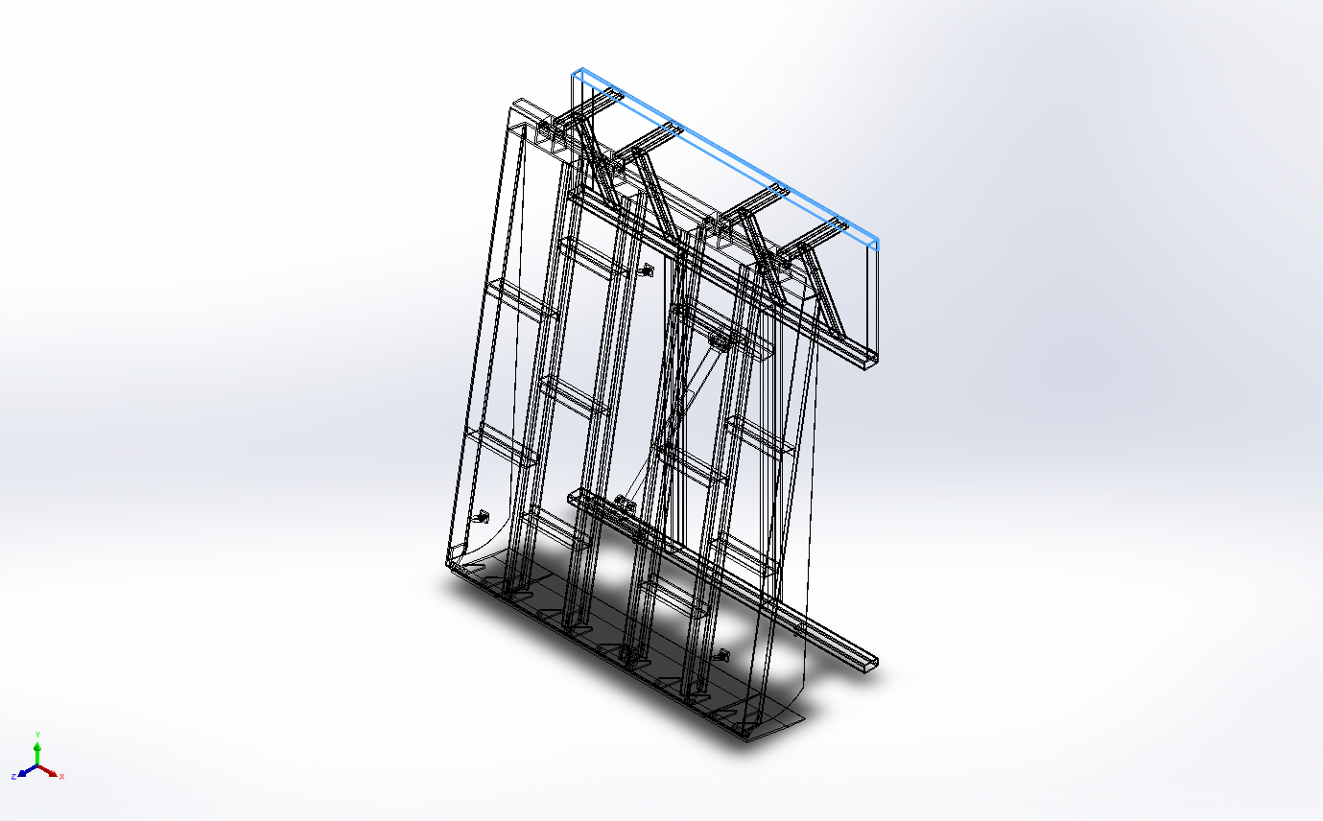 | Beam – Uniform C/S | Section Standard-weldment profiles/iso/angle iron  Section Area: 0.000719635m^2  Length:2,000mm  Volume:0.00143927m^3  Mass Density:7,900kg/m^3  Mass:11.3702kg  Weight:111.428N | E:\NIHVA AUTOMATION 2024\AUTOMATION\DOCK LEVELER\MARCS PETCARE\DOCK LEVELER 3D\Base Frame.SLDPRT  Dec 7 12:01:58 2024
SolidBody 6(Rectangular tube - configured 70 X 40 X 5(1)[1])  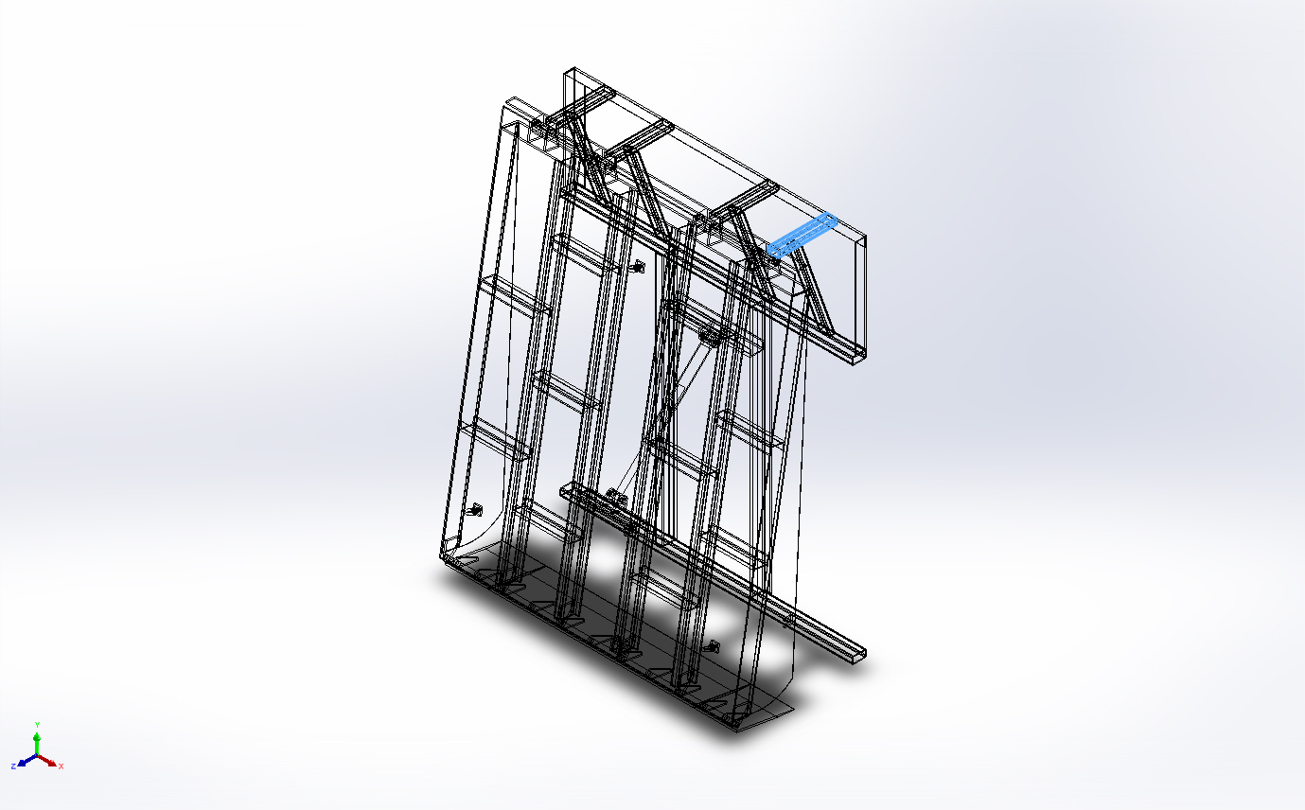 | Beam – Uniform C/S | Section Standard-weldment profiles/iso/rectangular tube  Section Area: 0.00103562m^2  Length:400mm  Volume:0.000414248m^3  Mass Density:7,900kg/m^3  Mass:3.27256kg  Weight:32.0711N | E:\NIHVA AUTOMATION 2024\AUTOMATION\DOCK LEVELER\MARCS PETCARE\DOCK LEVELER 3D\Base Frame.SLDPRT  Dec 7 12:01:58 2024
SolidBody 7(Rectangular tube - configured 70 X 40 X 5(1)[2])  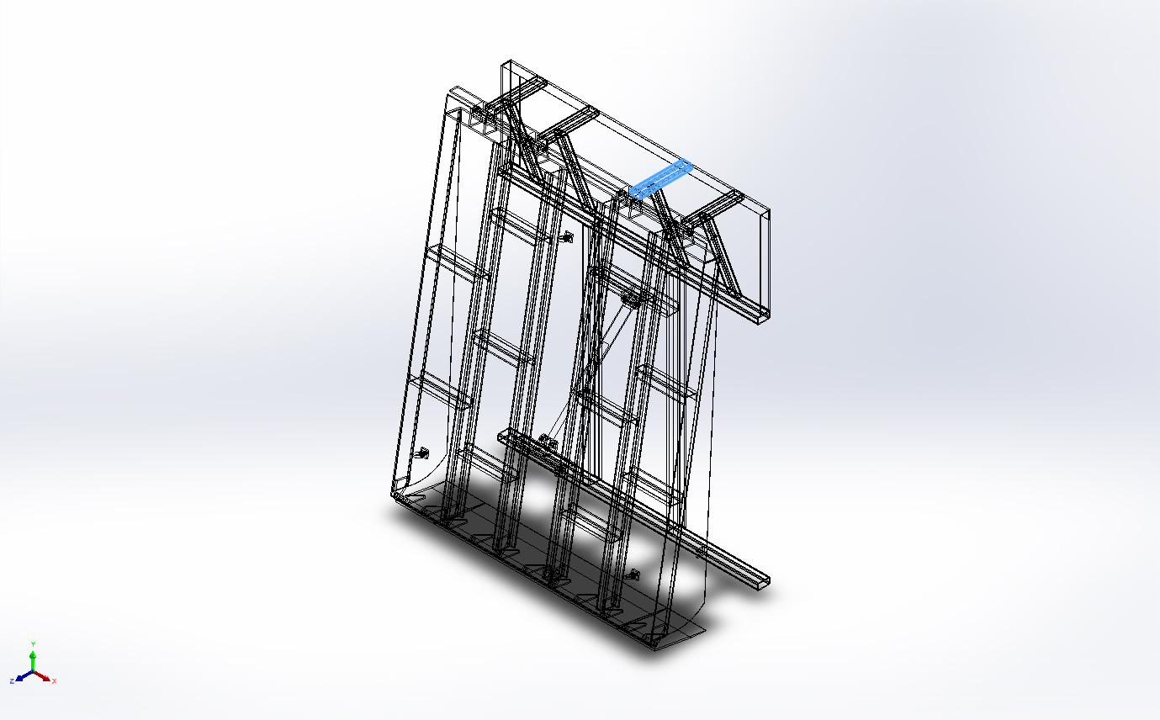 | Beam – Uniform C/S | Section Standard-weldment profiles/iso/rectangular tube  Section Area: 0.00103562m^2  Length:400mm  Volume:0.000414248m^3  Mass Density:7,900kg/m^3  Mass:3.27256kg  Weight:32.0711N | E:\NIHVA AUTOMATION 2024\AUTOMATION\DOCK LEVELER\MARCS PETCARE\DOCK LEVELER 3D\Base Frame.SLDPRT  Dec 7 12:01:58 2024
SolidBody 8(Rectangular tube - configured 70 X 40 X 5(1)[3])  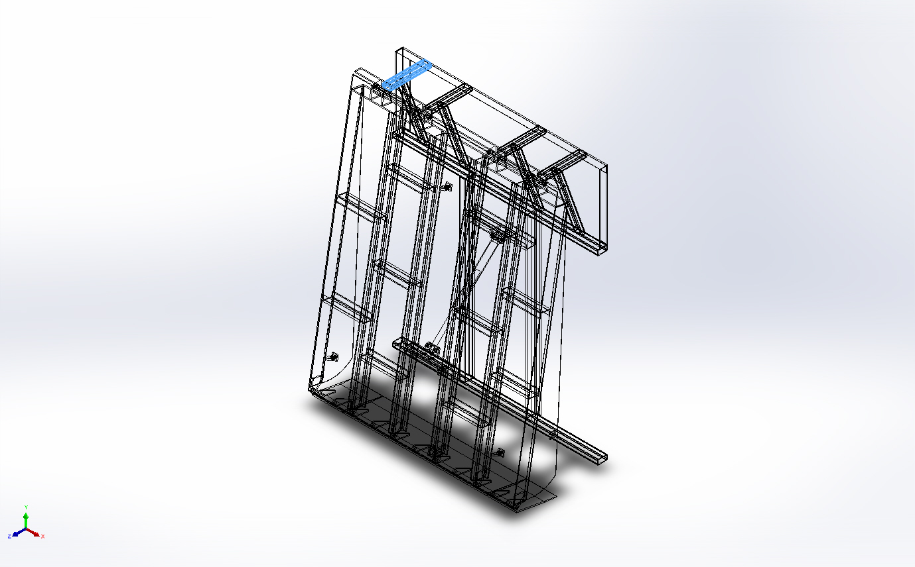 | Beam – Uniform C/S | Section Standard-weldment profiles/iso/rectangular tube  Section Area: 0.00103562m^2  Length:400mm  Volume:0.000414248m^3  Mass Density:7,900kg/m^3  Mass:3.27256kg  Weight:32.0711N | E:\NIHVA AUTOMATION 2024\AUTOMATION\DOCK LEVELER\MARCS PETCARE\DOCK LEVELER 3D\Base Frame.SLDPRT  Dec 7 12:01:58 2024
SolidBody 9(Trim/Extend3[1])  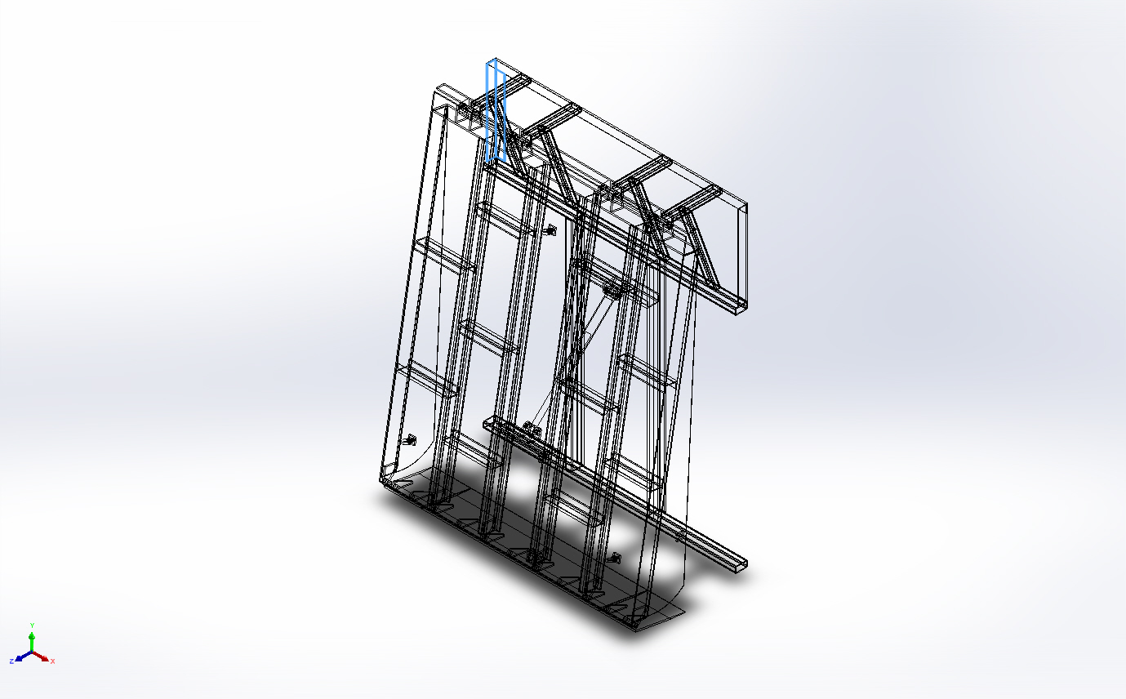 | Beam – Uniform C/S | Section Standard-weldment profiles/iso/angle iron  Section Area: 0.000719635m^2  Length:628.648mm  Volume:0.000456428m^3  Mass Density:7,900kg/m^3  Mass:3.60578kg  Weight:35.3367N | E:\NIHVA AUTOMATION 2024\AUTOMATION\DOCK LEVELER\MARCS PETCARE\DOCK LEVELER 3D\Base Frame.SLDPRT  Dec 7 12:01:58 2024
SolidBody 10(Trim/Extend3[2])  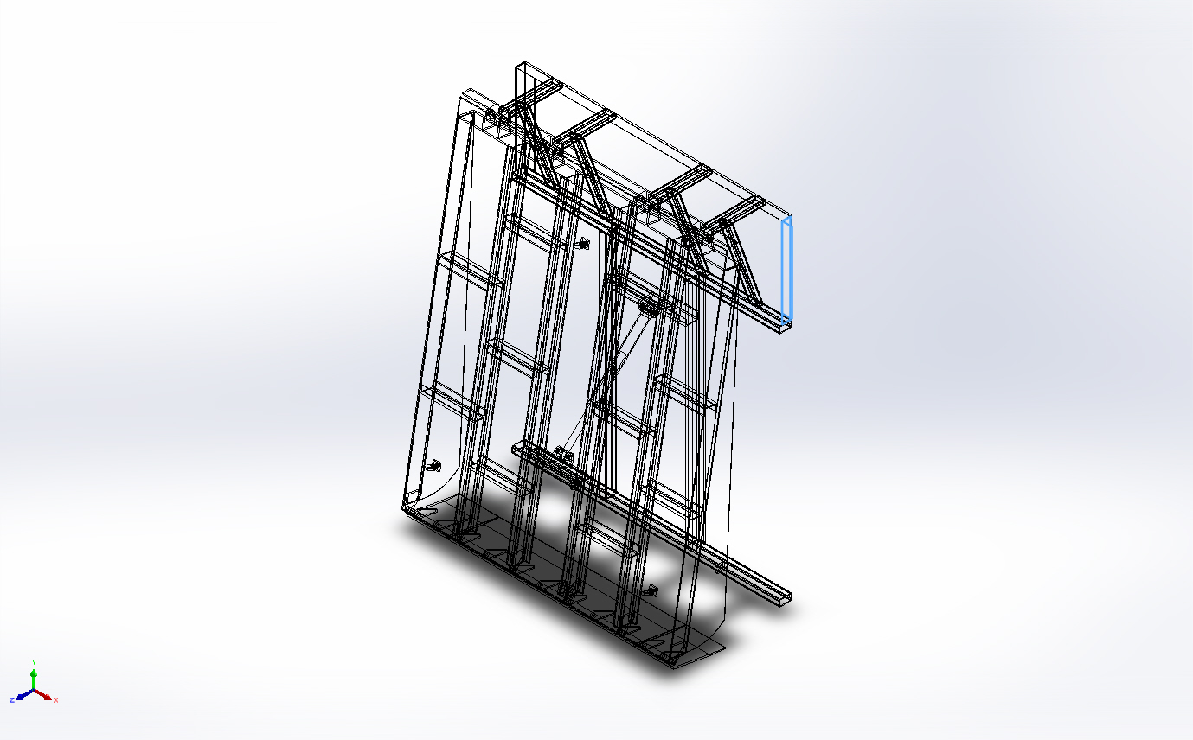 | Beam – Uniform C/S | Section Standard-weldment profiles/iso/angle iron  Section Area: 0.000719635m^2  Length:628.648mm  Volume:0.000456423m^3  Mass Density:7,900kg/m^3  Mass:3.60574kg  Weight:35.3363N | E:\NIHVA AUTOMATION 2024\AUTOMATION\DOCK LEVELER\MARCS PETCARE\DOCK LEVELER 3D\Base Frame.SLDPRT  Dec 7 12:01:58 2024
SolidBody 11(Trim/Extend7[1])  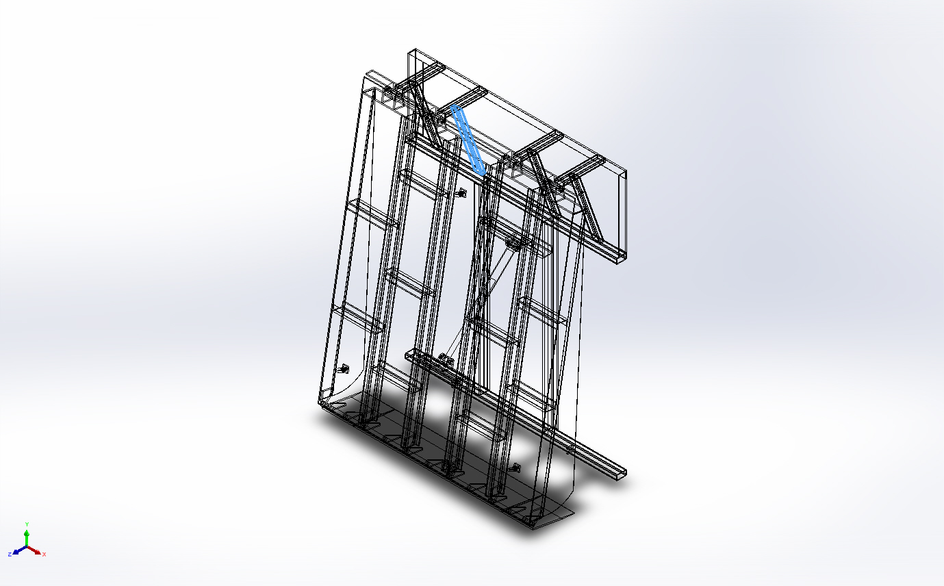 | Beam – Uniform C/S | Section Standard-weldment profiles/iso/rectangular tube  Section Area: 0.00103562m^2  Length:674.282mm  Volume:0.000698282m^3  Mass Density:7,900kg/m^3  Mass:5.51643kg  Weight:54.061N | E:\NIHVA AUTOMATION 2024\AUTOMATION\DOCK LEVELER\MARCS PETCARE\DOCK LEVELER 3D\Base Frame.SLDPRT  Dec 7 12:01:58 2024
SolidBody 12(Trim/Extend7[2])  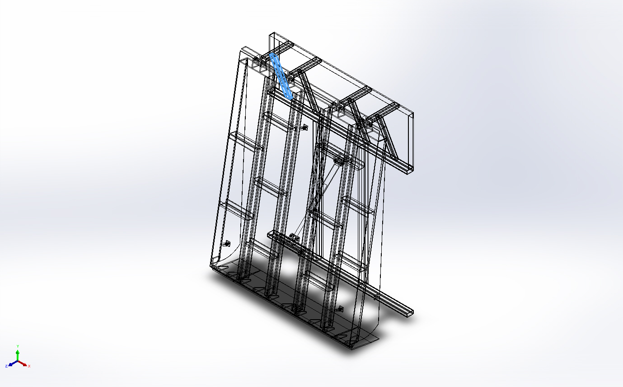 | Beam – Uniform C/S | Section Standard-weldment profiles/iso/rectangular tube  Section Area: 0.00103562m^2  Length:674.282mm  Volume:0.000698282m^3  Mass Density:7,900kg/m^3  Mass:5.51643kg  Weight:54.061N | E:\NIHVA AUTOMATION 2024\AUTOMATION\DOCK LEVELER\MARCS PETCARE\DOCK LEVELER 3D\Base Frame.SLDPRT  Dec 7 12:01:58 2024
SolidBody 13(Trim/Extend7[3])  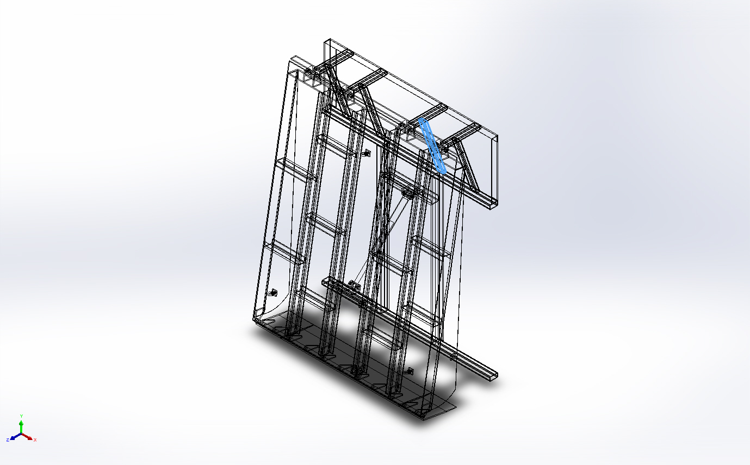 | Beam – Uniform C/S | Section Standard-weldment profiles/iso/rectangular tube  Section Area: 0.00103562m^2  Length:674.282mm  Volume:0.000698282m^3  Mass Density:7,900kg/m^3  Mass:5.51643kg  Weight:54.061N | E:\NIHVA AUTOMATION 2024\AUTOMATION\DOCK LEVELER\MARCS PETCARE\DOCK LEVELER 3D\Base Frame.SLDPRT  Dec 7 12:01:58 2024
SolidBody 14(Trim/Extend8)  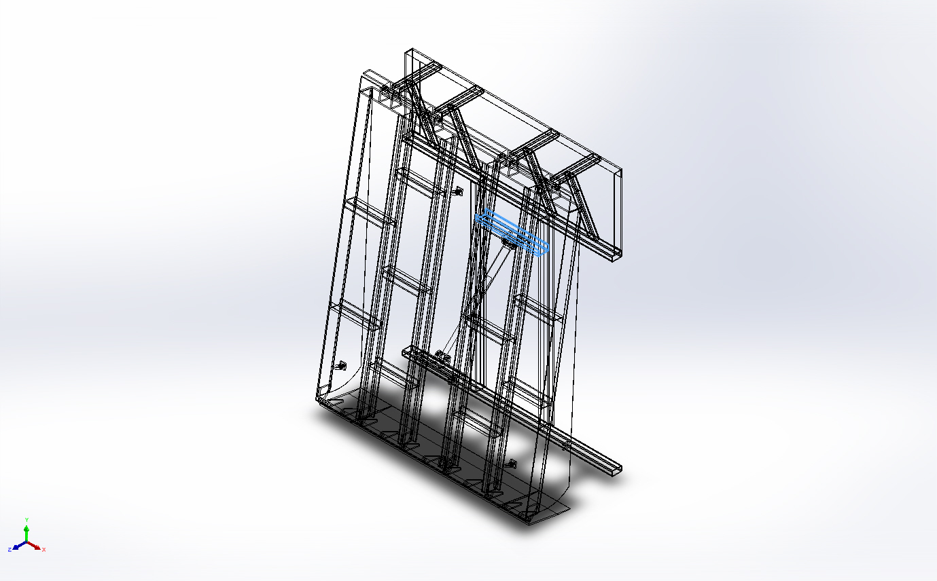 | Beam – Uniform C/S | Section Standard-weldment profiles/iso/c channel  Section Area: 0.00131018m^2  Length:600mm  Volume:0.000786105m^3  Mass Density:7,900kg/m^3  Mass:6.21023kg  Weight:60.8603N | E:\NIHVA AUTOMATION 2024\AUTOMATION\DOCK LEVELER\MARCS PETCARE\DOCK LEVELER 3D\Base Frame.SLDPRT  Dec 7 12:01:58 2024
SolidBody 15(Rectangular tube - configured 120 X 80 X 8(1)[1])  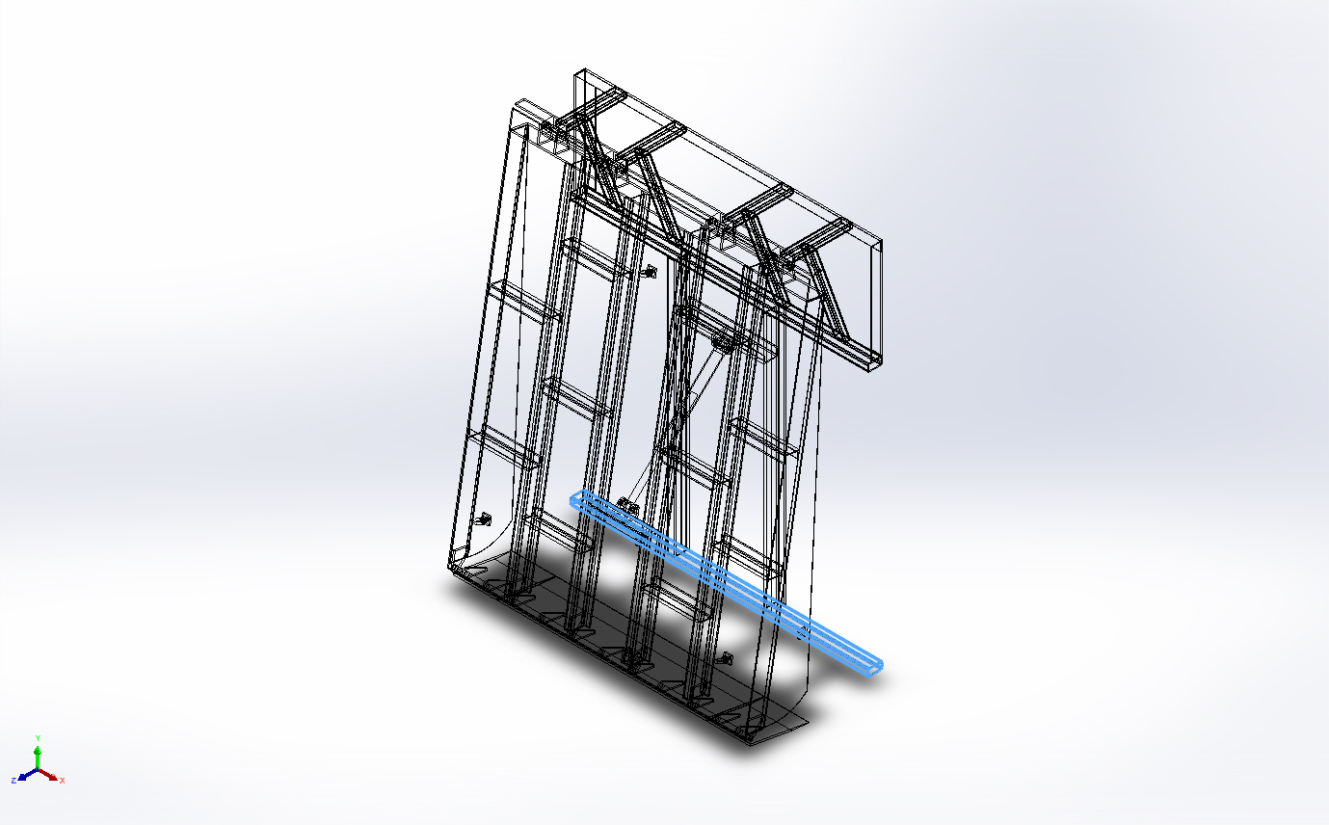 | Beam – Uniform C/S | Section Standard-weldment profiles/iso/rectangular tube  Section Area: 0.00158389m^2  Length:2,000mm  Volume:0.00316779m^3  Mass Density:7,900kg/m^3  Mass:25.0255kg  Weight:245.25N | E:\NIHVA AUTOMATION 2024\AUTOMATION\DOCK LEVELER\MARCS PETCARE\DOCK LEVELER 3D\Base Frame.SLDPRT  Dec 7 12:01:58 2024
SolidBody 16(Trim/Extend2[1])  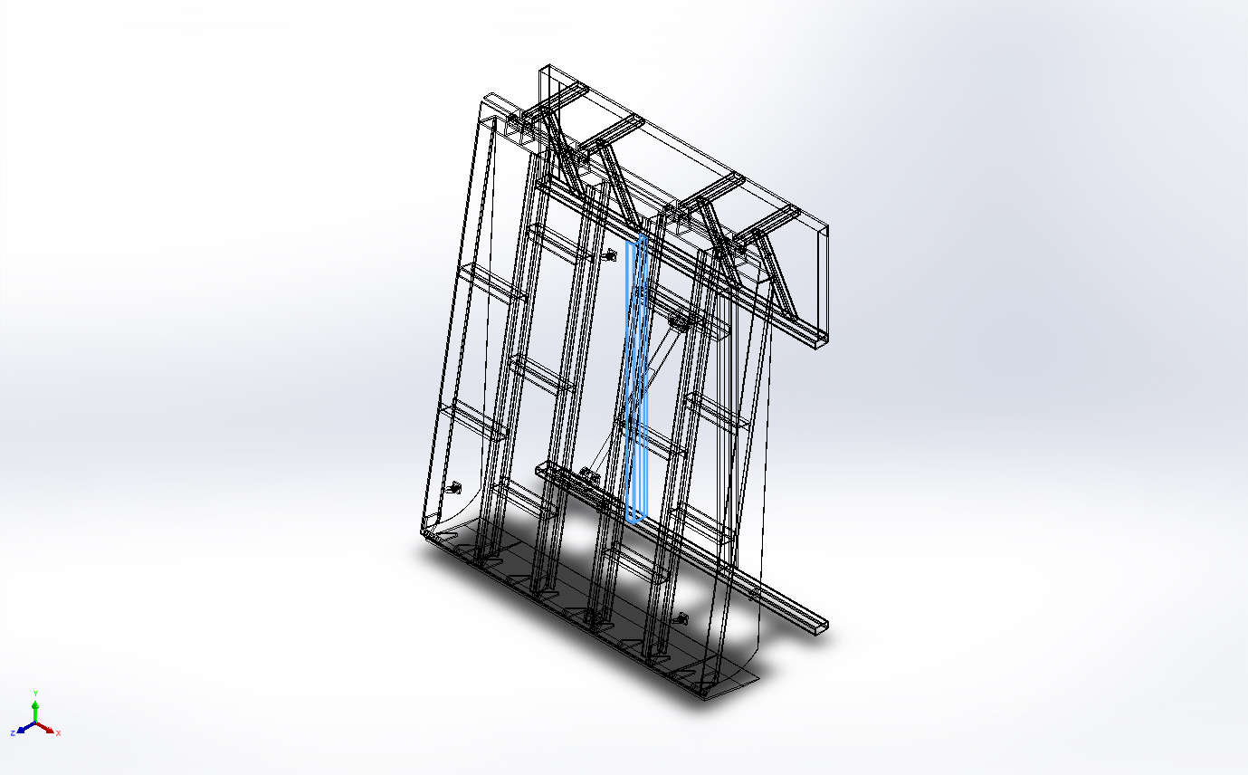 | Beam – Uniform C/S | Section Standard-weldment profiles/iso/c channel  Section Area: 0.00131018m^2  Length:1,725mm  Volume:0.00226005m^3  Mass Density:7,900kg/m^3  Mass:17.8544kg  Weight:174.973N | E:\NIHVA AUTOMATION 2024\AUTOMATION\DOCK LEVELER\MARCS PETCARE\DOCK LEVELER 3D\Base Frame.SLDPRT  Dec 7 12:01:58 2024
SolidBody 1(Trim/Extend10[1])  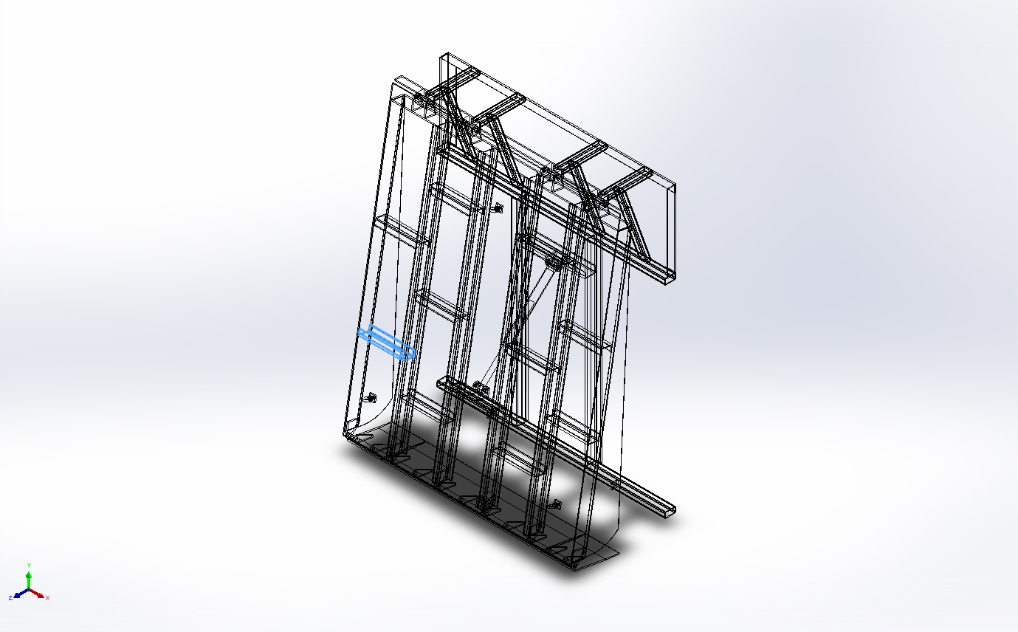 | Beam – Uniform C/S | Section Standard-weldment profiles/iso/c channel  Section Area: 0.00131018m^2  Length:380.432mm  Volume:0.000503077m^3  Mass Density:7,900kg/m^3  Mass:3.97431kg  Weight:38.9482N | E:\NIHVA AUTOMATION 2024\AUTOMATION\DOCK LEVELER\MARCS PETCARE\DOCK LEVELER 3D\DOCK PLATE.SLDPRT  Dec 7 11:07:02 2024
SolidBody 3(Sb beam - configured 120 X 12(1)[2])  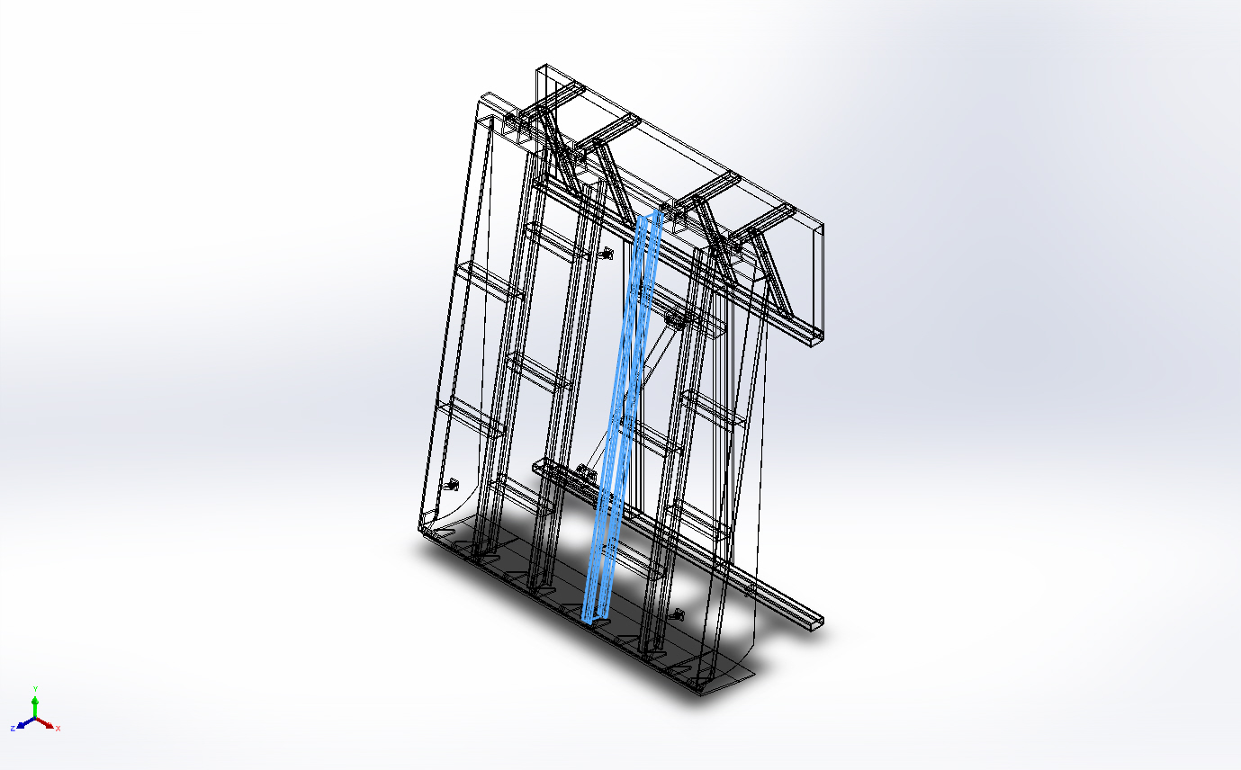 | Beam – Uniform C/S | Section Standard-weldment profiles/iso/sb beam  Section Area: 0.00146373m^2  Length:2,350mm  Volume:0.00343977m^3  Mass Density:7,900kg/m^3  Mass:27.1742kg  Weight:266.307N | E:\NIHVA AUTOMATION 2024\AUTOMATION\DOCK LEVELER\MARCS PETCARE\DOCK LEVELER 3D\DOCK PLATE.SLDPRT  Dec 7 11:07:02 2024
SolidBody 6(Sb beam - configured 120 X 12(1)[4])  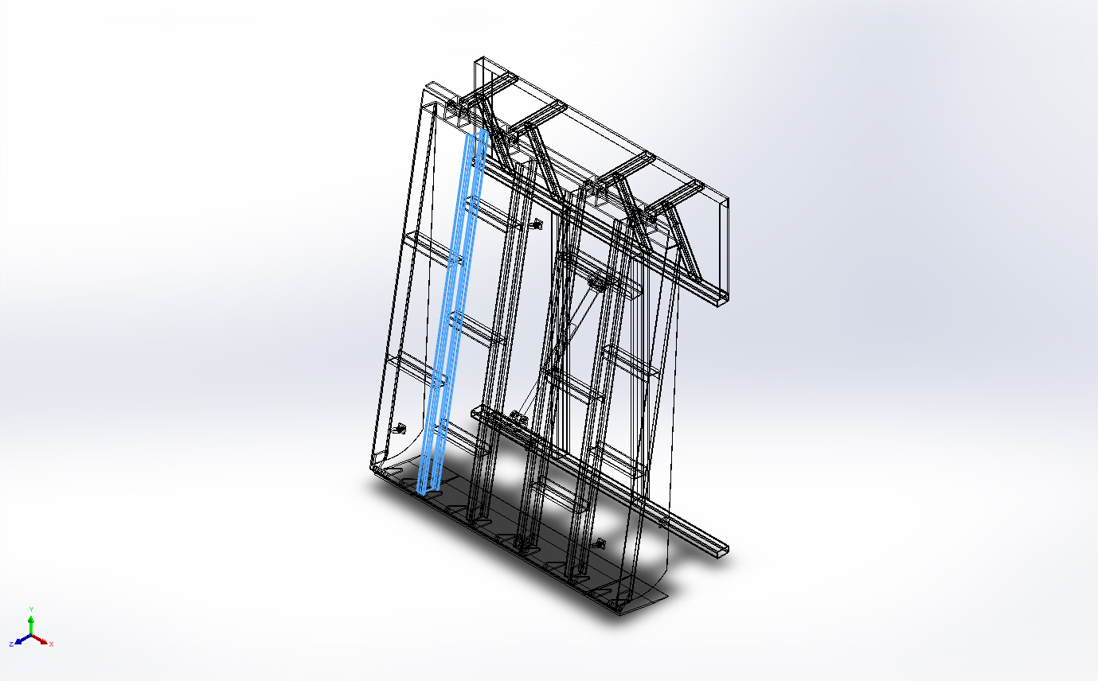 | Beam – Uniform C/S | Section Standard-weldment profiles/iso/sb beam  Section Area: 0.00146373m^2  Length:2,350mm  Volume:0.00343977m^3  Mass Density:7,900kg/m^3  Mass:27.1742kg  Weight:266.307N | E:\NIHVA AUTOMATION 2024\AUTOMATION\DOCK LEVELER\MARCS PETCARE\DOCK LEVELER 3D\DOCK PLATE.SLDPRT  Dec 7 11:07:02 2024
SolidBody 7(Sb beam - configured 120 X 12(1)[3])  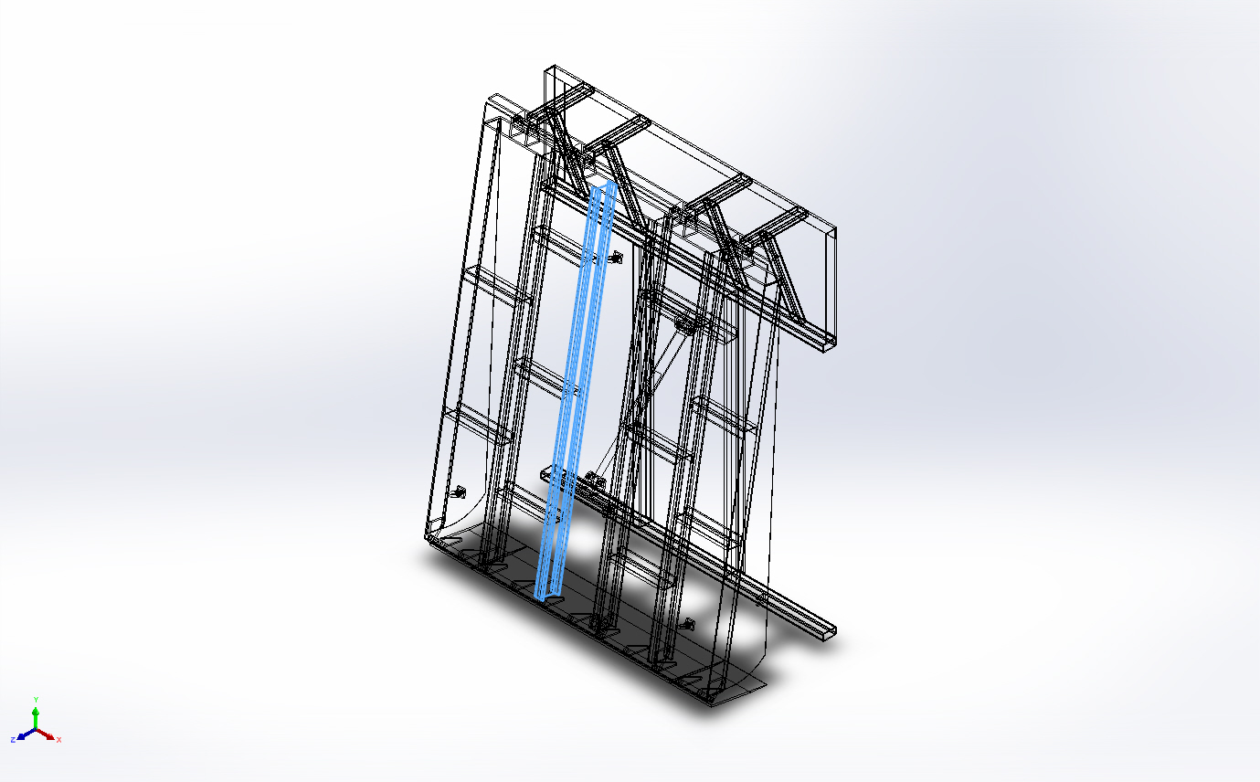 | Beam – Uniform C/S | Section Standard-weldment profiles/iso/sb beam  Section Area: 0.00146373m^2  Length:2,350mm  Volume:0.00343977m^3  Mass Density:7,900kg/m^3  Mass:27.1742kg  Weight:266.307N | E:\NIHVA AUTOMATION 2024\AUTOMATION\DOCK LEVELER\MARCS PETCARE\DOCK LEVELER 3D\DOCK PLATE.SLDPRT  Dec 7 11:07:02 2024
SolidBody 8(Trim/Extend5[1])  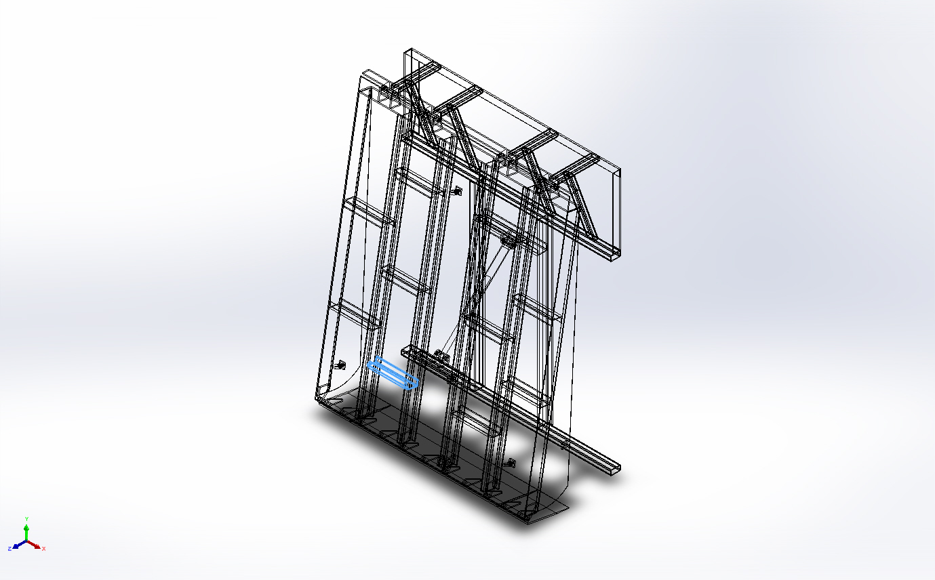 | Beam – Uniform C/S | Section Standard-weldment profiles/iso/c channel  Section Area: 0.00131018m^2  Length:372.863mm  Volume:0.000497808m^3  Mass Density:7,900kg/m^3  Mass:3.93268kg  Weight:38.5403N | E:\NIHVA AUTOMATION 2024\AUTOMATION\DOCK LEVELER\MARCS PETCARE\DOCK LEVELER 3D\DOCK PLATE.SLDPRT  Dec 7 11:07:02 2024
SolidBody 9(Trim/Extend11[1])  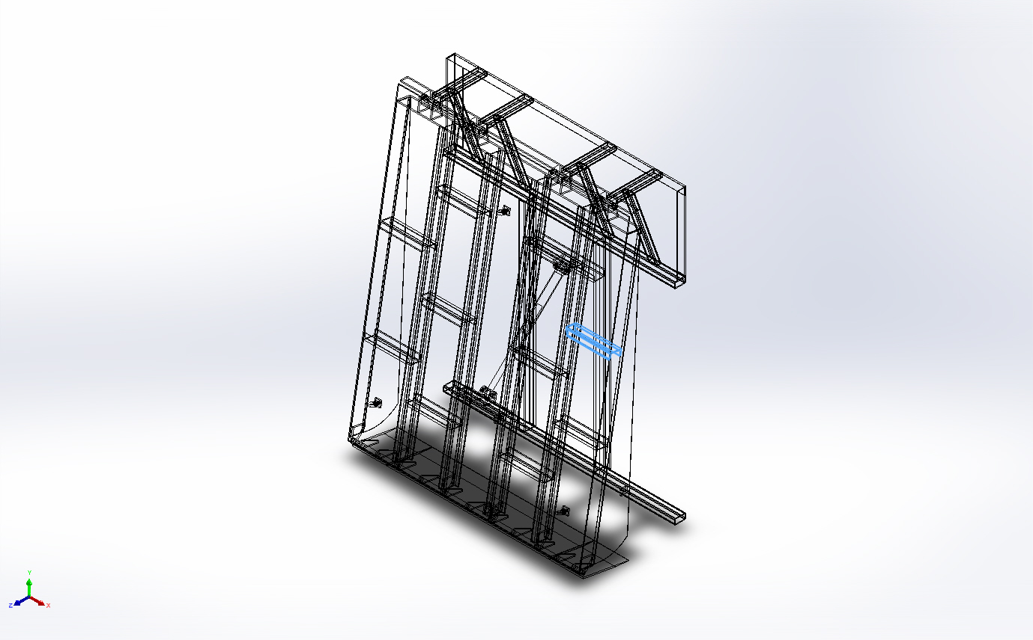 | Beam – Uniform C/S | Section Standard-weldment profiles/iso/c channel  Section Area: 0.00131018m^2  Length:380.432mm  Volume:0.000503078m^3  Mass Density:7,900kg/m^3  Mass:3.97432kg  Weight:38.9483N | E:\NIHVA AUTOMATION 2024\AUTOMATION\DOCK LEVELER\MARCS PETCARE\DOCK LEVELER 3D\DOCK PLATE.SLDPRT  Dec 7 11:07:02 2024
SolidBody 10(Trim/Extend9)  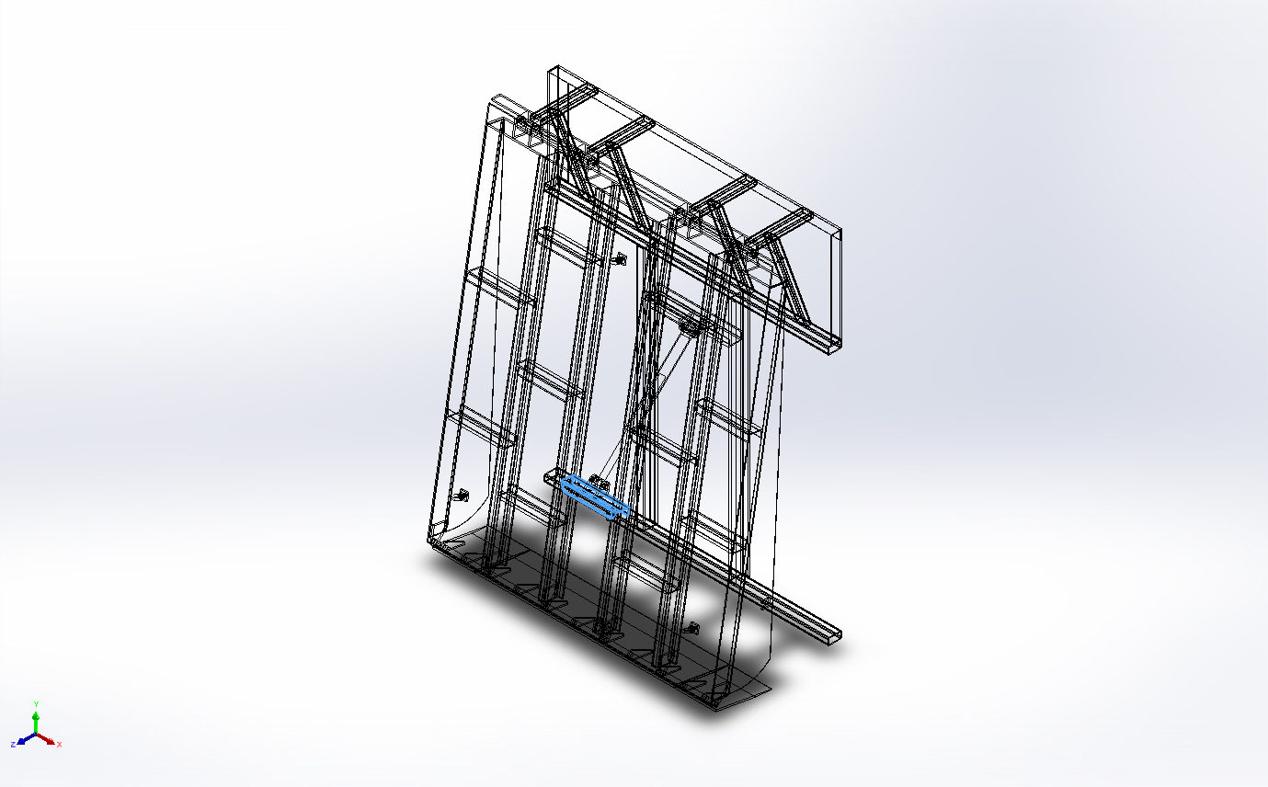 | Beam – Uniform C/S | Section Standard-weldment profiles/iso/c channel  Section Area: 0.00131018m^2  Length:372.863mm  Volume:0.000497807m^3  Mass Density:7,900kg/m^3  Mass:3.93267kg  Weight:38.5402N | E:\NIHVA AUTOMATION 2024\AUTOMATION\DOCK LEVELER\MARCS PETCARE\DOCK LEVELER 3D\DOCK PLATE.SLDPRT  Dec 7 11:07:02 2024
SolidBody 11(Trim/Extend5[2])  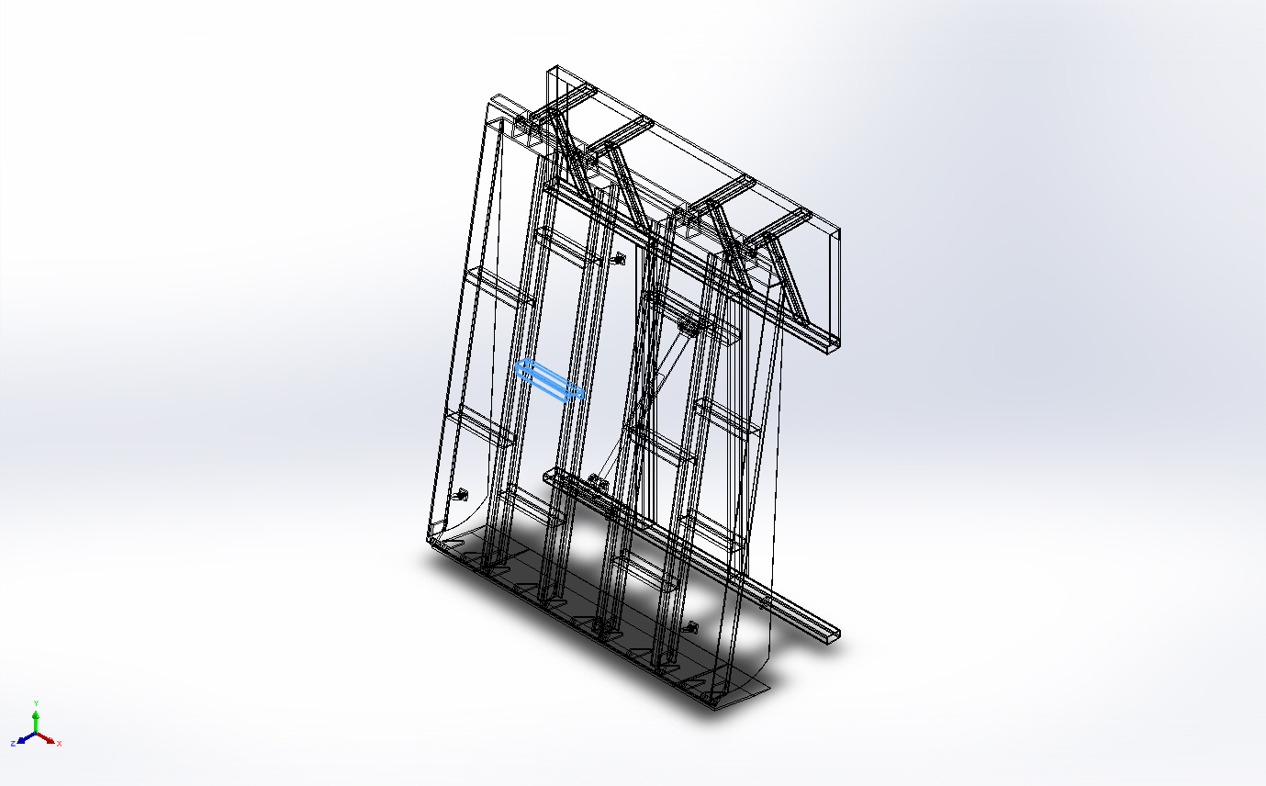 | Beam – Uniform C/S | Section Standard-weldment profiles/iso/c channel  Section Area: 0.00131018m^2  Length:372.863mm  Volume:0.000497807m^3  Mass Density:7,900kg/m^3  Mass:3.93267kg  Weight:38.5402N | E:\NIHVA AUTOMATION 2024\AUTOMATION\DOCK LEVELER\MARCS PETCARE\DOCK LEVELER 3D\DOCK PLATE.SLDPRT  Dec 7 11:07:02 2024
SolidBody 14(Trim/Extend5[3])  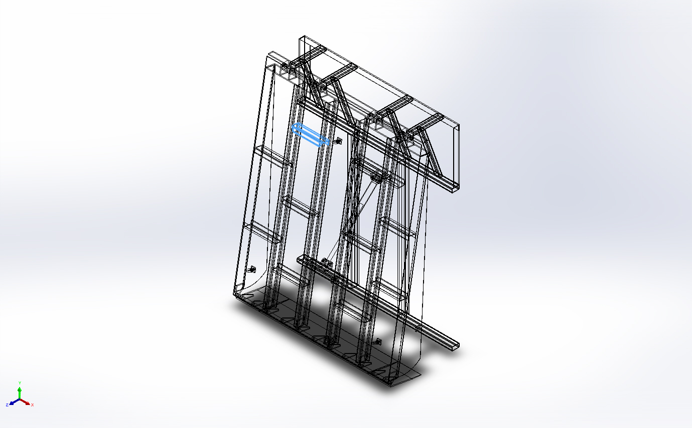 | Beam – Uniform C/S | Section Standard-weldment profiles/iso/c channel  Section Area: 0.00131018m^2  Length:372.863mm  Volume:0.000497807m^3  Mass Density:7,900kg/m^3  Mass:3.93267kg  Weight:38.5402N | E:\NIHVA AUTOMATION 2024\AUTOMATION\DOCK LEVELER\MARCS PETCARE\DOCK LEVELER 3D\DOCK PLATE.SLDPRT  Dec 7 11:07:02 2024
SolidBody 16(Trim/Extend7[1])  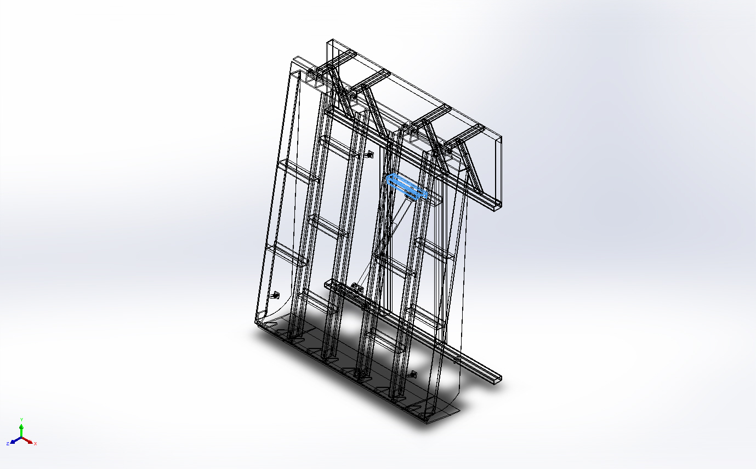 | Beam – Uniform C/S | Section Standard-weldment profiles/iso/c channel  Section Area: 0.00131018m^2  Length:372.863mm  Volume:0.000497807m^3  Mass Density:7,900kg/m^3  Mass:3.93267kg  Weight:38.5402N | E:\NIHVA AUTOMATION 2024\AUTOMATION\DOCK LEVELER\MARCS PETCARE\DOCK LEVELER 3D\DOCK PLATE.SLDPRT  Dec 7 11:07:02 2024
SolidBody 17(Trim/Extend7[2])  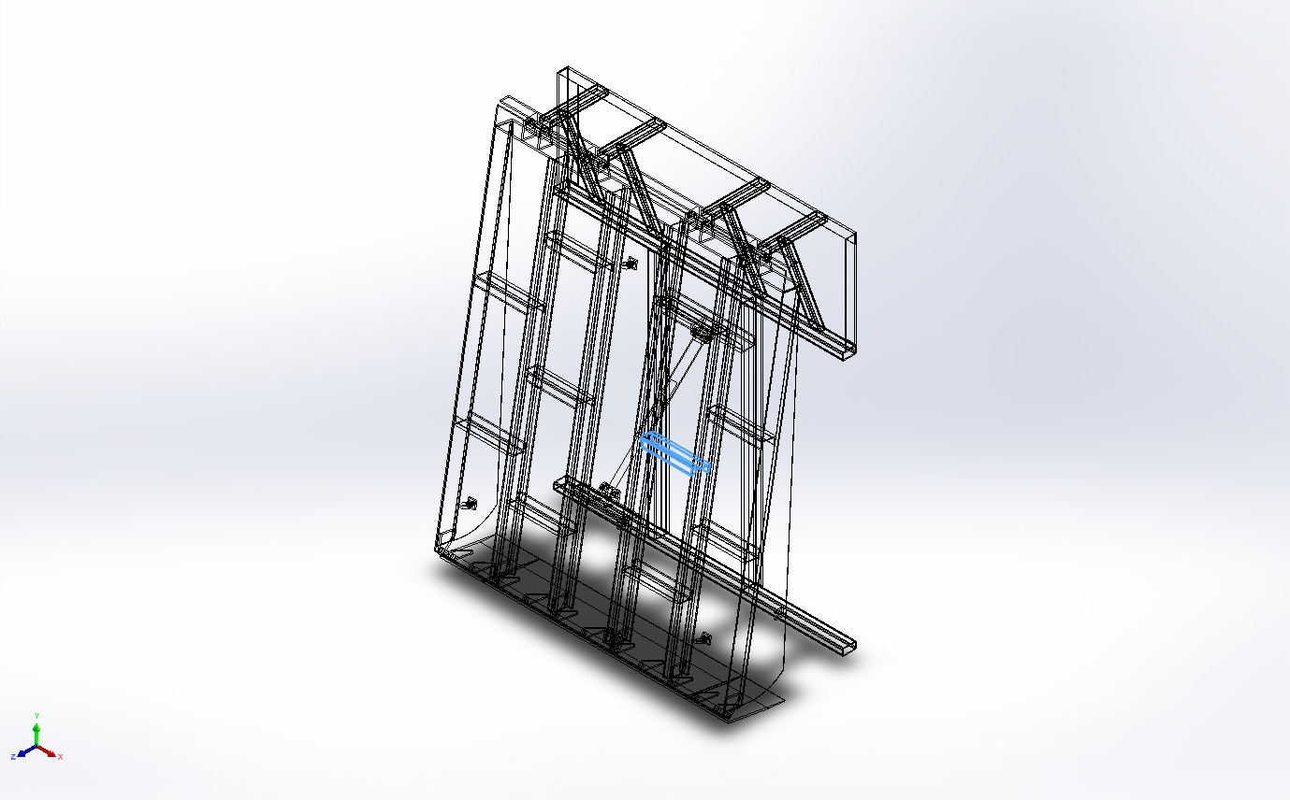 | Beam – Uniform C/S | Section Standard-weldment profiles/iso/c channel  Section Area: 0.00131018m^2  Length:372.863mm  Volume:0.000497807m^3  Mass Density:7,900kg/m^3  Mass:3.93267kg  Weight:38.5402N | E:\NIHVA AUTOMATION 2024\AUTOMATION\DOCK LEVELER\MARCS PETCARE\DOCK LEVELER 3D\DOCK PLATE.SLDPRT  Dec 7 11:07:02 2024
SolidBody 18(Trim/Extend10[2])  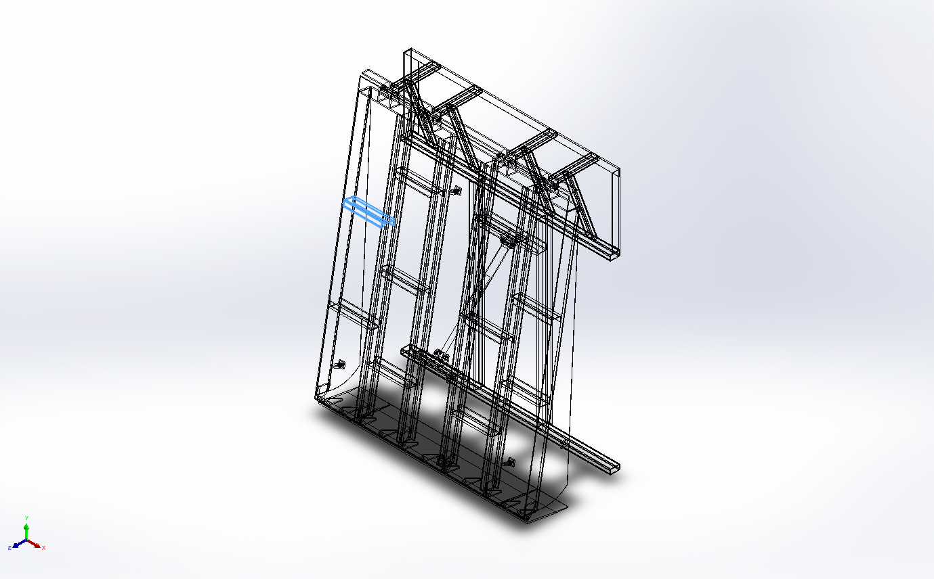 | Beam – Uniform C/S | Section Standard-weldment profiles/iso/c channel  Section Area: 0.00131018m^2  Length:380.432mm  Volume:0.000503077m^3  Mass Density:7,900kg/m^3  Mass:3.97431kg  Weight:38.9482N | E:\NIHVA AUTOMATION 2024\AUTOMATION\DOCK LEVELER\MARCS PETCARE\DOCK LEVELER 3D\DOCK PLATE.SLDPRT  Dec 7 11:07:02 2024
SolidBody 20(Trim/Extend7[3])  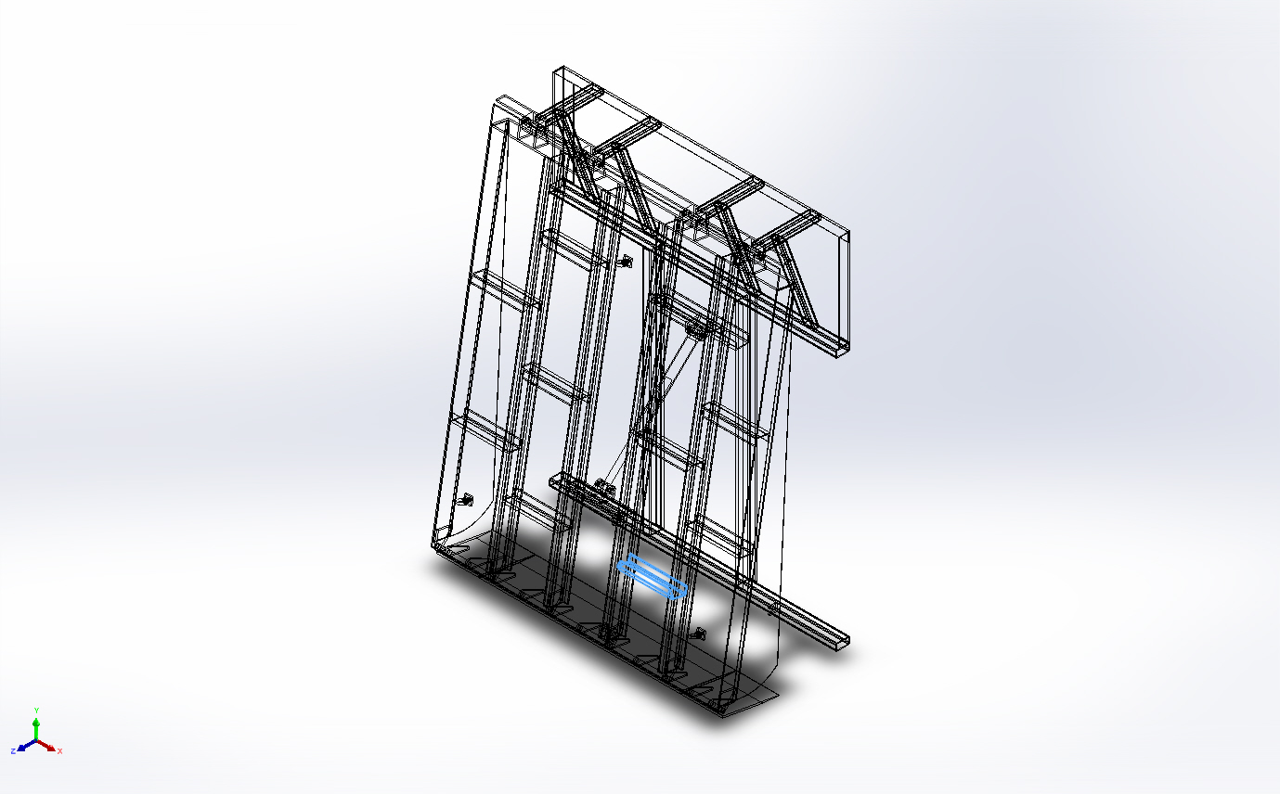 | Beam – Uniform C/S | Section Standard-weldment profiles/iso/c channel  Section Area: 0.00131018m^2  Length:372.863mm  Volume:0.000497808m^3  Mass Density:7,900kg/m^3  Mass:3.93268kg  Weight:38.5403N | E:\NIHVA AUTOMATION 2024\AUTOMATION\DOCK LEVELER\MARCS PETCARE\DOCK LEVELER 3D\DOCK PLATE.SLDPRT  Dec 7 11:07:02 2024
SolidBody 21(Sb beam - configured 120 X 12(1)[1])  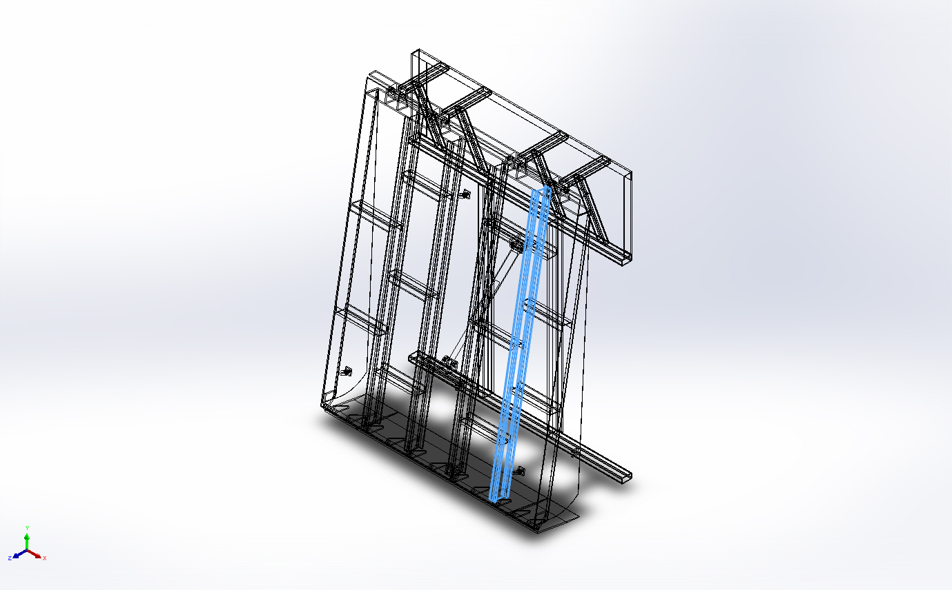 | Beam – Uniform C/S | Section Standard-weldment profiles/iso/sb beam  Section Area: 0.00146373m^2  Length:2,350mm  Volume:0.00343977m^3  Mass Density:7,900kg/m^3  Mass:27.1742kg  Weight:266.307N | E:\NIHVA AUTOMATION 2024\AUTOMATION\DOCK LEVELER\MARCS PETCARE\DOCK LEVELER 3D\DOCK PLATE.SLDPRT  Dec 7 11:07:02 2024
SolidBody 22(Trim/Extend11[2])  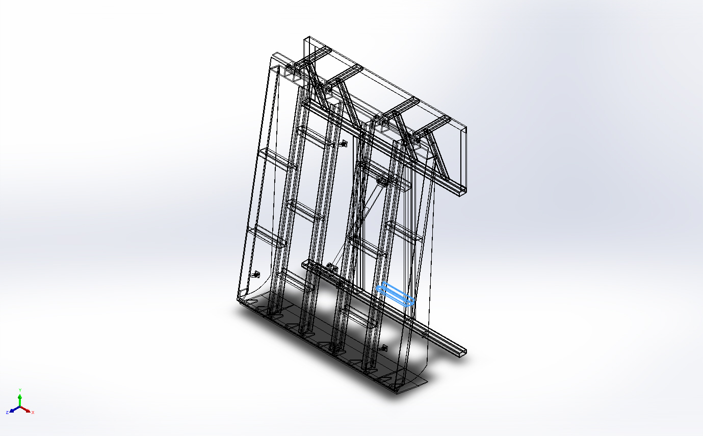 | Beam – Uniform C/S | Section Standard-weldment profiles/iso/c channel  Section Area: 0.00131018m^2  Length:380.432mm  Volume:0.000503079m^3  Mass Density:7,900kg/m^3  Mass:3.97432kg  Weight:38.9484N | E:\NIHVA AUTOMATION 2024\AUTOMATION\DOCK LEVELER\MARCS PETCARE\DOCK LEVELER 3D\DOCK PLATE.SLDPRT  Dec 7 11:07:02 2024

Study Properties
Study name | Static 1
Analysis type | Static
Mesh type | Mixed Mesh
Thermal Effect: | On
Thermal option | Include temperature loads
Zero strain temperature | 298 Kelvin
Include fluid pressure effects from SOLIDWORKS Flow Simulation | Off
Solver type | Direct sparse solver
Inplane Effect: | Off
Soft Spring: | Off
Inertial Relief: | Off
Incompatible bonding options | Automatic
Large displacement | Off
Compute free body forces | On
Friction | Off
Use Adaptive Method: | Off
Result folder | SOLIDWORKS document (E:\NIHVA AUTOMATION 2024\AUTOMATION\DOCK LEVELER\MARCS PETCARE\DOCK LEVELER 3D)

Units
Unit system: | SI (MKS)
Length/Displacement | mm
Temperature | Kelvin
Angular velocity | Rad/sec
Pressure/Stress | N/m^2

Material Properties
Model Reference | Properties | Components
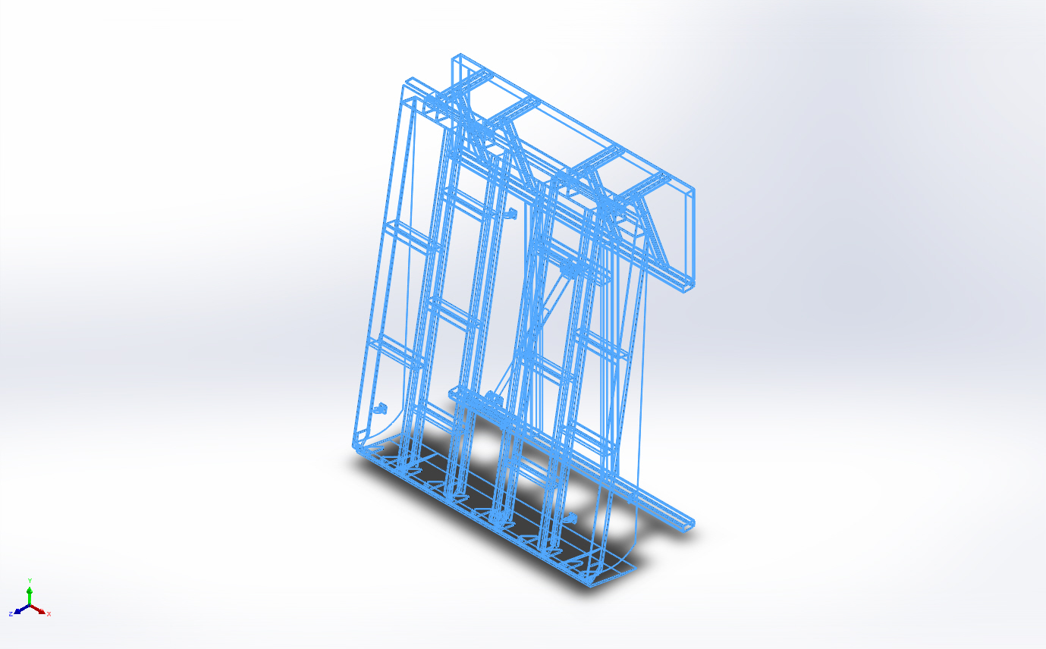 |  | SolidBody 1(Chamfer3)(200 mm filp plate. assembly-1/200 mm filp plate-1),  SolidBody 1(Fillet1)(200 mm filp plate. assembly-1/Flip Plate MTG BKT-1),  SolidBody 1(Fillet1)(200 mm filp plate. assembly-1/Flip Plate MTG BKT-3),  SolidBody 1(Chamfer3)(200 mm filp plate. assembly-2/200 mm filp plate-1),  SolidBody 1(Fillet1)(200 mm filp plate. assembly-2/Flip Plate MTG BKT-1),  SolidBody 1(Fillet1)(200 mm filp plate. assembly-2/Flip Plate MTG BKT-3),  SolidBody 1(Cut-Extrude4[1])(600 mm flip plate assembly-1/1600 mm filp plate-1),  SolidBody 2(Cut-Extrude4[2])(600 mm flip plate assembly-1/1600 mm filp plate-1),  SolidBody 3(Chamfer3)(600 mm flip plate assembly-1/1600 mm filp plate-1),  SolidBody 1(Fillet1)(600 mm flip plate assembly-1/Flip Plate MTG BKT-1),  SolidBody 1(Fillet1)(600 mm flip plate assembly-1/Flip Plate MTG BKT-10),  SolidBody 1(Fillet1)(600 mm flip plate assembly-1/Flip Plate MTG BKT-16),  SolidBody 1(Fillet1)(600 mm flip plate assembly-1/Flip Plate MTG BKT-17),  SolidBody 1(Fillet1)(600 mm flip plate assembly-1/Flip Plate MTG BKT-18),  SolidBody 1(Fillet1)(600 mm flip plate assembly-1/Flip Plate MTG BKT-19),  SolidBody 1(Fillet1)(600 mm flip plate assembly-1/Flip Plate MTG BKT-20),  SolidBody 1(Angle iron - configured 35 X 35 X 5(1)[2])(BS-1),  SolidBody 2(Angle iron - configured 35 X 35 X 5(1)[3])(BS-1),  SolidBody 3(Angle iron - configured 35 X 35 X 5(1)[1])(BS-1),  SolidBody 4(Cut-Extrude1)(BS-1),  SolidBody 1(Rectangular tube - configured 70 X 40 X 5(1)[4])(Base Frame-1),  SolidBody 2(Trim/Extend2[2])(Base Frame-1),  SolidBody 3(Trim/Extend7[4])(Base Frame-1),  SolidBody 4(Rectangular tube - configured 120 X 80 X 8(1)[2])(Base Frame-1),  SolidBody 5(Angle iron - configured 35 X 35 X 5(1)[1])(Base Frame-1),  SolidBody 6(Rectangular tube - configured 70 X 40 X 5(1)[1])(Base Frame-1),  SolidBody 7(Rectangular tube - configured 70 X 40 X 5(1)[2])(Base Frame-1),  SolidBody 8(Rectangular tube - configured 70 X 40 X 5(1)[3])(Base Frame-1),  SolidBody 9(Trim/Extend3[1])(Base Frame-1),  SolidBody 10(Trim/Extend3[2])(Base Frame-1),  SolidBody 11(Trim/Extend7[1])(Base Frame-1),  SolidBody 12(Trim/Extend7[2])(Base Frame-1),  SolidBody 13(Trim/Extend7[3])(Base Frame-1),  SolidBody 14(Trim/Extend8)(Base Frame-1),  SolidBody 15(Rectangular tube - configured 120 X 80 X 8(1)[1])(Base Frame-1),  SolidBody 16(Trim/Extend2[1])(Base Frame-1),  SolidBody 1(Boss-Extrude1)(CYL BODY 01-1),  SolidBody 2(Boss-Extrude3)(CYL BODY 01-1),  SolidBody 3(Mirror4[1])(CYL BODY 01-1),  SolidBody 4(Mirror4[2])(CYL BODY 01-1),  SolidBody 5(Cut-Extrude1)(CYL BODY 01-1),  SolidBody 1(Mirror2[2])(CYL SHAFT01-1),  SolidBody 2(Cut-Extrude1)(CYL SHAFT01-1),  SolidBody 3(Mirror2[1])(CYL SHAFT01-1),  SolidBody 1(Cut-Extrude1)(Cyl mtg pin-1),  SolidBody 2(Boss-Extrude2)(Cyl mtg pin-1),  SolidBody 1(Cut-Extrude1)(Cyl mtg pin-2),  SolidBody 2(Boss-Extrude2)(Cyl mtg pin-2),  SolidBody 1(Boss-Extrude1)(Cylinder MTG BKT-1),  SolidBody 1(Boss-Extrude1)(Cylinder MTG BKT-2),  SolidBody 1(Boss-Extrude1)(Cylinder MTG BKT-5),  SolidBody 1(Boss-Extrude1)(Cylinder MTG BKT-6),  SolidBody 1(Cut-Extrude2)(Dack bar-1),  SolidBody 1(Cut-Extrude2)(Dack bar-3),  SolidBody 1(External Circlip 22mm.STEP)(External Circlip 22mm.step-1),  SolidBody 1(External Circlip 22mm.STEP)(External Circlip 22mm.step-2),  SolidBody 1(External Circlip 22mm.STEP)(External Circlip 22mm.step-3),  SolidBody 1(External Circlip 22mm.STEP)(External Circlip 22mm.step-4),  SolidBody 1(External Circlip 22mm.STEP)(External Circlip 22mm.step-5),  SolidBody 1(External Circlip 22mm.STEP)(External Circlip 22mm.step-6),  SolidBody 1(External Circlip 22mm.STEP)(External Circlip 22mm.step-7),  SolidBody 1(External Circlip 22mm.STEP)(External Circlip 22mm.step-8),  SolidBody 1(Boss-Extrude2)(Lifting eye bolt M16 DIN580-1),  SolidBody 1(Boss-Extrude2)(Lifting eye bolt M16 DIN580-2),  SolidBody 1(Boss-Extrude2)(Lifting eye bolt M16 DIN580-3),  SolidBody 1(Cut-Extrude4)(MS dia 25 Rod-1),  SolidBody 1(Boss-Extrude1)(MTG Block-1),  SolidBody 1(Boss-Extrude1)(MTG Block-2),  SolidBody 1(Boss-Extrude1)(MTG Block-3),  SolidBody 1(Boss-Extrude1)(MTG Block-4),  SolidBody 1(Boss-Extrude1)(Support plate-1),  SolidBody 1(Trim/Extend10[1])(dack assembly-1/DOCK PLATE-1),  SolidBody 2(Cut-Extrude2[1])(dack assembly-1/DOCK PLATE-1),  SolidBody 3(Sb beam - configured 120 X 12(1)[2])(dack assembly-1/DOCK PLATE-1),  SolidBody 4(Cut-Extrude2[2])(dack assembly-1/DOCK PLATE-1),  SolidBody 5(Boss-Extrude6)(dack assembly-1/DOCK PLATE-1),  SolidBody 6(Sb beam - configured 120 X 12(1)[4])(dack assembly-1/DOCK PLATE-1),  SolidBody 7(Sb beam - configured 120 X 12(1)[3])(dack assembly-1/DOCK PLATE-1),  SolidBody 8(Trim/Extend5[1])(dack assembly-1/DOCK PLATE-1),  SolidBody 9(Trim/Extend11[1])(dack assembly-1/DOCK PLATE-1),  SolidBody 10(Trim/Extend9)(dack assembly-1/DOCK PLATE-1),  SolidBody 11(Trim/Extend5[2])(dack assembly-1/DOCK PLATE-1),  SolidBody 12(Boss-Extrude5)(dack assembly-1/DOCK PLATE-1),  SolidBody 13(Boss-Extrude7)(dack assembly-1/DOCK PLATE-1),  SolidBody 14(Trim/Extend5[3])(dack assembly-1/DOCK PLATE-1),  SolidBody 15(Cut-Extrude2[4])(dack assembly-1/DOCK PLATE-1),  SolidBody 16(Trim/Extend7[1])(dack assembly-1/DOCK PLATE-1),  SolidBody 17(Trim/Extend7[2])(dack assembly-1/DOCK PLATE-1),  SolidBody 18(Trim/Extend10[2])(dack assembly-1/DOCK PLATE-1),  SolidBody 19(Cut-Extrude2[3])(dack assembly-1/DOCK PLATE-1),  SolidBody 20(Trim/Extend7[3])(dack assembly-1/DOCK PLATE-1),  SolidBody 21(Sb beam - configured 120 X 12(1)[1])(dack assembly-1/DOCK PLATE-1),  SolidBody 22(Trim/Extend11[2])(dack assembly-1/DOCK PLATE-1),  SolidBody 1(Boss-Extrude1)(dack assembly-1/Dack flip plate bkt-1),  SolidBody 1(Boss-Extrude1)(dack assembly-1/Dack flip plate bkt-10),  SolidBody 1(Boss-Extrude1)(dack assembly-1/Dack flip plate bkt-11),  SolidBody 1(Boss-Extrude1)(dack assembly-1/Dack flip plate bkt-12),  SolidBody 1(Boss-Extrude1)(dack assembly-1/Dack flip plate bkt-7),  SolidBody 1(Boss-Extrude1)(dack assembly-1/Dack flip plate bkt-8),  SolidBody 1(Boss-Extrude1)(dack assembly-1/Side Cover-1),  SolidBody 1(Boss-Extrude1)(dack assembly-1/Side Cover-3),  SolidBody 1(Boss-Extrude1)(dack assembly-1/dack bkt-1),  SolidBody 1(Boss-Extrude1)(dack assembly-1/dack bkt-2),  SolidBody 1(Boss-Extrude1)(dack assembly-1/dack bkt-3),  SolidBody 1(Boss-Extrude1)(dack assembly-1/dack bkt-4),  SolidBody 1(Boss-Extrude1)(dack assembly-1/dack bkt-5),  SolidBody 1(Boss-Extrude1)(dack assembly-1/dack bkt-6),  SolidBody 1(Boss-Extrude1)(dack assembly-1/dack bkt-7),  SolidBody 1(Boss-Extrude1)(dack assembly-1/dack bkt-8),  SolidBody 1(Boss-Extrude1)(lip plat rest bkt-1),  SolidBody 1(Boss-Extrude1)(lip plat rest bkt-3)
  Name: | AISI 1020
  Model type: | Linear Elastic Isotropic
  Default failure criterion: | Max von Mises Stress
  Yield strength: | 3.51571e+08 N/m^2
  Tensile strength: | 4.20507e+08 N/m^2
  Elastic modulus: | 2e+11 N/m^2
  Poisson's ratio: | 0.29
  Mass density: | 7,900 kg/m^3
  Shear modulus: | 7.7e+10 N/m^2
  Thermal expansion coefficient: | 1.5e-05 /Kelvin
Curve Data:N/A

Loads and Fixtures
Fixture name | Fixture Image | Fixture Details
Fixed-1 | 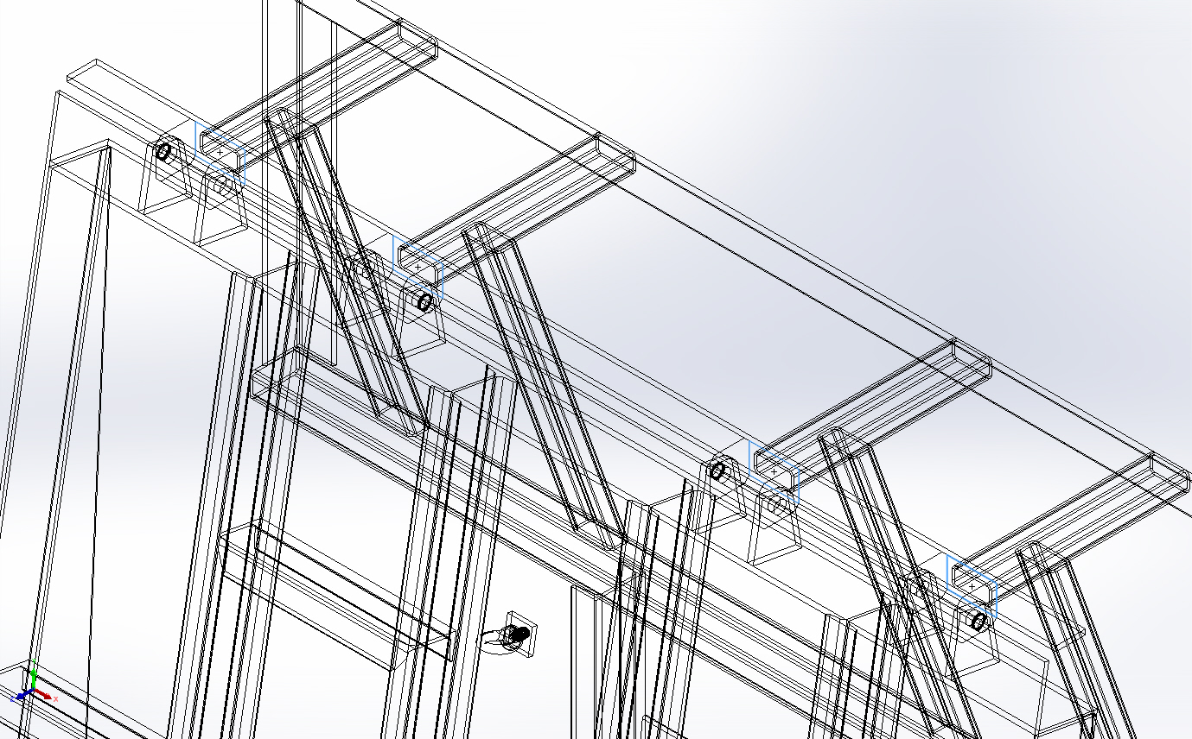
  Entities: | 4 face(s)
  Type: | Fixed Geometry
Resultant Forces
Components | X | Y | Z | Resultant
Reaction force(N) | -0.0183411 | 25,543.6 | 144,865 | 147,100
Reaction Moment(N.m) | 0 | 0 | 0 | 1e-33

Virtual wall-1 | 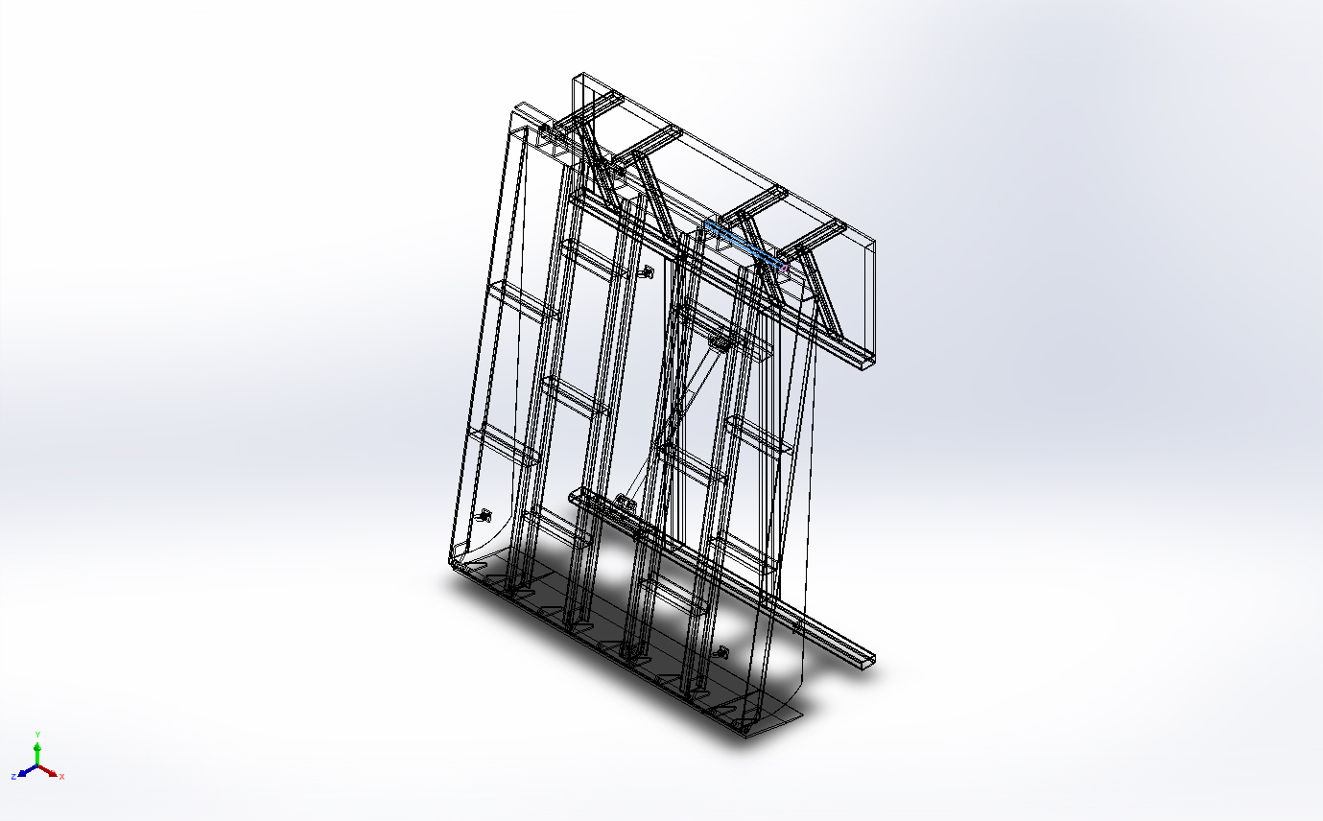
  Type: | Virtual wall
  Entities: | 1 face(s), 1 plane(s)
  Wall Type: | Rigid
Virtual wall-2 | 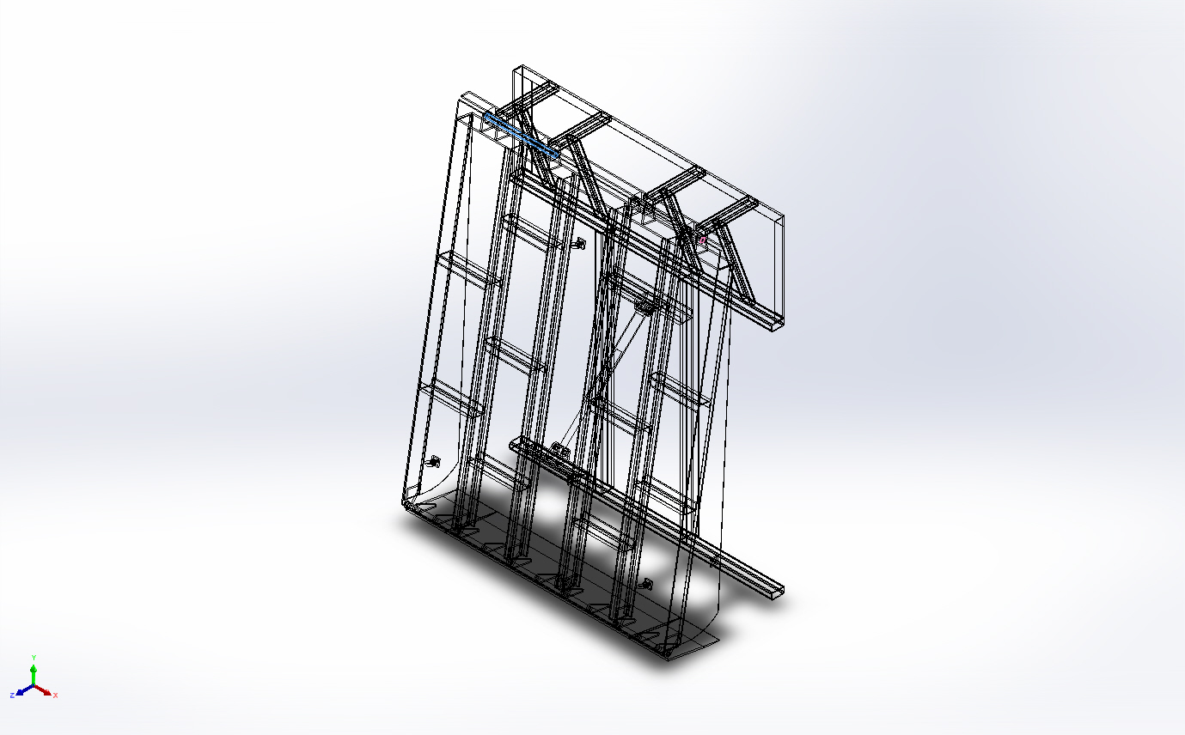
  Type: | Virtual wall
  Entities: | 1 face(s), 1 plane(s)
  Wall Type: | Rigid
Virtual wall-3 | 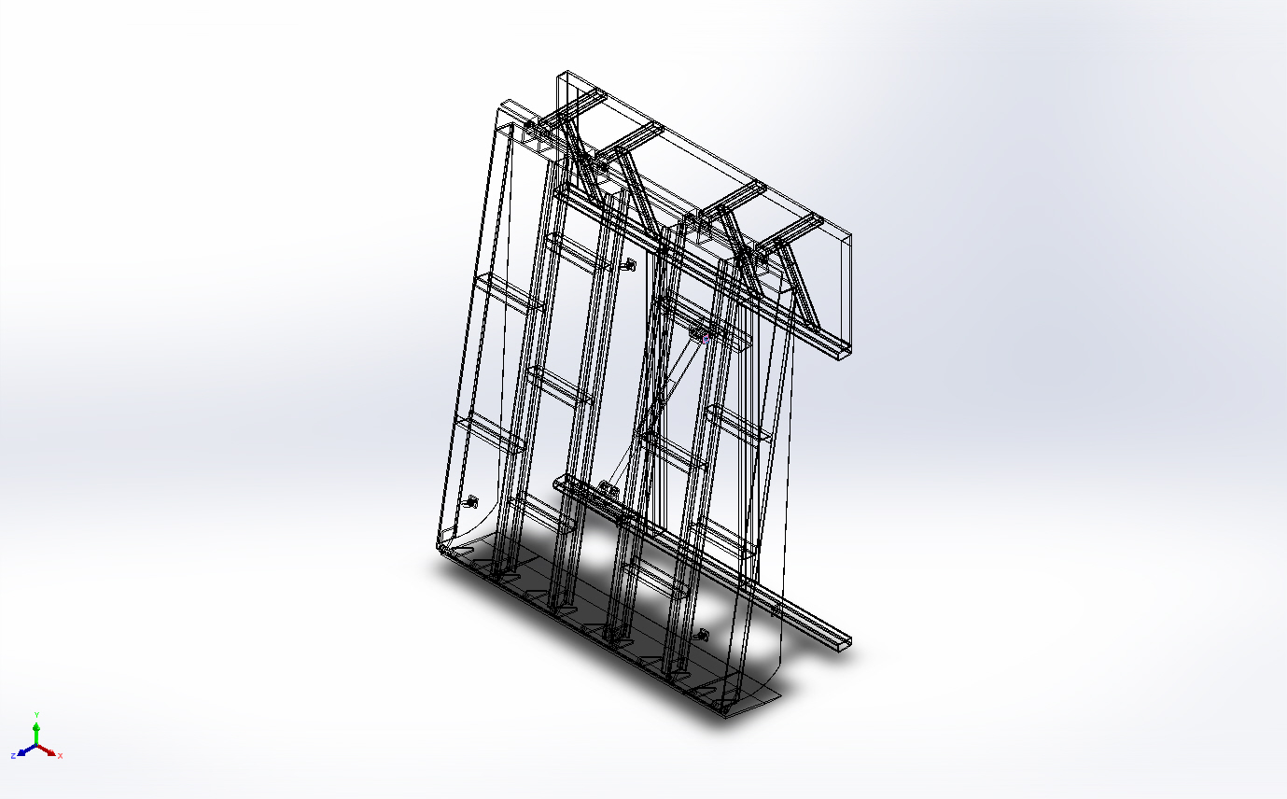
  Type: | Virtual wall
  Entities: | 1 face(s), 1 plane(s)
  Wall Type: | Rigid
Virtual wall-4 | 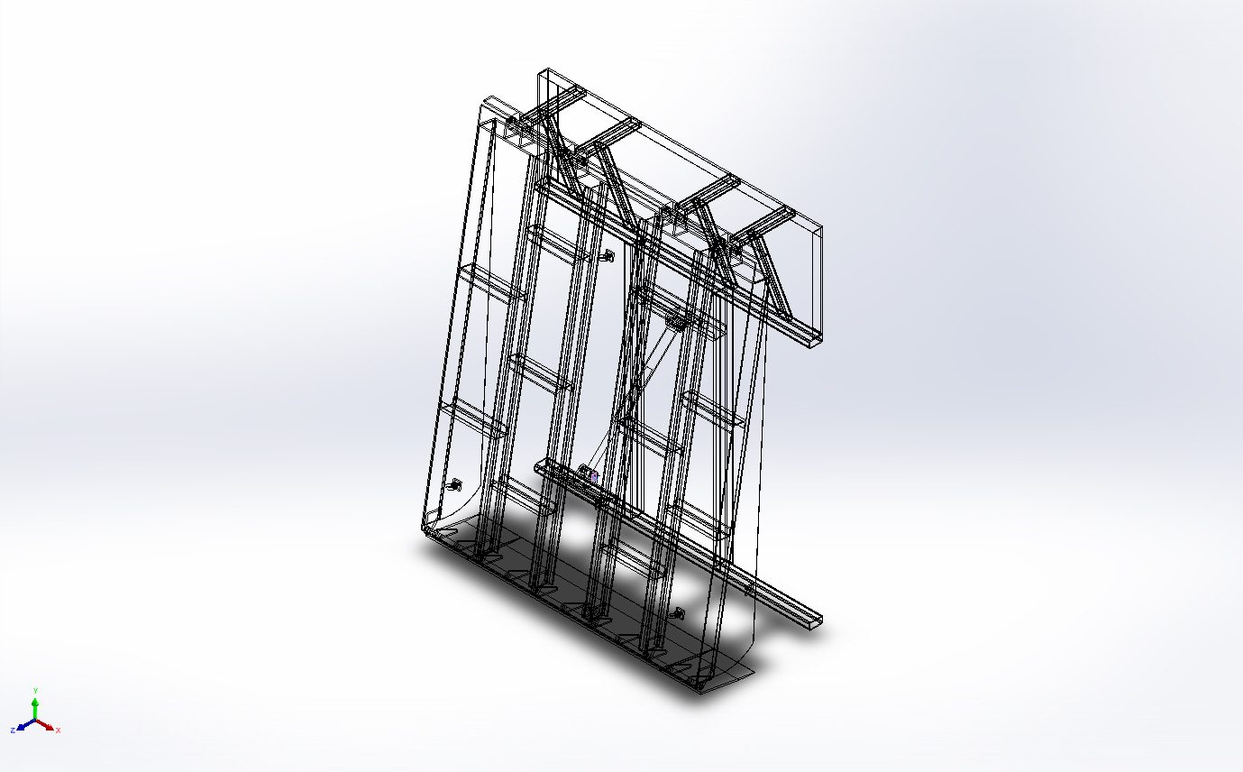
  Type: | Virtual wall
  Entities: | 1 face(s), 1 plane(s)
  Wall Type: | Rigid

Load name | Load Image | Load Details
Force-1 | 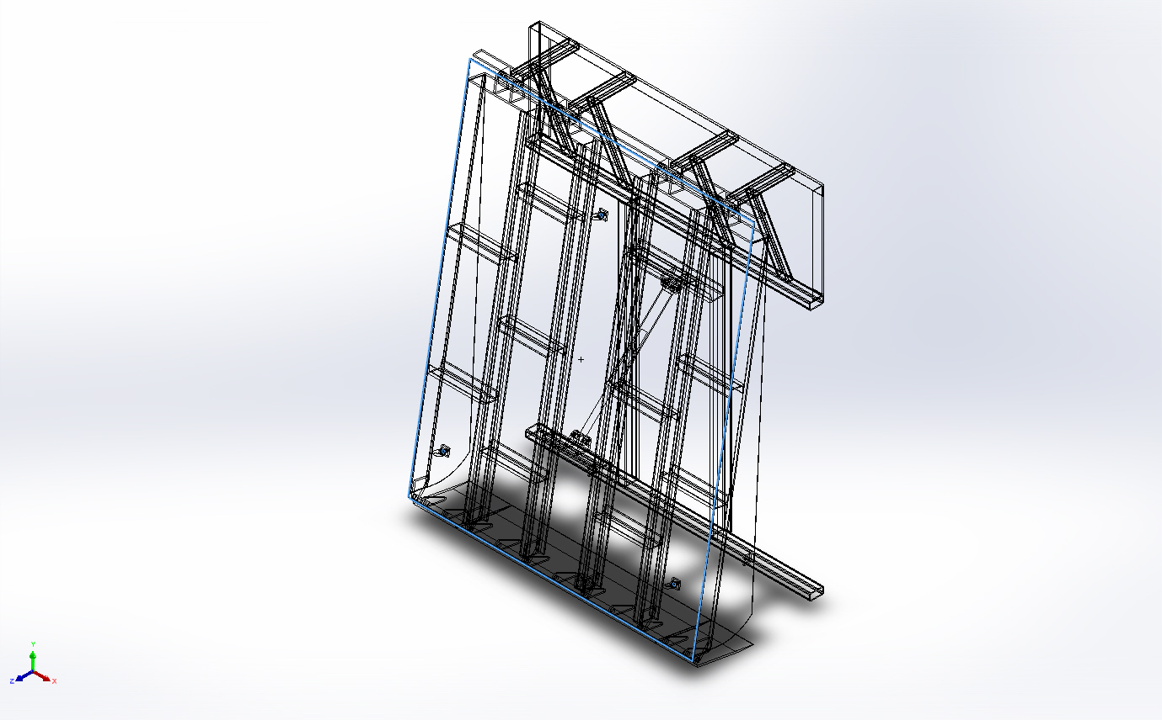
  Entities: | 1 face(s)
  Type: | Apply normal force
  Value: | 15,000 kgf

Connector Definitions
No Data

Contact Information

Contact | Contact Image | Contact Properties
Global Contact | 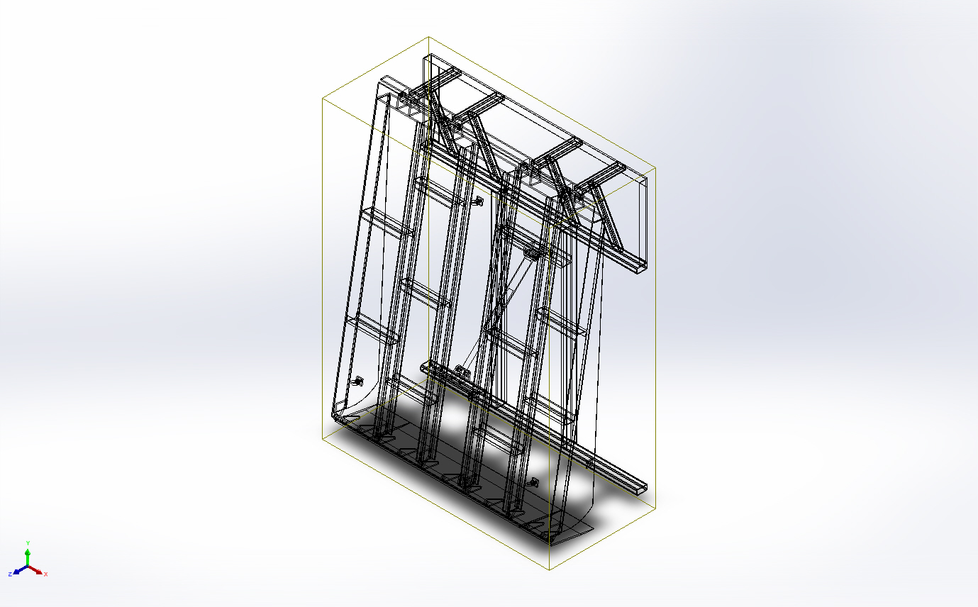
  Type: | Bonded
  Components: | 1 component(s)
  Options: | Incompatible mesh

Mesh information
Mesh type | Mixed Mesh
Mesher Used: | Curvature-based mesh
Jacobian points for High quality mesh | 16 Points
Jacobian check for shell | Off
Maximum element size | 246.857 mm
Minimum element size | 12.3429 mm
Mesh Quality | High
Remesh failed parts with incompatible mesh | Off

Mesh information - Details
Total Nodes | 209730
Total Elements | 122143
Time to complete mesh(hh;mm;ss): | 00:00:18
Computer name:
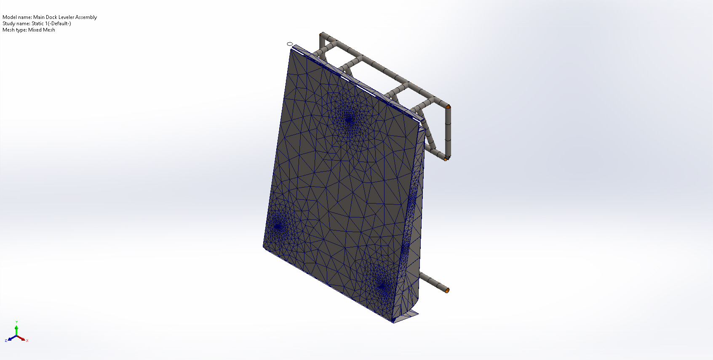

Sensor Details
No Data

Resultant Forces

Reaction forces
Selection set | Units | Sum X | Sum Y | Sum Z | Resultant
Entire Model | N | -0.0183411 | 25,543.6 | 144,865 | 147,100

Reaction Moments
Selection set | Units | Sum X | Sum Y | Sum Z | Resultant
Entire Model | N.m | 0 | 0 | 0 | 1e-33

Free body forces
Selection set | Units | Sum X | Sum Y | Sum Z | Resultant
Entire Model | N | 0.0459595 | 1.58984 | -0.304932 | 1.61947

Free body moments
Selection set | Units | Sum X | Sum Y | Sum Z | Resultant
Entire Model | N.m | -7.11179e-08 | -9.59021e-08 | 3.95708e-07 | 4.13328e-07

Beams

Beam Forces
Beam Name | Joints | Axial(N) | Shear1(N) | Shear2(N) | Moment1(N.m) | Moment2(N.m) | Torque(N.m)
Beam-1(Angle iron - configured 35 X 35 X 5(1)[2]) | 1 | 498.625 | 56.778 | 24.0109 | -10.6732 | 7.24564 | 0.0592845
Beam-1(Angle iron - configured 35 X 35 X 5(1)[2]) | 2 | -458.353 | 131.211 | -138.767 | -0.182808 | -15.3055 | 0.601649
Beam-2(Angle iron - configured 35 X 35 X 5(1)[3]) | 1 | 1.98078e-11 | -1.7132e-11 | 6.84535e-11 | -5.0279e-14 | 9.5532e-12 | -7.90744e-13
Beam-2(Angle iron - configured 35 X 35 X 5(1)[3]) | 2 | 2.07493e-10 | 6.10916e-11 | 2.10797e-11 | -8.2147e-11 | -1.47434e-10 | 2.19343e-12
Beam-3(Angle iron - configured 35 X 35 X 5(1)[1]) | 1 | -1.79542e-11 | -8.78375e-12 | -7.44356e-12 | 8.66289e-13 | -3.17511e-13 | -1.08118e-13
Beam-3(Angle iron - configured 35 X 35 X 5(1)[1]) | 2 | 7.03442e-11 | 1.7687e-11 | 1.37273e-10 | 2.82294e-10 | -2.21943e-11 | -2.06981e-12
Beam-4(Rectangular tube - configured 70 X 40 X 5(1)[4]) | 1 | 0 | 0 | 0 | 0 | 0 | 0
Beam-4(Rectangular tube - configured 70 X 40 X 5(1)[4]) | 2 | 0 | 0 | 0 | 0 | 0 | 0
Beam-4(Rectangular tube - configured 70 X 40 X 5(1)[4]) | 3 | 0 | 0 | 0 | 0 | 0 | 0
Beam-5(Trim/Extend2[2]) | 1 | 0 | 0 | 0 | 0 | 0 | 0
Beam-5(Trim/Extend2[2]) | 2 | 0 | 0 | 0 | 0 | 0 | 0
Beam-5(Trim/Extend2[2]) | 3 | 0 | 0 | 0 | 0 | 0 | 0
Beam-6(Trim/Extend7[4]) | 1 | 0 | 0 | 0 | 0 | 0 | 0
Beam-6(Trim/Extend7[4]) | 2 | 0 | 0 | 0 | 0 | 0 | 0
Beam-7(Rectangular tube - configured 120 X 80 X 8(1)[2]) | 1 | 0 | 0 | 0 | 0 | 0 | 0
Beam-7(Rectangular tube - configured 120 X 80 X 8(1)[2]) | 2 | 0 | 0 | 0 | 0 | 0 | 0
Beam-7(Rectangular tube - configured 120 X 80 X 8(1)[2]) | 3 | 0 | 0 | 0 | 0 | 0 | 0
Beam-7(Rectangular tube - configured 120 X 80 X 8(1)[2]) | 4 | 0 | 0 | 0 | 0 | 0 | 0
Beam-7(Rectangular tube - configured 120 X 80 X 8(1)[2]) | 5 | 0 | 0 | 0 | 0 | 0 | 0
Beam-7(Rectangular tube - configured 120 X 80 X 8(1)[2]) | 6 | 0 | 0 | 0 | 0 | 0 | 0
Beam-8(Angle iron - configured 35 X 35 X 5(1)[1]) | 1 | 0 | 0 | 0 | 0 | 0 | 0
Beam-8(Angle iron - configured 35 X 35 X 5(1)[1]) | 2 | 0 | 0 | 0 | 0 | 0 | 0
Beam-8(Angle iron - configured 35 X 35 X 5(1)[1]) | 3 | 0 | 0 | 0 | 0 | 0 | 0
Beam-8(Angle iron - configured 35 X 35 X 5(1)[1]) | 4 | 0 | 0 | 0 | 0 | 0 | 0
Beam-8(Angle iron - configured 35 X 35 X 5(1)[1]) | 5 | 0 | 0 | 0 | 0 | 0 | 0
Beam-8(Angle iron - configured 35 X 35 X 5(1)[1]) | 6 | 0 | 0 | 0 | 0 | 0 | 0
Beam-9(Rectangular tube - configured 70 X 40 X 5(1)[1]) | 1 | 0 | 0 | 0 | 0 | 0 | 0
Beam-9(Rectangular tube - configured 70 X 40 X 5(1)[1]) | 2 | 0 | 0 | 0 | 0 | 0 | 0
Beam-9(Rectangular tube - configured 70 X 40 X 5(1)[1]) | 3 | 0 | 0 | 0 | 0 | 0 | 0
Beam-10(Rectangular tube - configured 70 X 40 X 5(1)[2]) | 1 | 0 | 0 | 0 | 0 | 0 | 0
Beam-10(Rectangular tube - configured 70 X 40 X 5(1)[2]) | 2 | 0 | 0 | 0 | 0 | 0 | 0
Beam-10(Rectangular tube - configured 70 X 40 X 5(1)[2]) | 3 | 0 | 0 | 0 | 0 | 0 | 0
Beam-11(Rectangular tube - configured 70 X 40 X 5(1)[3]) | 1 | 0 | 0 | 0 | 0 | 0 | 0
Beam-11(Rectangular tube - configured 70 X 40 X 5(1)[3]) | 2 | 0 | 0 | 0 | 0 | 0 | 0
Beam-11(Rectangular tube - configured 70 X 40 X 5(1)[3]) | 3 | 0 | 0 | 0 | 0 | 0 | 0
Beam-12(Trim/Extend3[1]) | 1 | 0 | 0 | 0 | 0 | 0 | 0
Beam-12(Trim/Extend3[1]) | 2 | 0 | 0 | 0 | 0 | 0 | 0
Beam-13(Trim/Extend3[2]) | 1 | 0 | 0 | 0 | 0 | 0 | 0
Beam-13(Trim/Extend3[2]) | 2 | 0 | 0 | 0 | 0 | 0 | 0
Beam-14(Trim/Extend7[1]) | 1 | 0 | 0 | 0 | 0 | 0 | 0
Beam-14(Trim/Extend7[1]) | 2 | 0 | 0 | 0 | 0 | 0 | 0
Beam-15(Trim/Extend7[2]) | 1 | 0 | 0 | 0 | 0 | 0 | 0
Beam-15(Trim/Extend7[2]) | 2 | 0 | 0 | 0 | 0 | 0 | 0
Beam-16(Trim/Extend7[3]) | 1 | 0 | 0 | 0 | 0 | 0 | 0
Beam-16(Trim/Extend7[3]) | 2 | 0 | 0 | 0 | 0 | 0 | 0
Beam-17(Trim/Extend8) | 1 | 0 | 0 | 0 | 0 | 0 | 0
Beam-17(Trim/Extend8) | 2 | 0 | 0 | 0 | 0 | 0 | 0
Beam-18(Rectangular tube - configured 120 X 80 X 8(1)[1]) | 1 | 0 | 0 | 0 | 0 | 0 | 0
Beam-18(Rectangular tube - configured 120 X 80 X 8(1)[1]) | 2 | 0 | 0 | 0 | 0 | 0 | 0
Beam-18(Rectangular tube - configured 120 X 80 X 8(1)[1]) | 3 | 0 | 0 | 0 | 0 | 0 | 0
Beam-18(Rectangular tube - configured 120 X 80 X 8(1)[1]) | 4 | 0 | 0 | 0 | 0 | 0 | 0
Beam-19(Trim/Extend2[1]) | 1 | 0 | 0 | 0 | 0 | 0 | 0
Beam-19(Trim/Extend2[1]) | 2 | 0 | 0 | 0 | 0 | 0 | 0
Beam-19(Trim/Extend2[1]) | 3 | 0 | 0 | 0 | 0 | 0 | 0
Beam-20(Trim/Extend10[1]) | 1 | 12,246.8 | 3,360.6 | 122.584 | -16.2899 | -266.245 | 2.60757
Beam-20(Trim/Extend10[1]) | 2 | -12,246.8 | -3,360.6 | -122.59 | 64.2827 | -1,049.43 | -2.60737
Beam-21(Sb beam - configured 120 X 12(1)[2]) | 1 | 150,716 | 19,719 | -22,355.8 | 2,232.64 | -7,586.72 | -78.4324
Beam-21(Sb beam - configured 120 X 12(1)[2]) | 2 | -1,998.79 | 2,901.49 | 594.856 | 4.39668 | -154.438 | 2.45185
Beam-21(Sb beam - configured 120 X 12(1)[2]) | 3 | -26,387.9 | 7,016.53 | -3,763.13 | -508.366 | 255.067 | -9.35257
Beam-21(Sb beam - configured 120 X 12(1)[2]) | 4 | -127,661 | 6,378.74 | -3,682.84 | -154.111 | 6,658.1 | -16.576
Beam-21(Sb beam - configured 120 X 12(1)[2]) | 5 | -51,242.4 | 6,233.12 | 2,192.5 | 312.816 | 2,241.64 | 13.9121
Beam-21(Sb beam - configured 120 X 12(1)[2]) | 6 | -12,935 | -2,201.97 | 4,562.18 | 641.833 | 1,431.38 | 36.925
Beam-22(Sb beam - configured 120 X 12(1)[4]) | 1 | 224,683 | -5,043.99 | 2,273.54 | -384.339 | -10,783.6 | -21.0784
Beam-22(Sb beam - configured 120 X 12(1)[4]) | 2 | 399.924 | 153.118 | 767.446 | -0.875838 | -64.7491 | -2.76733
Beam-22(Sb beam - configured 120 X 12(1)[4]) | 3 | -22,183.2 | 1,412.31 | -3,530.98 | -435.477 | 1,284.52 | -11.9286
Beam-22(Sb beam - configured 120 X 12(1)[4]) | 4 | -10,096.9 | 6,966.38 | 4,562.85 | 574.485 | -234.589 | 29.2964
Beam-22(Sb beam - configured 120 X 12(1)[4]) | 5 | -62,236.5 | 9,847.7 | 1,961.37 | 296.606 | 2,192.11 | 11.9663
Beam-22(Sb beam - configured 120 X 12(1)[4]) | 6 | -198,089 | 45,979.6 | -1,197.15 | -175.131 | 7,526 | 4.67295
Beam-22(Sb beam - configured 120 X 12(1)[4]) | 7 | -108,632 | 15,351.7 | -1,024.29 | -122.859 | 4,084.96 | -2.00238
Beam-23(Sb beam - configured 120 X 12(1)[3]) | 1 | 172,931 | -6,773.98 | 10,809.1 | -1,148.35 | -11,583.8 | 33.2156
Beam-23(Sb beam - configured 120 X 12(1)[3]) | 2 | -224.245 | 4,579.8 | 207.875 | 10.556 | -492.619 | 11.9048
Beam-23(Sb beam - configured 120 X 12(1)[3]) | 3 | -11,298.5 | 2,227.83 | -3,009.83 | -420.284 | 1,237.71 | -21.004
Beam-23(Sb beam - configured 120 X 12(1)[3]) | 4 | -22,174.3 | 5,761.83 | 5,074.61 | 630.758 | 517.822 | 27.3362
Beam-23(Sb beam - configured 120 X 12(1)[3]) | 5 | -55,944.9 | 3,942.52 | -2,099.76 | -211.786 | 3,049.42 | -7.39514
Beam-23(Sb beam - configured 120 X 12(1)[3]) | 6 | -139,323 | 14,354.5 | 1,975.87 | 55.8695 | 6,787.48 | 11.45
Beam-24(Trim/Extend5[1]) | 1 | 17,201 | 1,589.78 | 670.119 | 166.097 | 245.811 | -3.54718
Beam-24(Trim/Extend5[1]) | 2 | -17,201 | -1,589.76 | -670.122 | 98.6009 | -873.771 | 3.54682
Beam-25(Trim/Extend11[1]) | 1 | 2,458.47 | -1,369.82 | -1,648.55 | 277.209 | -599.549 | 11.3012
Beam-25(Trim/Extend11[1]) | 2 | -2,458.47 | 1,369.82 | 1,648.55 | 368.199 | 63.2656 | -11.3013
Beam-26(Trim/Extend9) | 1 | -29,081.5 | -285.255 | -907.321 | 228.414 | -989.035 | 5.02881
Beam-26(Trim/Extend9) | 2 | 29,081.5 | 285.281 | 907.316 | 129.977 | 876.354 | -5.0279
Beam-27(Trim/Extend5[2]) | 1 | 13,546.3 | 3,526.18 | 313.395 | 61.2206 | 145.555 | -4.6947
Beam-27(Trim/Extend5[2]) | 2 | -13,546.3 | -3,526.18 | -313.395 | 62.5704 | -1,538.4 | 4.69474
Beam-28(Trim/Extend5[3]) | 1 | -4,821.4 | 1,552.77 | 412.176 | -5.1661 | -410.405 | -2.04388
Beam-28(Trim/Extend5[3]) | 2 | 4,821.4 | -1,552.77 | -412.176 | 167.976 | -202.938 | 2.04388
Beam-29(Trim/Extend7[1]) | 1 | -8,115.56 | -1,667.25 | 1,509.31 | 172.12 | 154.012 | -11.116
Beam-29(Trim/Extend7[1]) | 2 | 8,115.56 | 1,667.25 | -1,509.31 | 424.057 | 504.553 | 11.116
Beam-30(Trim/Extend7[2]) | 1 | 8,994.77 | 1,583.73 | 1,159.65 | 205.707 | 134.575 | -6.19786
Beam-30(Trim/Extend7[2]) | 2 | -8,994.77 | -1,583.73 | -1,159.65 | 252.356 | -760.148 | 6.19789
Beam-31(Trim/Extend10[2]) | 1 | 277.147 | 47.0833 | 178.803 | 25.5406 | 375.983 | -1.84911
Beam-31(Trim/Extend10[2]) | 2 | -277.147 | -47.0833 | -178.803 | 44.4608 | -394.416 | 1.84894
Beam-32(Trim/Extend7[3]) | 1 | 15,909.6 | -1,817.55 | 1,206.2 | 266.872 | 875.035 | -7.42538
Beam-32(Trim/Extend7[3]) | 2 | -15,909.6 | 1,817.57 | -1,206.2 | 209.577 | -157.099 | 7.42504
Beam-33(Sb beam - configured 120 X 12(1)[1]) | 1 | 303,840 | 63,402.6 | 1,540.41 | 99.8405 | -9,643.25 | -8.40048
Beam-33(Sb beam - configured 120 X 12(1)[1]) | 2 | 148.348 | 401.541 | -544.52 | 15.9952 | -82.5631 | 18.0672
Beam-33(Sb beam - configured 120 X 12(1)[1]) | 3 | -116,515 | 21,136.5 | 4,485.71 | 370.486 | 4,560.32 | 29.4208
Beam-33(Sb beam - configured 120 X 12(1)[1]) | 4 | -230,702 | 59,779.7 | 5,674.91 | 677.145 | 8,570.69 | 35.2789
Beam-33(Sb beam - configured 120 X 12(1)[1]) | 5 | -69,904.8 | 8,806.08 | -1,652.25 | -158.602 | 2,414.51 | -1.75756
Beam-33(Sb beam - configured 120 X 12(1)[1]) | 6 | -13,102.4 | 6,686.48 | -3,197.86 | -278.703 | -197.23 | -8.87006
Beam-33(Sb beam - configured 120 X 12(1)[1]) | 7 | -37,816.4 | 12.2474 | 3,936.51 | 570.528 | 1,947.68 | 29.6637
Beam-34(Trim/Extend11[2]) | 1 | -12,369.5 | 3,291.53 | -1,525.23 | 304.429 | 252.609 | 15.1992
Beam-34(Trim/Extend11[2]) | 2 | 12,369.5 | -3,291.53 | 1,525.23 | 292.7 | 1,036.03 | -15.1992

Beam Stresses
Beam Name | Joints | Axial(N/m^2) | Bending Dir1(N/m^2) | Bending Dir2(N/m^2) | Torsional (N/m^2) | Upper bound axial and bending(N/m^2)
Beam-1(Angle iron - configured 35 X 35 X 5(1)[2]) | 1 | -692,887 | 3.30925e+06 | 3.00126e+06 | 693,016 | 7.00339e+06
Beam-1(Angle iron - configured 35 X 35 X 5(1)[2]) | 2 | -636,925 | 1.96702e+06 | 3.35878e+06 | 7.03307e+06 | 5.96272e+06
Beam-2(Angle iron - configured 35 X 35 X 5(1)[3]) | 1 | -2.75248e-08 | 1.26408e-06 | 2.118e-06 | -9.24351e-06 | 3.40961e-06
Beam-2(Angle iron - configured 35 X 35 X 5(1)[3]) | 2 | 2.88331e-07 | 1.1812e-06 | 2.18111e-05 | 2.56404e-05 | 2.32807e-05
Beam-3(Angle iron - configured 35 X 35 X 5(1)[1]) | 1 | 2.4949e-08 | -2.33107e-07 | -1.83795e-07 | -1.26311e-06 | 4.41851e-07
Beam-3(Angle iron - configured 35 X 35 X 5(1)[1]) | 2 | 9.77498e-08 | 6.53024e-05 | 4.19301e-05 | -2.41809e-05 | 0.00010733
Beam-4(Rectangular tube - configured 70 X 40 X 5(1)[4]) | 1 | 0 | 0 | 0 | 0 | 0
Beam-4(Rectangular tube - configured 70 X 40 X 5(1)[4]) | 2 | 0 | 0 | 0 | 0 | 0
Beam-4(Rectangular tube - configured 70 X 40 X 5(1)[4]) | 3 | 0 | 0 | 0 | 0 | 0
Beam-5(Trim/Extend2[2]) | 1 | 0 | 0 | 0 | 0 | 0
Beam-5(Trim/Extend2[2]) | 2 | 0 | 0 | 0 | 0 | 0
Beam-5(Trim/Extend2[2]) | 3 | 0 | 0 | 0 | 0 | 0
Beam-6(Trim/Extend7[4]) | 1 | 0 | 0 | 0 | 0 | 0
Beam-6(Trim/Extend7[4]) | 2 | 0 | 0 | 0 | 0 | 0
Beam-7(Rectangular tube - configured 120 X 80 X 8(1)[2]) | 1 | 0 | 0 | 0 | 0 | 0
Beam-7(Rectangular tube - configured 120 X 80 X 8(1)[2]) | 2 | 0 | 0 | 0 | 0 | 0
Beam-7(Rectangular tube - configured 120 X 80 X 8(1)[2]) | 3 | 0 | 0 | 0 | 0 | 0
Beam-7(Rectangular tube - configured 120 X 80 X 8(1)[2]) | 4 | 0 | 0 | 0 | 0 | 0
Beam-7(Rectangular tube - configured 120 X 80 X 8(1)[2]) | 5 | 0 | 0 | 0 | 0 | 0
Beam-7(Rectangular tube - configured 120 X 80 X 8(1)[2]) | 6 | 0 | 0 | 0 | 0 | 0
Beam-8(Angle iron - configured 35 X 35 X 5(1)[1]) | 1 | 0 | 0 | 0 | 0 | 0
Beam-8(Angle iron - configured 35 X 35 X 5(1)[1]) | 2 | 0 | 0 | 0 | 0 | 0
Beam-8(Angle iron - configured 35 X 35 X 5(1)[1]) | 3 | 0 | 0 | 0 | 0 | 0
Beam-8(Angle iron - configured 35 X 35 X 5(1)[1]) | 4 | 0 | 0 | 0 | 0 | 0
Beam-8(Angle iron - configured 35 X 35 X 5(1)[1]) | 5 | 0 | 0 | 0 | 0 | 0
Beam-8(Angle iron - configured 35 X 35 X 5(1)[1]) | 6 | 0 | 0 | 0 | 0 | 0
Beam-9(Rectangular tube - configured 70 X 40 X 5(1)[1]) | 1 | 0 | 0 | 0 | 0 | 0
Beam-9(Rectangular tube - configured 70 X 40 X 5(1)[1]) | 2 | 0 | 0 | 0 | 0 | 0
Beam-9(Rectangular tube - configured 70 X 40 X 5(1)[1]) | 3 | 0 | 0 | 0 | 0 | 0
Beam-10(Rectangular tube - configured 70 X 40 X 5(1)[2]) | 1 | 0 | 0 | 0 | 0 | 0
Beam-10(Rectangular tube - configured 70 X 40 X 5(1)[2]) | 2 | 0 | 0 | 0 | 0 | 0
Beam-10(Rectangular tube - configured 70 X 40 X 5(1)[2]) | 3 | 0 | 0 | 0 | 0 | 0
Beam-11(Rectangular tube - configured 70 X 40 X 5(1)[3]) | 1 | 0 | 0 | 0 | 0 | 0
Beam-11(Rectangular tube - configured 70 X 40 X 5(1)[3]) | 2 | 0 | 0 | 0 | 0 | 0
Beam-11(Rectangular tube - configured 70 X 40 X 5(1)[3]) | 3 | 0 | 0 | 0 | 0 | 0
Beam-12(Trim/Extend3[1]) | 1 | 0 | 0 | 0 | 0 | 0
Beam-12(Trim/Extend3[1]) | 2 | 0 | 0 | 0 | 0 | 0
Beam-13(Trim/Extend3[2]) | 1 | 0 | 0 | 0 | 0 | 0
Beam-13(Trim/Extend3[2]) | 2 | 0 | 0 | 0 | 0 | 0
Beam-14(Trim/Extend7[1]) | 1 | 0 | 0 | 0 | 0 | 0
Beam-14(Trim/Extend7[1]) | 2 | 0 | 0 | 0 | 0 | 0
Beam-15(Trim/Extend7[2]) | 1 | 0 | 0 | 0 | 0 | 0
Beam-15(Trim/Extend7[2]) | 2 | 0 | 0 | 0 | 0 | 0
Beam-16(Trim/Extend7[3]) | 1 | 0 | 0 | 0 | 0 | 0
Beam-16(Trim/Extend7[3]) | 2 | 0 | 0 | 0 | 0 | 0
Beam-17(Trim/Extend8) | 1 | 0 | 0 | 0 | 0 | 0
Beam-17(Trim/Extend8) | 2 | 0 | 0 | 0 | 0 | 0
Beam-18(Rectangular tube - configured 120 X 80 X 8(1)[1]) | 1 | 0 | 0 | 0 | 0 | 0
Beam-18(Rectangular tube - configured 120 X 80 X 8(1)[1]) | 2 | 0 | 0 | 0 | 0 | 0
Beam-18(Rectangular tube - configured 120 X 80 X 8(1)[1]) | 3 | 0 | 0 | 0 | 0 | 0
Beam-18(Rectangular tube - configured 120 X 80 X 8(1)[1]) | 4 | 0 | 0 | 0 | 0 | 0
Beam-19(Trim/Extend2[1]) | 1 | 0 | 0 | 0 | 0 | 0
Beam-19(Trim/Extend2[1]) | 2 | 0 | 0 | 0 | 0 | 0
Beam-19(Trim/Extend2[1]) | 3 | 0 | 0 | 0 | 0 | 0
Beam-20(Trim/Extend10[1]) | 1 | 9.34742e+06 | -2.07121e+06 | 6.65835e+06 | 7.76179e+06 | 1.8077e+07
Beam-20(Trim/Extend10[1]) | 2 | 9.34742e+06 | -8.17336e+06 | -2.62445e+07 | -7.76119e+06 | 4.37653e+07
Beam-21(Sb beam - configured 120 X 12(1)[2]) | 1 | -1.02967e+08 | -2.91382e+08 | -1.33315e+08 | -1.70962e+08 | 5.27663e+08
Beam-21(Sb beam - configured 120 X 12(1)[2]) | 2 | -1.36554e+06 | 573,811 | 2.7138e+06 | 5.34439e+06 | 4.65315e+06
Beam-21(Sb beam - configured 120 X 12(1)[2]) | 3 | -1.80278e+07 | -6.63469e+07 | -4.48207e+06 | -2.03862e+07 | 8.88568e+07
Beam-21(Sb beam - configured 120 X 12(1)[2]) | 4 | -8.72161e+07 | -2.0113e+07 | -1.16997e+08 | -3.61314e+07 | 2.24326e+08
Beam-21(Sb beam - configured 120 X 12(1)[2]) | 5 | -3.50081e+07 | 4.08256e+07 | -3.93904e+07 | 3.03247e+07 | 1.15224e+08
Beam-21(Sb beam - configured 120 X 12(1)[2]) | 6 | -8.83699e+06 | 8.37656e+07 | -2.51524e+07 | 8.0487e+07 | 1.17755e+08
Beam-22(Sb beam - configured 120 X 12(1)[4]) | 1 | -1.535e+08 | 5.01601e+07 | -1.89491e+08 | -4.59454e+07 | 3.93151e+08
Beam-22(Sb beam - configured 120 X 12(1)[4]) | 2 | 273,222 | -114,306 | 1.13778e+06 | -6.03205e+06 | 1.52531e+06
Beam-22(Sb beam - configured 120 X 12(1)[4]) | 3 | -1.51552e+07 | -5.68341e+07 | -2.25718e+07 | -2.60012e+07 | 9.45611e+07
Beam-22(Sb beam - configured 120 X 12(1)[4]) | 4 | -6.89809e+06 | 7.4976e+07 | 4.12222e+06 | 6.38585e+07 | 8.59963e+07
Beam-22(Sb beam - configured 120 X 12(1)[4]) | 5 | -4.25191e+07 | 3.871e+07 | -3.852e+07 | 2.60834e+07 | 1.19749e+08
Beam-22(Sb beam - configured 120 X 12(1)[4]) | 6 | -1.35332e+08 | -2.28563e+07 | -1.32248e+08 | 1.01858e+07 | 2.90436e+08
Beam-22(Sb beam - configured 120 X 12(1)[4]) | 7 | -7.42157e+07 | -1.60343e+07 | -7.17813e+07 | -4.36467e+06 | 1.62031e+08
Beam-23(Sb beam - configured 120 X 12(1)[3]) | 1 | -1.18144e+08 | 1.49871e+08 | -2.03551e+08 | 7.24014e+07 | 4.71566e+08
Beam-23(Sb beam - configured 120 X 12(1)[3]) | 2 | -153,201 | 1.37766e+06 | 8.65636e+06 | 2.59494e+07 | 1.01872e+07
Beam-23(Sb beam - configured 120 X 12(1)[3]) | 3 | -7.719e+06 | -5.48513e+07 | -2.17491e+07 | -4.57833e+07 | 8.43195e+07
Beam-23(Sb beam - configured 120 X 12(1)[3]) | 4 | -1.51491e+07 | 8.23203e+07 | -9.09922e+06 | 5.95857e+07 | 1.06569e+08
Beam-23(Sb beam - configured 120 X 12(1)[3]) | 5 | -3.82208e+07 | -2.76402e+07 | -5.35848e+07 | -1.61195e+07 | 1.19446e+08
Beam-23(Sb beam - configured 120 X 12(1)[3]) | 6 | -9.51832e+07 | 7.29153e+06 | -1.1927e+08 | 2.49579e+07 | 2.21745e+08
Beam-24(Trim/Extend5[1]) | 1 | 1.31288e+07 | 2.11187e+07 | -6.14734e+06 | -1.05579e+07 | 4.03948e+07
Beam-24(Trim/Extend5[1]) | 2 | 1.31288e+07 | -1.25368e+07 | -2.18516e+07 | 1.05569e+07 | 4.75171e+07
Beam-25(Trim/Extend11[1]) | 1 | -1.87644e+06 | -3.52463e+07 | -1.49937e+07 | 3.36366e+07 | 5.21165e+07
Beam-25(Trim/Extend11[1]) | 2 | -1.87644e+06 | 4.68154e+07 | -1.58217e+06 | -3.3637e+07 | 5.0274e+07
Beam-26(Trim/Extend9) | 1 | 2.21967e+07 | -2.90422e+07 | -2.47341e+07 | 1.49702e+07 | 7.5973e+07
Beam-26(Trim/Extend9) | 2 | 2.21967e+07 | 1.65262e+07 | -2.19162e+07 | -1.49675e+07 | 6.0639e+07
Beam-27(Trim/Extend5[2]) | 1 | 1.03393e+07 | 7.78403e+06 | -3.64009e+06 | -1.39756e+07 | 2.17634e+07
Beam-27(Trim/Extend5[2]) | 2 | 1.03393e+07 | -7.95564e+06 | -3.84728e+07 | 1.39757e+07 | 5.67677e+07
Beam-28(Trim/Extend5[3]) | 1 | -3.67997e+06 | -656,855 | 1.02636e+07 | -6.0844e+06 | 1.46004e+07
Beam-28(Trim/Extend5[3]) | 2 | -3.67997e+06 | -2.13576e+07 | -5.07516e+06 | 6.0844e+06 | 3.01127e+07
Beam-29(Trim/Extend7[1]) | 1 | -6.19425e+06 | 2.18846e+07 | -3.8516e+06 | -3.30912e+07 | 3.19304e+07
Beam-29(Trim/Extend7[1]) | 2 | -6.19425e+06 | -5.39176e+07 | 1.2618e+07 | 3.30912e+07 | 7.27299e+07
Beam-30(Trim/Extend7[2]) | 1 | 6.86532e+06 | 2.6155e+07 | -3.36549e+06 | -1.84503e+07 | 3.63858e+07
Beam-30(Trim/Extend7[2]) | 2 | 6.86532e+06 | -3.20863e+07 | -1.901e+07 | 1.84504e+07 | 5.79617e+07
Beam-31(Trim/Extend10[2]) | 1 | 211,534 | 3.24741e+06 | -9.40271e+06 | -5.50365e+06 | 1.28617e+07
Beam-31(Trim/Extend10[2]) | 2 | 211,534 | -5.65307e+06 | -9.86369e+06 | 5.50314e+06 | 1.57283e+07
Beam-32(Trim/Extend7[3]) | 1 | 1.21431e+07 | 3.3932e+07 | -2.18832e+07 | -2.21011e+07 | 6.79583e+07
Beam-32(Trim/Extend7[3]) | 2 | 1.21431e+07 | -2.66471e+07 | -3.92879e+06 | 2.21001e+07 | 4.2719e+07
Beam-33(Sb beam - configured 120 X 12(1)[1]) | 1 | -2.07579e+08 | -1.30302e+07 | -1.69452e+08 | -1.83109e+07 | 3.90062e+08
Beam-33(Sb beam - configured 120 X 12(1)[1]) | 2 | 101,349 | 2.08753e+06 | 1.45081e+06 | 3.93818e+07 | 3.63969e+06
Beam-33(Sb beam - configured 120 X 12(1)[1]) | 3 | -7.96014e+07 | 4.83521e+07 | -8.01345e+07 | 6.41297e+07 | 2.08088e+08
Beam-33(Sb beam - configured 120 X 12(1)[1]) | 4 | -1.57612e+08 | 8.83742e+07 | -1.50605e+08 | 7.68987e+07 | 3.96592e+08
Beam-33(Sb beam - configured 120 X 12(1)[1]) | 5 | -4.77579e+07 | -2.06992e+07 | -4.24281e+07 | -3.83102e+06 | 1.10885e+08
Beam-33(Sb beam - configured 120 X 12(1)[1]) | 6 | -8.95138e+06 | -3.63735e+07 | 3.46575e+06 | -1.93344e+07 | 4.87906e+07
Beam-33(Sb beam - configured 120 X 12(1)[1]) | 7 | -2.58356e+07 | 7.44597e+07 | -3.42248e+07 | 6.4659e+07 | 1.3452e+08
Beam-34(Trim/Extend11[2]) | 1 | 9.44114e+06 | -3.87072e+07 | 6.31733e+06 | 4.52462e+07 | 5.44657e+07
Beam-34(Trim/Extend11[2]) | 2 | 9.44114e+06 | 3.7216e+07 | -2.59093e+07 | -4.52462e+07 | 7.25665e+07

Study Results

Name | Type | Min | Max
Stress1 | VON: von Mises Stress | 0.000e+00N/m^2  Node: 5377 | 3.105e+09N/m^2  Node: 195677
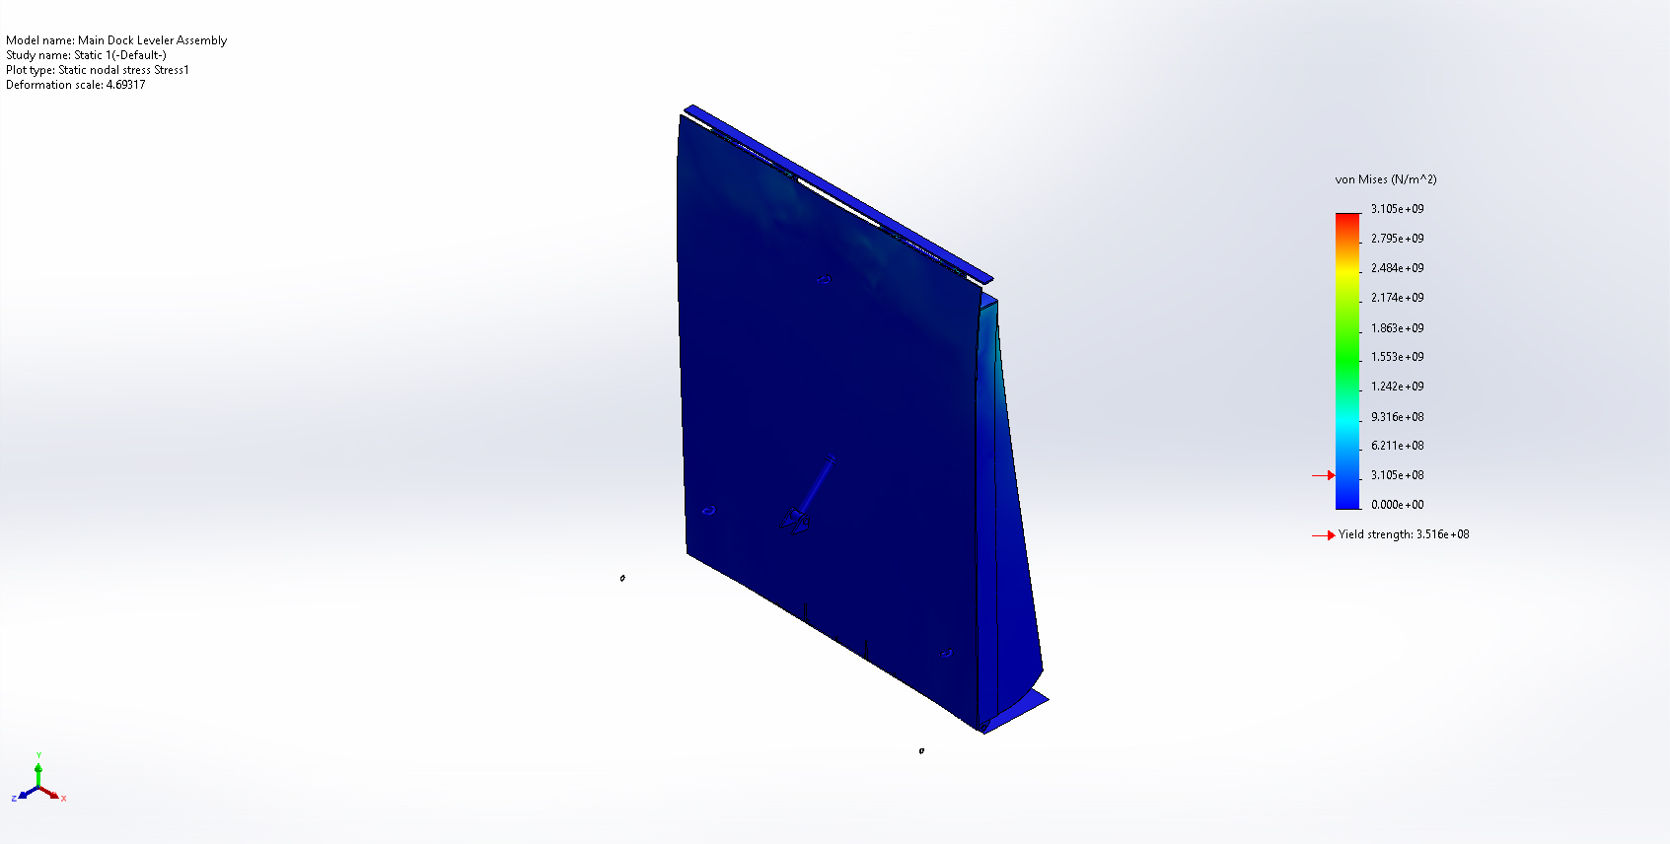
Main Dock Leveler Assembly-Static 1-Stress-Stress1

Name | Type | Min | Max
Displacement1 | URES: Resultant Displacement | 0.000e+00mm  Node: 5377 | 1.066e+02mm  Node: 20
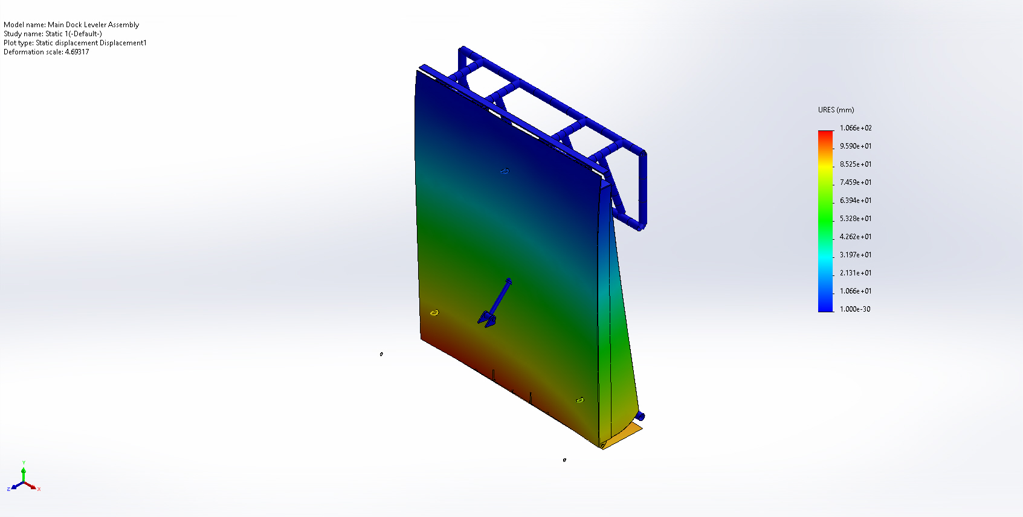
Main Dock Leveler Assembly-Static 1-Displacement-Displacement1

Name | Type | Min | Max
Strain1 | ESTRN: Equivalent Strain | 0.000e+00  Element: 2160 | 9.757e-03  Element: 116959
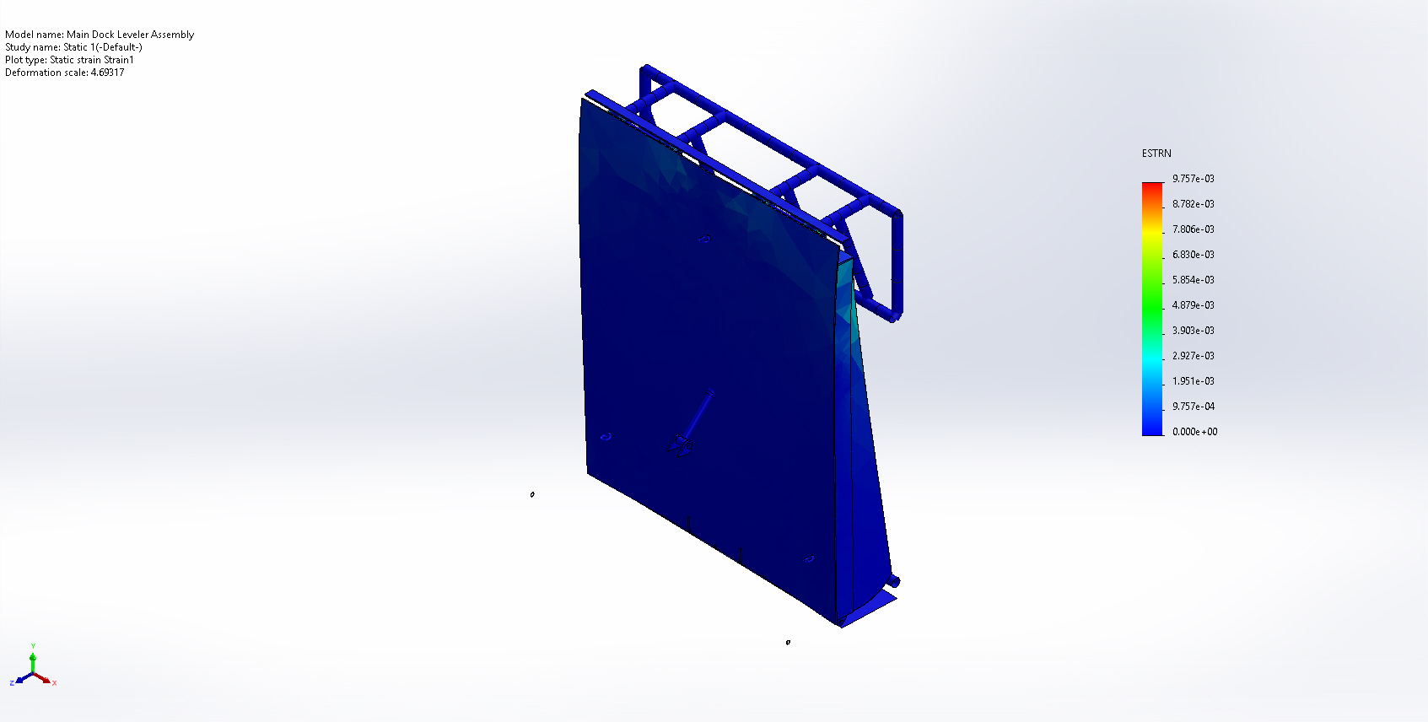
Main Dock Leveler Assembly-Static 1-Strain-Strain1

Name | Type
Displacement1{1} | Deformed shape
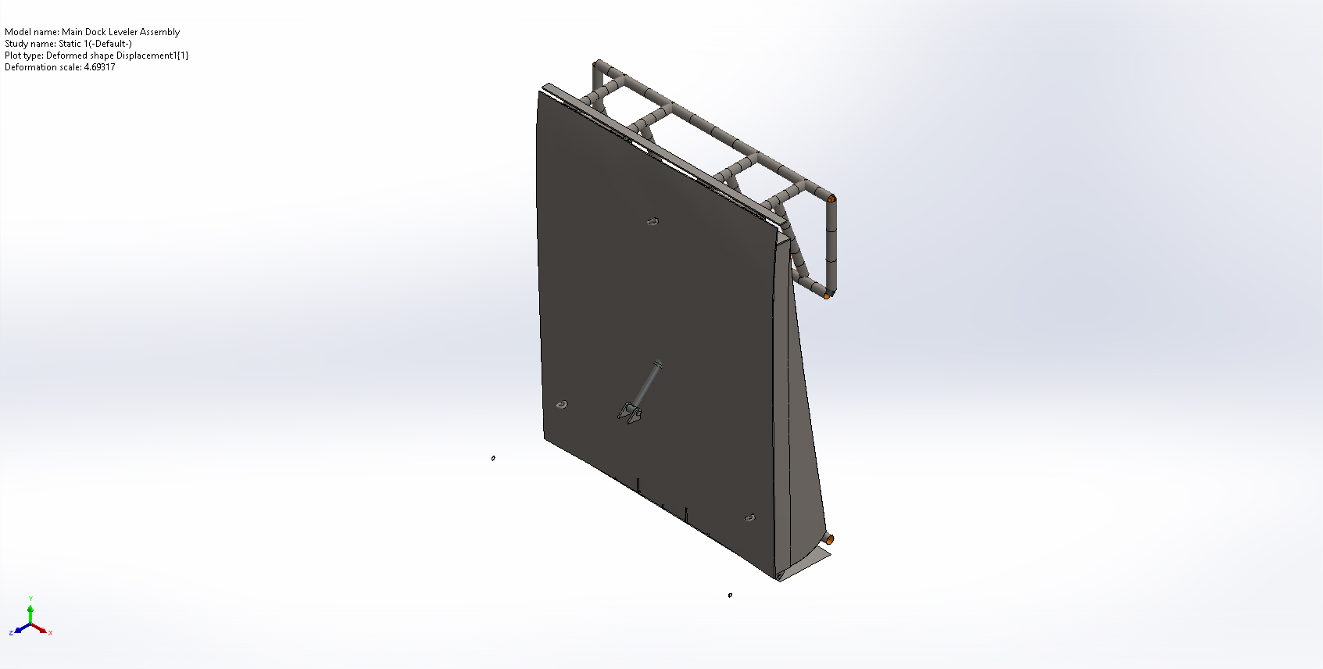
Main Dock Leveler Assembly-Static 1-Displacement-Displacement1{1}

Conclusion

